Working Methodology
To be completed when tasks involve multiple or complex activities that are not covered in their entirety by risk assessments and/or key procedures.

Note: This form is only valid when sections K and L are completed and signed the manager responsible and all personnel involved.
Site/project name: |  |  |  | Kidderpore Avenue |  |  |  |  | Project no.: | 468
Address: |  |  |  | Mount Anvil Ltd, Hampstead Manor, Kidderpore Avenue, West Hampstead,  North London
Area/location: |  |  |  | Skeel House
Company: |  |  | J. Reddington Ltd
SSOW No. |  | Enabling |  |  | Title: | -Underpinning Works to Skeel House
Project manager: |  |  | Daragh Quinn Construction manager: Mick O’Hara
Prepared by: |  |  |  | Louise Ormsby |  |  |  |  | Date: |  | 15/08/2016
Revision: |  |  |  | Revised by: |  |  |  |  | Revision Date:
A: Brief description of work to be undertaken
Underpinning works to Skeel House
Work location: Skeel House
Start date: 22/08/2016 |  |  |  |  |  |  |  | Duration: As per construction programme
B: Work equipment required for a safe working environment
Note: Include all equipment needed for a safe work environment, Do not include PPE – see section H.
Tools  - Dumpy level  - EDM  - Monopole  - Laser level  - Prism  - Ranging pole  - Shovels  - H16 dowels  - Disc cutter  - Crowd barriers  - Warning signage  - Spray paint |  |  |  |  |  |  |  | Documentation  Reference drawing: 9100-DRG-00SK-LG001  Materials  - Concrete  - Plywood  - Type 1 graded fill

C: Sequence of main job tasks
Underpinning Works

- An exclusion zone restricting access to un-authorized personnel will be established, i.e. only personnel directly involved with the excavation works are to have access.

- Movement monitoring will be in place by JRL, a control point retro will be put in place in various locations and monitored twice weekly throughout the works.

- Enter into lower ground level of Skeel House and take level survey. Care will be taken on entry to protect existing doors and historic fabric and throughout surveying works as to protect this Grade 2 listed building and its historic and architectural interest.

- Carefully and methodically remove existing internal floor for access and store in proposed area. Existing internal walls will be protected at all times during underpinning works so as not to damage any element of the walls historic features.

- Carefully expose the existing foundation by hand digging and clear any debris from the existing foundation around the perimeter of Skeel House.

- Assess the structural nature of the historic walls and remove the assumed existing masonry footing profile and remove existing foundation footing so as not to hinder any progress.

- Mark out underpinning sequence, starting with the corners 1, 2, 3, 4 sprayed on the wall below floor level. The sequence between each corner will be maximum 1 metre wide ‘hit and miss’ sections. Between 2 – 4 pins will be removed at any one time.

- Excavate by hand digging in order to protect the building, 1m x 1m deep, underpinning section down to formation level.

- Form step on underpinning for new floor to sit on, insert 4 x H16 dowels (2 bottom and 2 top) between underpinning bases.

- 75mm dry packing will be placed before concrete pour.

- Pour mass concrete so that the line of underpinning is the same line as the top of the existing wall.

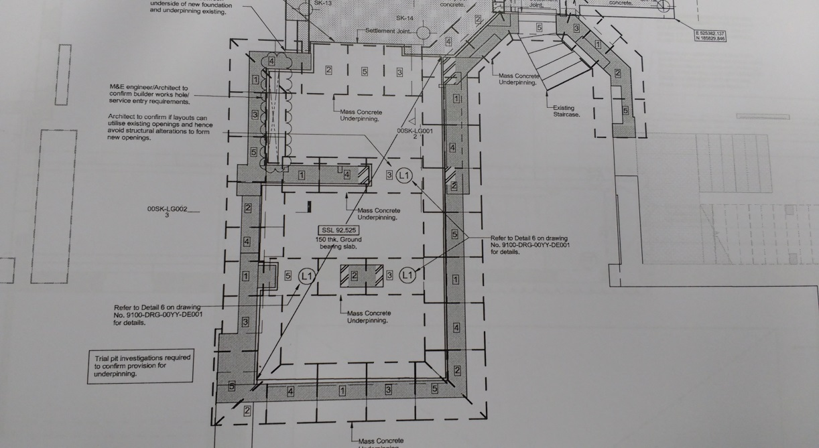

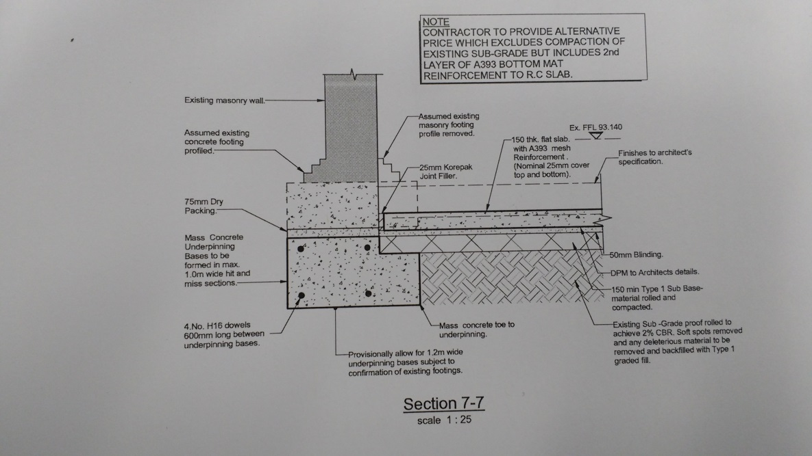
Note
Works will be inspected by a Mount Anvil Ltd representative and any additional remedial works will be completed.

On completion of all works the areas will be cleared of all remaining waste, equipment, tools and materials and handed over to the Mount Anvil Ltd follow on trades.

G: Details of work permits or authorisations required (tick and attach permits or other forms are required for the work activity)
Permit to work  (general) |  | Permit to work  (excavate) |  | Permit to work  (hot work) |  | Permit to work  (confined spaces)
Permit to work (electrical) |  | Permit to work  (working platform certificate) |  | Permit to work  (mobile crane authorisation) |  | Permit to work  (other)
If Other, please describe:

J: Details of contacts, site management etc., or special emergency arrangements
Senior Contract Manager - Brian Hallinan - 0778 977 8195

Contract Manager - Paul Bradley - 0784 002 7016

Project Manager - Daragh Quinn – 0770 375 6318

Construction Manager - Mick O’Hara - 0778 859 3350

Senior Engineer - Luke Flatley – 0795 775 7707

H&S Advisor - Louise Ormsby - 0781 845 1748

JRL Safety Department – 020 895 37800
K: Name of person responsible for implementation of working methodology (communications and monitoring compliance)
Name (please print):
Position: |  | Contact no:
1. Check all sections and confirm correct.
Signature: | - |  | Date: | -
2. Issue document to site team and ensure briefing.
Signature: | - |  | Date: | -

Working Methodology
L: Details of personnel involved and confirmation that information and instructions in this document have been satisfactorily communicated.
I/We the undersigned have been briefed on the underpinning working methodology within retained and listed buildings in accordance with Mount Anvil Ltd requirements for careful working and the protection and conservation of historic fabrics of the building.
Date | Name | Position/Role | Signature | Briefing given by

