Mr Simon Ayres
UCL Wolfson House
Room 515
4 Stephenson Way
LONDON NW1 2HE
Application Ref: 2016/2353/L
Please ask for: Antonia Powell
Telephone: 020 7974 2648
24 August 2016

Dear Sir/Madam

DECISION

Planning (Listed Building and Conservation Areas) Act 1990

Listed Building Consent Granted

Address:
UCL Main Building
Gower Street
London
WC1E 6BT

Proposal:
Addition of emergency lighting to the Donaldson Library to comply with local authority compliance requirements and British Standards. The current emergency lighting within the Library does not illuminate the exit routes sufficiently to allow safe egress from the area. The proposal is to add twelve luminaires to the main space column locations. The luminaires will be surfaced installed together with associated cabling. The cabling will be hidden wherever possible, with local areas flush installed to reduce the aesthetic impact. The locations and products proposed to be used are detailed on the drawings accompanying and technical information.

Drawing Nos: Location Plan; Betacalco Windsor lighting specification sheets x8; photo sheets x2; Drwg No. 1404-ES-005-03; Design and Access Statement - UCL Wilkins Building, Donaldson Library.

The Council has considered your application and decided to grant Listed Building Consent subject to the following condition(s):

Conditions And Reasons:

1 | The works hereby permitted shall be begun not later than the end of three years from the date of this consent.  Reason: In order to comply with the provisions of Section 18 of the Planning (Listed Buildings and Conservation Areas) Act 1990.
2 | All new work and work of making good shall be carried out to match the original work as closely as possible in materials and detailed execution.  Reason: In order to safeguard the special architectural and historic interest of the building in accordance with the requirements of policy CS14 of the London Borough of Camden Local Development Framework Core Strategy and policy DP25 of the London Borough of Camden Local Development Framework Development Policies.
3 | The works hereby approved are only those specifically indicated on the drawing(s) referred to above.  Reason: In order to safeguard the special architectural and historic interest of the building in accordance with the requirements of policy CS14 of the London Borough of Camden Local Development Framework Core Strategy and policy DP25 of the London Borough of Camden Local Development Framework Development Policies.

Informative(s):

This application concerns the installation of additional lighting to the Listed Grade I Donaldson Library within the Wilkins Building of UCL. The upgrading and provision of emergency lighting to the historic library interior has been considered in detail. Initial concerns by the planning authority and Historic England relating to the method of installation and integration of the lamps and associated service runs within the historic fabric have been resolved satisfactorily. The cabling is to be run behind the timber and plaster work as discussed on site. No cables will be surface mounted and they will not be visible. Lighting switches are to be located sensitively away from library joinery or decorative plaster details and hidden from view with low visible impact.

The site's planning history was taken into account when coming to this decision. No objections were received as a result of public consultation.

Special attention has been paid to the desirability of preserving the special interest of the listed building, under s.16 of the Listed Buildings and Conservation Areas Act 1990 as amended by the Enterprise and Regulatory Reform Act (ERR) 2013.

As such, the proposed development is in general accordance with policies CS5 and CS14 of the London Borough of Camden Local Development Framework Core Strategy, and policies DP24, DP25 and DP26 of the London Borough of Camden Local Development Framework Development Policies. The proposed development also accords with policies 7.4, 7.6 and 7.8 of the London Plan March 2015, consolidated with alterations since 2011; and paragraphs 14, 17, 56-66 and 126-141 of the National Planning Policy Framework.

This application is therefore granted.

Your proposals may be subject to control under the Building Regulations and/or the London Buildings Acts which cover aspects including fire and emergency escape, access and facilities for people with disabilities and sound insulation between dwellings. You are advised to consult the Council's Building Control Service, Camden Town Hall, Argyle Street WC1H 8EQ, (tel: 020-7974 6941).

You can find advice about your rights of appeal at:

http://www.planningportal.gov.uk/planning/appeals/guidance/guidancecontent

Yours faithfully
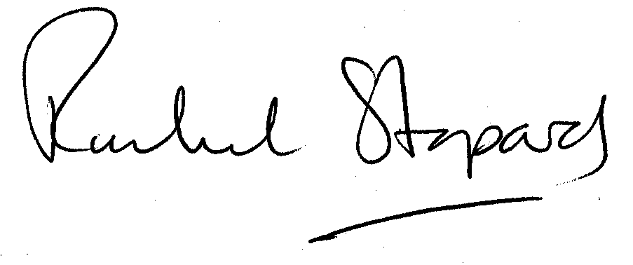
Rachel Stopard
Executive Director Supporting Communities

