24 Betterton Street, 2016/1125/L

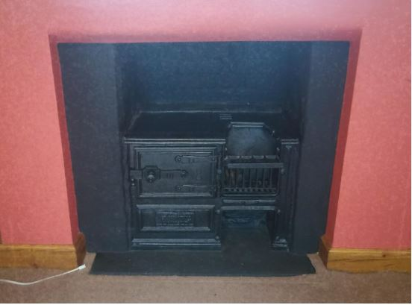
An existing fireplace: no surround or mantelpiece and unused reproduction kitchen stove, unsuitable for principal room in house of this high status and period

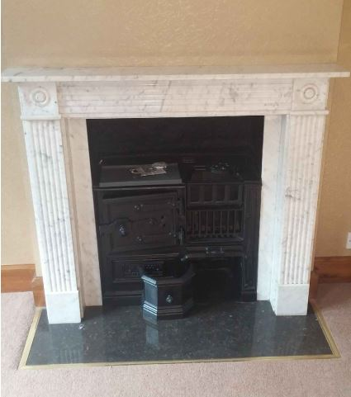
An existing fireplace: wrong period and another unused reproduction kitchen stove, again unsuitable for principal room in house of this high status and period
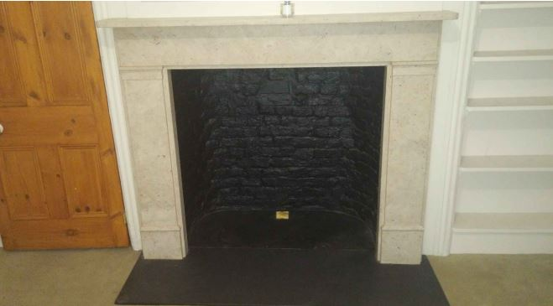
An existing fireplace: wrong period
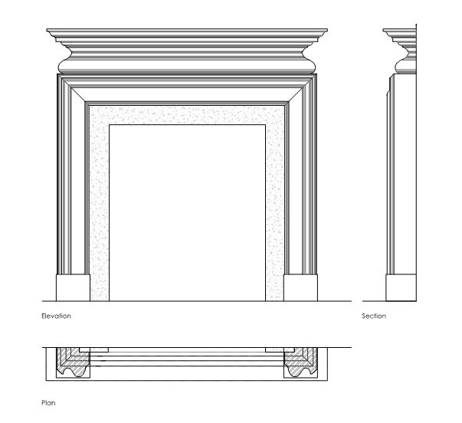
Drawing of the proposed fireplace: based on scholarly research and other house owned by the family and built in the same period

