Mr Dean Wain
Morrison Design Ltd
103 Belper Road
Derby
DE13ES

103 Belper Road  Derby  DE13ES |  | Application Ref: 2016/1528/A
 |  | Please ask for: Antonia Powell
 |  | Telephone: 020 7974 2648
 |  | 8 August 2016

Dear Sir/Madam

DECISION

Town and Country Planning Act 1990

Advertisement Consent Granted

Address:
17 Upper Woburn Place
London
WC1H 0HT

Proposal:
Proposed 4x illuminated box signs to front elevation, 2x plaque signs to either side of entrance door and lighting to front canopy
Drawing Nos: Site location plan; 3915 082; 083 rev A; 084 rev A; 085 rev B; 086 rev B; 087; The Hilton London Euston Upper Woburn Place Heritage Statement by Morrison Design dated February 2016; The Hilton London Euston Upper Woburn Place Design and Access Statement by Morrison Design dated January 2016.

The Council has considered your application and decided to grant consent subject to the following condition(s):

Conditions and Reasons:

1 | No advertisement is to be displayed without the permission of the owner of the site or any other person with an interest in the site entitled to grant permission.  Reason: - As required by regulation 2(1) and Schedule 2 of the Town & Country Planning (Control of Advertisements) (England) Regulations 2007.
2 | No advertisement shall be sited or displayed so as to  (a) endanger persons using any highway, railway, waterway, dock, harbour or aerodrome (civil or military);  (b) obscure, or hinder the ready interpretation of any traffic sign, railway signal or aid to navigation by water or air; or  (c) hinder the operation of any device used for the purpose of security or surveillance or for measuring the speed of any vehicle  Reason: - As required by regulation 2(1) and Schedule 2 of the Town & Country Planning (Control of Advertisements) (England) Regulations 2007.
3 | Any advertisement displayed and any site used for the display of advertisements, shall be maintained in a condition that does not impair the visual amenity of the site.  Reason: - As required by regulation 2(1) and Schedule 2 of the Town & Country Planning (Control of Advertisements) (England) Regulations 2007.
4 | Any structure or hoarding erected or used principally for the purpose of displaying advertisements shall be maintained in a safe condition.  Reason: - As required by regulation 2(1) and Schedule 2 of the Town & Country Planning (Control of Advertisements) (England) Regulations 2007.
5 | Where an advertisement is required under these Regulations to be removed, the site shall be left in a condition that does not endanger the public or impair visual amenity.  Reason: - As required by regulation 2(1) and Schedule 2 of the Town & Country Planning (Control of Advertisements) (England) Regulations 2007.

Informative(s):

This application concerns the installation of signage and lighting to the front elevation of the terrace occupied by the Hilton Hotel formerly occupied by the Cora Hotel. The listed grade II historic terrace is composed of seven buildings.

The proposed internally illuminated (letters only) fascia signs and plaque signs are considered acceptable in terms of size, design, level of illumination and location and would preserve and enhance the character and appearance of the conservation area. The proposal will not impact on neighbour amenity in terms of an unacceptable level of light spill nor would it be harmful to either pedestrian or vehicular safety.

The sites planning and enforcement history and relevant appeal decisions have been taken into account when coming to this decision.

Special attention has been paid to the desirability of preserving or enhancing the character or appearance of the conservation area, and setting of the listed building under section 72 and 66 of the Listed Buildings and Conservation Areas Act 1990 as amended by the Enterprise and Regulatory Reform Act (ERR) 2013.

As such, the proposed development is in general accordance with policies CS5, and CS14 of the London Borough of Camden Local Development Framework Core Strategy, and policies DP24, DP25 and DP26 of the London Borough of Camden Local Development Framework Development Policies. The proposed development also accords with policies 7.4 and 7.6 of the London Plan 20116 and paragraphs 14, 17, 56-67 of the National Planning Policy Framework.

In dealing with the application, the Council has sought to work with the applicant in a positive and proactive way in accordance with paragraphs 186 and 187 of the National Planning Policy Framework.

You can find advice in regard to your rights of appeal at:
http://www.planningportal.gov.uk/planning/appeals/guidance/guidancecontent

Yours faithfully
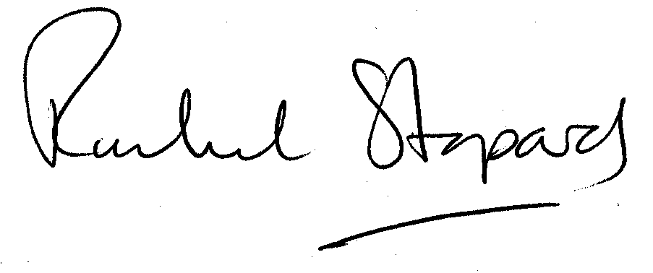
Rachel Stopard
Executive Director Supporting Communities

