Mr Andrew Jobling
Levitt Bernstein Architects
1 Kingsland Passage
London
E8 2BB
1 Kingsland Passage  London  E8 2BB |  | Application Ref: 2016/3406/L
 |  | Please ask for: Catherine Bond
 |  | Telephone: 020 7974 2669
 |  | 8 August 2016

Dear Sir/Madam

DECISION

Planning (Listed Building and Conservation Areas) Act 1990

Listed Building Consent Granted

Address:
Flat G
79 Rowley Way
London
NW8 0SL

Proposal:
Alterations to bathroom comprising removal of bath and replacement with wet-room style shower and changes to washbasin.
Drawing Nos: Site Location Plan; 2504_RL_902 P1; 2504_RL_903 P1; Design, Heritage and Access Statement.

The Council has considered your application and decided to grant Listed Building Consent subject to the following condition(s):

Conditions And Reasons:

1 | The works hereby permitted shall be begun not later than the end of three years from the date of this consent.  Reason: In order to comply with the provisions of Section 18 of the Planning (Listed Buildings and Conservation Areas) Act 1990.
2 | All new work and work of making good shall be carried out to match the original work as closely as possible in materials and detailed execution.  Reason: In order to safeguard the special architectural and historic interest of the building in accordance with the requirements of policy CS14 of the London Borough of Camden Local Development Framework Core Strategy and policy DP25 of the London Borough of Camden Local Development Framework Development Policies.
3 | The works hereby approved are only those specifically indicated on the drawing(s) referred to above.  Reason: In order to safeguard the special architectural and historic interest of the building in accordance with the requirements of policy CS14 of the London Borough of Camden Local Development Framework Core Strategy and policy DP25 of the London Borough of Camden Local Development Framework Development Policies.

Informative(s):

Reasons for granting listed building consent

The proposed works comprise the replacement of the existing enamelled cast-iron bath and non-original tiling in the bathroom of this grade II* listed dwelling with a level-access wet shower with a thermostatic electric shower specification. Associated works include white floor-to-ceiling tiling and fittings such as a shower seat, plus non-slip vinyl safety flooring and a sealed steam-proof light fitting. The washbasin is original, and will be refitted at a slightly higher level. The works are to meet the needs of a disabled resident of the property, and have been requested by Camden Occupational Therapy Services. The works do not harm the special interest of the grade II* listed building.

Public consultation was undertaken by placement of a press notice and site notice, and no responses were received. Historic England was consulted, whereby a response was received on 3 August 2016 authorising the London Borough of Camden to determine this application in accordance with national and local policy guidance and on the basis of its specialist conservation advice. The site's planning history was taken into account when coming to this decision.

Special regard has been attached to the desirability of preserving the listed building and its features of special architectural or historic interest, under s.16 of the Listed Buildings and Conservation Areas Act 1990 as amended by the Enterprise and Regulatory Reform Act (ERR) 2013.

As such, the proposal is in general accordance with policy CS14 of the London Borough of Camden Local Development Framework Core Strategy, and policy DP25 of the London Borough of Camden Local Development Framework Development Policies. The proposed development also accords with policy 7.8 of The London Plan 2015 consolidated with alterations since 2011, and paragraphs 14, 17 and 126-141 of the National Planning Policy Framework.

Your proposals may be subject to control under the Building Regulations and/or the London Buildings Acts which cover aspects including fire and emergency escape, access and facilities for people with disabilities and sound insulation between dwellings. You are advised to consult the Council's Building Control Service, 5 Pancras Square, London N1C 4AG, (tel: 020-7974 6941).

You can find advice about your rights of appeal at:

http://www.planningportal.gov.uk/planning/appeals/guidance/guidancecontent

Yours faithfully
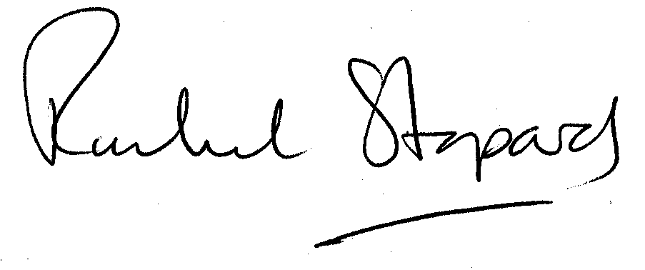
Rachel Stopard
Executive Director Supporting Communities

