Mr Ben Archer
Haines Phillips Architects
Tankerton Works
12 Argyle Walk
London
WC1H 8HA
Tankerton Works  12 Argyle Walk  London  WC1H 8HA |  | Application Ref: 2016/2482/L
 |  | Please ask for: Catherine Bond
 |  | Telephone: 020 7974 2669
 |  | 8 August 2016

Dear Sir/Madam

DECISION

Planning (Listed Building and Conservation Areas) Act 1990

Listed Building Consent Granted

Address:
Lauderdale House
Highgate Hill
London
N6 5HG

Proposal:
Relocated position of new glazed internal door and screen, as granted by listed building consent ref 2012/3058/L dated 14/08/2012 for the erection of enlarged single storey rear extension and various associated works including internal alterations.

Drawing Nos: Site Location Plan; GA 015 PL; 210 PL rev 1; DA 211 PL(2); Photos of Timbers; Design, Heritage and Access Statement.

The Council has considered your application and decided to grant Listed Building Consent subject to the following condition(s):

Conditions And Reasons:

1 | The development hereby permitted shall begin either before the expiration of five years from the date of this permission or before the expiration of two years from the date of the last of the reserved matters to be approved, whichever is the later.  Reason: In order to comply with the provisions of Section 92 of the Town and Country Planning Act 1990 (as amended).
2 | All new work and work of making good shall be carried out to match the original work as closely as possible in materials and detailed execution.  Reason: In order to safeguard the special architectural and historic interest of the building in accordance with the requirements of policy CS14 of the London Borough of Camden Local Development Framework Core Strategy and policy DP25 of the London Borough of Camden Local Development Framework Development Policies.
3 | The works hereby approved are only those specifically indicated on the drawing(s) referred to above.  Reason: In order to safeguard the special architectural and historic interest of the building in accordance with the requirements of policy CS14 of the London Borough of Camden Local Development Framework Core Strategy and policy DP25 of the London Borough of Camden Local Development Framework Development Policies.

Informative(s):

Reasons for granting listed building consent:

This application is for a relocated position of a new glazed internal door and screen adjacent to a staircase on the first floor of the grade II* listed 16th century Lauderdale House. The proposed works have become necessary as a result of the unexpected discovery during building works of historic timbers within an internal wall, which has listed building consent to be removed to create a new door opening as part of a wider scheme of restoration and upgrading of the property (ref 2012/3058/L granted on 14/08/2012).

The original proposal for this application was to move the position of the new glazed door by approximately 600mm, and to carefully relocate the fragile central timber so that was situated away from the door. However, the scheme was revised so that the historic timbers could remain in situ, and untouched by the proposals. The proposed scheme now constitutes the retention of the timbers in their existing location. The new door and screen will still be relocated approximately 600mm to allow for the retention of the timber and to read as a separate visual entity.

It is considered that the works are necessary to implement the existing listed building consent which is to facilitate an important project to extend Lauderdale House and upgrade its visitor and educational facilities. It is therefore concluded that the works will not harm the special interest of the grade II* listed building.

Public consultation was undertaken by placement of a press notice and site notice, and no responses were received. Historic England was consulted, whereby a response was received on 22 July 2016 authorising the London Borough of Camden to determine this application in accordance with national and local policy guidance and on the basis of its specialist conservation advice. The site's planning history was taken into account when coming to this decision.

Special regard has been attached to the desirability of preserving the listed building and its features of special architectural or historic interest, under s.16 of the Listed Buildings and Conservation Areas Act 1990 as amended by the Enterprise and Regulatory Reform Act (ERR) 2013.

As such, the proposal is in general accordance with policy CS14 of the London Borough of Camden Local Development Framework Core Strategy, and policy DP25 of the London Borough of Camden Local Development Framework Development Policies. The proposed development also accords with policy 7.8 of The London Plan 2015 consolidated with alterations since 2011, and paragraphs 14, 17 and 126-141 of the National Planning Policy Framework.

Your proposals may be subject to control under the Building Regulations and/or the London Buildings Acts which cover aspects including fire and emergency escape, access and facilities for people with disabilities and sound insulation between dwellings. You are advised to consult the Council's Building Control Service, 5 Pancras Square, London N1C 4AG (tel: 020-7974 6941).

You are advised that any works of alterations or upgrading not included on the approved drawings which are required to satisfy Building Regulations or Fire Certification may require a further application for listed building consent.

You can find advice about your rights of appeal at:

http://www.planningportal.gov.uk/planning/appeals/guidance/guidancecontent

Yours faithfully
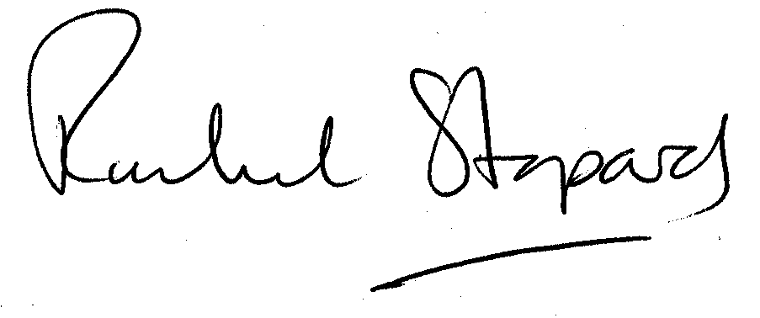
Rachel Stopard
Executive Director Supporting Communities

