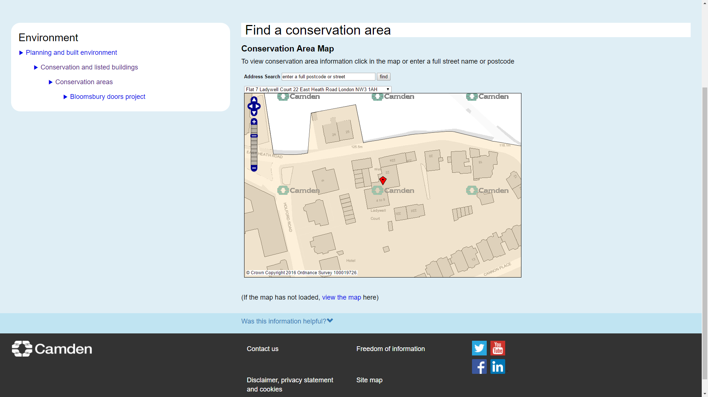
T1 Sycamore T 2 Rowan

