Yuen Chong
desM
4 London Road
Welwyn
Hertfordshire AL6 9EL
4 London Road  Welwyn  Hertfordshire AL6 9EL |  | Application Ref: 2016/2168/L
 |  | Please ask for: Antonia Powell
 |  | Telephone: 020 7974 2648
 |  | 5 August 2016

Dear Sir/Madam

DECISION

Planning (Listed Building and Conservation Areas) Act 1990

Listed Building Consent Granted

Address:
UCL Cruciform Building
Gower Street
London
WC1E 6AE

Proposal:
Refurbishment of existing laboratory at Wing 2.1 on second floor.

Drawing Nos: Site Plan; Location plan; Drawing Nos. 1237_P_301; 1237_P_302; 1237_P_402; 1237_P_701; 1237_P_801; EC14284-004-Plant Noise Impact Assessment; Document entitled: UCL Cruciform Building Cortical Neuromics Design and Access Statement issue V 1.0 by desM architects and 1237 supplement document.

The Council has considered your application and decided to grant Listed Building Consent subject to the following condition(s):

Conditions And Reasons:

1 | The works hereby permitted shall be begun not later than the end of three years from the date of this consent.  Reason: In order to comply with the provisions of Section 18 of the Planning (Listed Buildings and Conservation Areas) Act 1990.
2 | All new work and work of making good shall be carried out to match the original work as closely as possible in materials and detailed execution.  Reason: In order to safeguard the special architectural and historic interest of the building in accordance with the requirements of policy CS14 of the London Borough of Camden Local Development Framework Core Strategy and policy DP25 of the London Borough of Camden Local Development Framework Development Policies.
3 | The works hereby approved are only those specifically indicated on the drawing(s) referred to above.  Reason: In order to safeguard the special architectural and historic interest of the building in accordance with the requirements of policy CS14 of the London Borough of Camden Local Development Framework Core Strategy and policy DP25 of the London Borough of Camden Local Development Framework Development Policies.
4 | All fixing to the original glazed bricks to be through the mortar joints or existing holes to avoid further damage to the historic fabric.  Reason: In order to safeguard the special architectural and historic interest of the building in accordance with the requirements of policy CS14 of the London Borough of Camden Local Development Framework Core Strategy and policy DP25 of the London Borough of Camden Local Development Framework Development Policies.

Informative(s):

Reasons for granting listed building consent:

This application concerns the refurbishment of the second floor laboratory and involves the removal of late 20th century partitions and services. The remaining elements of architectural or historic significance are the glazed tiled walls around the perimeter of the space. The proposed works, providing they do not impact on the historic glazed bricks, are not considered to harm the significance of the interior of the grade II listed purpose built hospital building.

No consultation has been undertaken as all the works are internal. The site's planning history was taken into account when coming to this decision.

Special regard has been attached to the desirability of preserving the listed building and its features of special architectural or historic interest, under s.16 of the Listed Buildings and Conservation Areas Act 1990 as amended by the Enterprise and Regulatory Reform Act (ERR) 2013.

As such, the proposal is in general accordance with policy CS14 of the London Borough of Camden Local Development Framework Core Strategy, and policy DP25 of the London Borough of Camden Local Development Framework Development Policies. The proposed development also accords with policy 7.8 of The London Plan 2015 consolidated with alterations since 2011, and paragraphs 14, 17 and 126-141 of the National Planning Policy Framework.

You are advised that any works of alterations or upgrading not included on the approved drawings which are required to satisfy Building Regulations or Fire Certification may require a further application for listed building consent.

Your proposals may be subject to control under the Building Regulations and/or the London Buildings Acts which cover aspects including fire and emergency escape, access and facilities for people with disabilities and sound insulation between dwellings. You are advised to consult the Council's Building Control Service, 5 Pancras Square, London N1C 4AG, (tel: 020-7974 6941).

You can find advice about your rights of appeal at:

http://www.planningportal.gov.uk/planning/appeals/guidance/guidancecontent

Yours faithfully
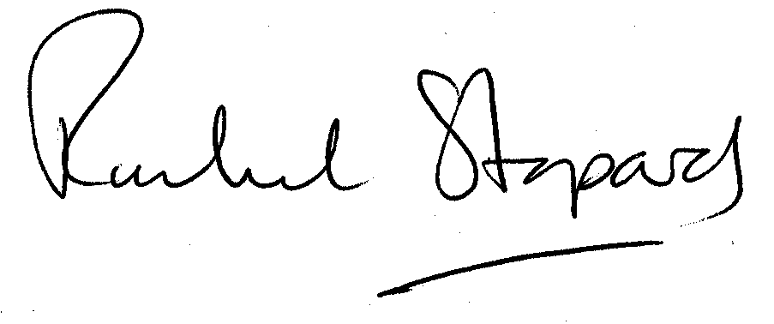
Rachel Stopard
Executive Director Supporting Communities

