Miss Ellie Bird
Deloitte Real Estate
Athene Place
66 Shoe Lane
London
EC4A 3BQ
Athene Place  66 Shoe Lane  London  EC4A 3BQ |  | Application Ref: 2016/3298/P
 |  | Please ask for: Antonia Powell
 |  | Telephone: 020 7974 2648
 |  | 5 August 2016

Dear Sir/Madam

DECISION

Town and Country Planning Act 1990 (as amended)

Full Planning Permission Granted

Address:
Bentham House
4-8 Endsleigh Gardens
London
WC1H 0EG

Proposal:
Installation of rooflight and 2 air vents at roof level.
Drawing Nos:
Site location plan;
3000.L.106 rev P17;
Planning Statement by Deloitte Real Estate dated June 2016;
UCL Laws Revised Heritage Statement by Alan Baxter's Associates dated April 2016;
Bentham House: Rewiring and layout changes Design and Access Statement by Levitt Bernstein dated June 2016.

The Council has considered your application and decided to grant permission subject to the following condition(s):

Condition(s) and Reason(s):

1 | The development hereby permitted must be begun not later than the end of three years from the date of this permission.  Reason: In order to comply with the provisions of Section 91 of the Town and Country Planning Act 1990 (as amended).
2 | All new external work shall be carried out in materials that resemble, as closely as possible, in colour and texture those of the existing building, unless otherwise specified in the approved application.  Reason: To safeguard the appearance of the premises and the character of the immediate area in accordance with the requirements of policy CS14 of the London Borough of Camden Local Development Framework Core Strategy and policy DP24 [and DP25 if in CA] of the London Borough of Camden Local Development Framework Development Policies.
3 | The development hereby permitted shall be carried out in accordance with the following approved plans:  Site location plan;  3000.L.106 rev P17;  Planning Statement by Deloitte Real Estate dated June 2016;  UCL Laws Revised Heritage Statement by Alan Baxter's Associates dated April 2016; Bentham House: Rewiring and layout changes Design and Access Statement by Levitt Bernstein dated June 2016;  Reason:  For the avoidance of doubt and in the interest of proper planning.

Informative(s):

Your proposals may be subject to control under the Building Regulations and/or the London Buildings Acts which cover aspects including fire and emergency escape, access and facilities for people with disabilities and sound insulation between dwellings. You are advised to consult the Council's Building Control Service, 5 Pancras Square, London N1C 4AG, (tel: 020-7974 6941).

Noise from demolition and construction works is subject to control under the Control of Pollution Act 1974. You must carry out any building works that can be heard at the boundary of the site only between 08.00 and 18.00 hours Monday to Friday and 08.00 to 13.00 on Saturday and not at all on Sundays and Public Holidays. You are advised to consult the Council's Compliance and Enforcement team [Regulatory Services], 5 Pancras Square, London N1C 4AG (Tel. No. 020 7974 4444 or on the website http://www.camden.gov.uk/ccm/content/contacts/council-contacts/environment/contact-the-environmental-health-team.en or seek prior approval under Section 61 of the Act if you anticipate any difficulty in carrying out construction other than within the hours stated above.

Reasons for granting permission [Delegated]:

This application relates to Bentham House (Listed Grade II) which opened in 1957 as the headquarters for the National Union of General and Municipal Workers. Since 1965 the building has been occupied by UCL Laws Faculty. UCL seeks a number of amendments to the approved scheme (2014/5034/P), including the addition of new partitions at first to fourth floor and the provision of new work space to the fifth floor involving a new roof light and two air vents at roof level,

The additional changes to the approved scheme have been discussed in detail on site and the application reflects the considered design rational. These proposals are considered acceptable.

The site's planning history was taken into account when coming to this decision. No objections were received as a result of public consultation.

Special regard has been attached to the desirability of preserving the listed building and its features of special architectural or historic interest, under s.16, and to preserving or enhancing the character and appearance of the conservation area, under s.72 of the Listed Buildings and Conservation Areas Act 1990 as amended by the Enterprise and Regulatory Reform Act (ERR) 2013.

As such, the proposed development is in general accordance with policies CS5 and CS14 of the London Borough of Camden Local Development Framework Core Strategy, and policies DP24, DP25 and DP26 of the London Borough of Camden Local Development Framework Development Policies. The proposed development also accords with policies 7.4, 7.6 and 7.8 of the London Plan March 2015, consolidated with alterations since 2011; and paragraphs 14, 17, 56-66 and 126-141 of the National Planning Policy Framework.

In dealing with the application, the Council has sought to work with the applicant in a positive and proactive way in accordance with paragraphs 186 and 187 of the National Planning Policy Framework.

You can find advice about your rights of appeal at:

http://www.planningportal.gov.uk/planning/appeals/guidance/guidancecontent

Yours faithfully
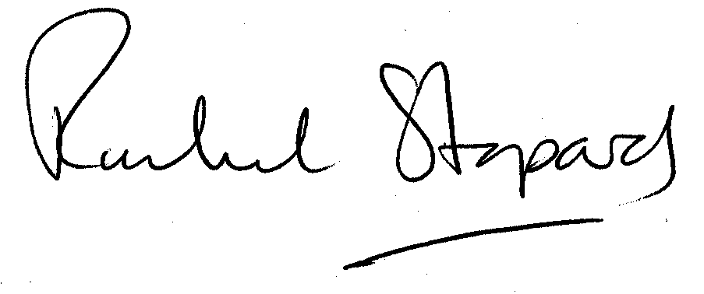
Rachel Stopard
Executive Director Supporting Communities

