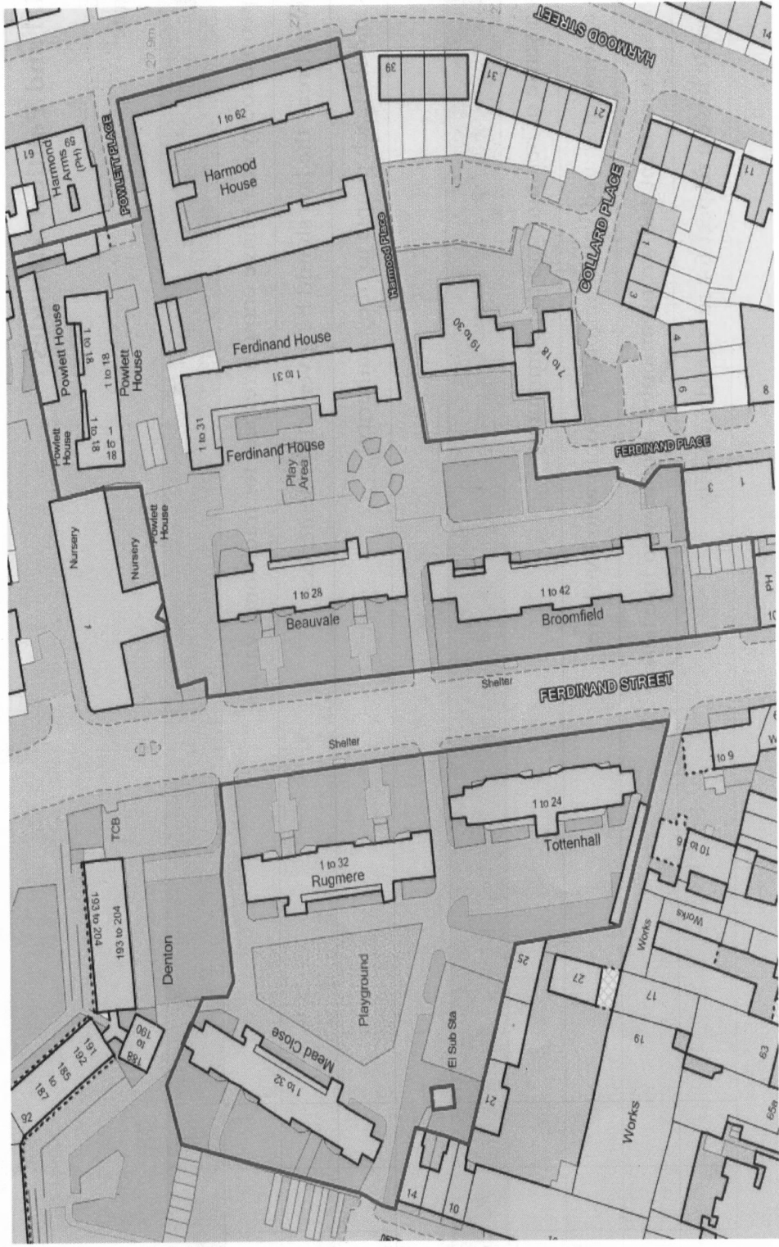

**=** **5 x ROAD ENTRANCES ON TO FERDINAND ESTATE**