Mr. Paul Stevenson
Paul Stevenson Design Ltd
34 Crediton Rd
London
NW10 3DU
34 Crediton Rd  London  NW10 3DU |  | Application Ref: 2016/1761/L
 |  | Please ask for: Catherine Bond
 |  | Telephone: 020 7974 2669
 |  | 2 August 2016

Dear Sir/Madam

DECISION

Planning (Listed Building and Conservation Areas) Act 1990

Listed Building Consent Granted

Address:
29 Jeffrey's Street
London
NW1 9PS

Proposal:
Various internal alterations including installation of WC at lower-ground floor level, plus external works comprising installation of replacement window in front elevation at lower-ground floor level and installation of window and French doors in rear elevation at lower-ground floor level.
Drawing Nos: Site location plan; 030915-01 (A1) rev A; 030915-02 (A3); 030915-03 (A3); photo 1; photo 2; photo 3; photo 4; photo 5; Heritage, Design & Access Statement.

The Council has considered your application and decided to grant Listed Building Consent subject to the following condition(s):

Conditions And Reasons:

1 | The works hereby permitted shall be begun not later than the end of three years from the date of this consent.  Reason: In order to comply with the provisions of Section 18 of the Planning (Listed Buildings and Conservation Areas) Act 1990.
2 | All new external and internal works and finishes and works of making good to the retained fabric, shall match the existing adjacent work with regard to the methods used and to material, colour, texture and profile, unless shown otherwise on the drawings or other documentation hereby approved or required by any condition(s) attached to this consent.  Reason: In order to safeguard the special architectural and historic interest of the building in accordance with the requirements of policy CS14 of the London Borough of Camden Local Development Framework Core Strategy and policy DP25 of the London Borough of Camden Local Development Framework Development Policies.
3 | The works hereby approved are only those specifically indicated on the drawing(s) referred to above.  Reason: In order to safeguard the special architectural and historic interest of the building in accordance with the requirements of policy CS14 of the London Borough of Camden Local Development Framework Core Strategy and policy DP25 of the London Borough of Camden Local Development Framework Development Policies.

Informative(s):

Reasons for granting listed building consent:

This application has been submitted pursuant to pre-application advice given in December 2015.

Internally, it is proposed to install a WC in a small cubicle at lower-ground floor level, which will be accessed directly off the stairhall, and be located on the north-western side of the kitchen adjacent to the flank wall in the likely location of the former entrance corridor. As such, it will not harm the plan form, and all new ductwork will be take advantage of existing service routes. Further works to create a more open-plan living space at this level, originally forming part of this application, have been omitted at the request of the applicant.

Externally, it is proposed to remove the existing modern French doors and window in the lower-ground floor rear extension, which are constructed from timber and are subdivided into small panes. The proposed replacements will utilise the same openings, but will be of a simpler design with black frames in powder-coated aluminium. An original proposal for a walk-on rooflight in the existing ground-floor roof of the rear extension has been removed from the scheme at the applicant's request.

At the front of the property, it is proposed to replace a 20th century Crittall window which lights the front lower-ground floor room with a new timber casement window painted white, adhering to the dimensions and proportions of the existing window.

The works are considered to have a neutral impact on the grade II listed building, thereby causing no harm to its special interest.

Public consultation was undertaken by means of a site notice and press notice, whereby there were no responses. The Jeffrey's Street CAAC was consulted. but did not respond. The site's planning history was taken into account when coming to this decision.

Special regard has been attached to the desirability of preserving the listed building and its features of special architectural or historic interest, under s.16 of the Listed Buildings and Conservation Areas Act 1990 as amended by the Enterprise and Regulatory Reform Act (ERR) 2013.

As such, the proposal is in general accordance with policy CS14 of the London Borough of Camden Local Development Framework Core Strategy, and policy DP25 of the London Borough of Camden Local Development Framework Development Policies. The proposed development also accords with policy 7.8 of The London Plan 2016 and paragraphs 14, 17 and 126-141 of the National Planning Policy Framework.

Your proposals may be subject to control under the Building Regulations and/or the London Buildings Acts which cover aspects including fire and emergency escape, access and facilities for people with disabilities and sound insulation between dwellings. You are advised to consult the Council's Building Control Service, 5 Pancras Square, London N1C 4AG, (tel: 020-7974 6941).

Your proposals may be subject to control under the Party Wall etc Act 1996 which covers party wall matters, boundary walls and excavations near neighbouring buildings. You are advised to consult a suitably qualified and experienced Building Engineer.

Noise from demolition and construction works is subject to control under the Control of Pollution Act 1974. You must carry out any building works that can be heard at the boundary of the site only between 08.00 and 18.00 hours Monday to Friday and 08.00 to 13.00 on Saturday and not at all on Sundays and Public Holidays. You are advised to consult the Council's Noise and Licensing Enforcement Team, 5 Pancras Square, London N1C 4AG (Tel. No. 020 7974 4444 or on the website http://www.camden.gov.uk/ccm/content/contacts/council-contacts/environment/contact-the-environmental-health-team.en or seek prior approval under Section 61 of the Act if you anticipate any difficulty in carrying out construction other than within the hours stated above.

You can find advice about your rights of appeal at:

http://www.planningportal.gov.uk/planning/appeals/guidance/guidancecontent

Yours faithfully
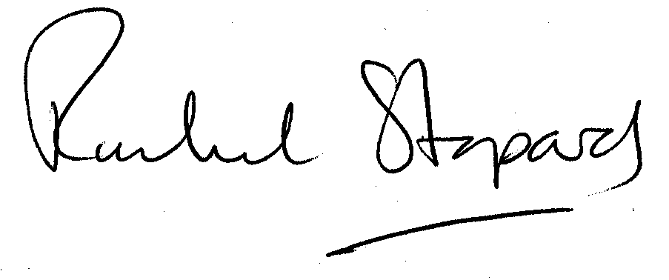
Rachel Stopard
Executive Director Supporting Communities

