Iceni Projects Limited

Flitcroft House

114 - 116 Charing Cross Road

London

WC2H 0JR
Application Ref: 2015/1444/P
Please ask for: Kathryn Moran
Telephone: 020 7974 5709
1 February 2016

Dear Sir/Madam

DECISION

Town and Country Planning Act 1990 (as amended)

Full Planning Permission Refused

Address:
Mansfield Bowling Club
Croftdown Road
London
NW5 1EP

Proposal:
Creation of a new publicly accessible open space; enhanced tennis facilities including the reconfiguration and extension of the courts to provide an additional court and increased playing area to accord with LTA requirements; the provision of a new ancillary pavilion (Class D2) to replace existing ancillary buildings and structures providing community and leisure space; a new community garden; and the demolition and replacement of the existing bowling club building with a new part three storey, part 2 storey building providing 21 residential dwellings (Class C3) with associated access, parking and landscaping.

Drawing Nos: Utilities Statement, Sustainability Strategy Report by MTT Ltd, Travel Plan by Ardent Consulting Engineers, Transport Statement by Ardent Consulting Engineers, External Lighting Impact Assessment; Environmental Noise Survey Report by Sandy Brown Associates LLP, Energy Strategy Report by MTT Ltd, Phase 1 Habitat Survey and Reptile Survey James Blake Associates; Drainage Strategy by Ardent Consulting Engineers; Daylight and Sunlight Assessment by MTT Ltd, Strategic Construction Management Plan; Arboriculture Implications Assessment and Arboricultural Method Statement by James Blake Associates; Sports and Leisure Report by SLC, Affordable Housing Statement by DS2, Heritage Housing Statement by Iceni Engagement, Statement of Community Engagement by Iceni Engagement, Planning Statement by Iceni Projects, Design and Access Statement by Iceni Projects, Phase 2 Survey Report; Basement Impact Assessment by Train and Kemp; Site Location Plan; 2130 AA4437 F; 2163 AA 437 C; 2187 AA4437 C; 2186 AA4437 C; 2185 AA4437 C; 2159 AA4437 B; 2158 AA4437 B; 2147 AA4437 B; 2146 AA4437 B; 2145 AA4437 B; 2120 AA4437 B; AL4437 2003; A4437-2002; AL4437 2001; AL4437 2000; 2180 AA4437 B; 2175 AA4437 B; 2171 AA4437 C; 2170 AA4437 B; 2164 AA4437 B; 2162 AA4437 B; 2161 AA4437 B; 2160 AA4437 B; 2140 AA4437 B; 2136 AA4437 C; 2135 AA4437 C; 2100 AA4437 B; 2121 AA4437 B; 2111 AA4437 B; 2110 AA4437 B; 2107 AA4437 B; 2106 AA4437 B; 2105 AA4437 B; 2103 AA4437 B; 2102 AA4437 B; 2101 AA4437 B; Independent Assessment of BIA by Campbell Reith; Independent Assessment of SLC report by KKP.

The Council has considered your application and decided to refuse planning permission for the following reasons:

Reasons for Refusal

1 | The applicant has failed to demonstrate that the existing leisure facility is no longer required, that there is no demand for an alternative leisure use of the site which would be suitable and that therefore the loss of the facility would not undermine the range of services and facilities needed to support local communities, contrary to policy CS10 (Supporting Community Facilities and Services) ) and CS19 (Delivering and monitoring the Core Strategy) of the London Borough of Camden Local Development Framework Core Strategy and policy DP15 (Community and Leisure Uses) of the London Borough of Camden Local Development Framework Development Policies.
2 | In the absence of a s106 legal agreement to secure a financial contribution towards providing new or improved local sports facilities, the development would fail to mitigate the harm to the range of leisure services and facilities needed to support local communities, contrary to policy CS10 (Supporting Community Facilities and Services) and CS19 (Delivering and monitoring the Core Strategy) of the London Borough of Camden Local Development Framework Core Strategy and policy DP15 (Community and Leisure Uses) of the London Borough of Camden Local Development Framework Development Policies.
3 | In the absence of a s106 legal agreement to secure the provision of replacement affordable tennis facilities, would fail to ensure that the development would not undermine the provision of existing leisure services and facilities to support local communities, for which there is demonstrable need, contrary to policies CS10 (Supporting Community Facilities and Services) and CS19 (Delivering and monitoring the Core Strategy) of the London Borough of Camden Local Development Framework Core Strategy and policy DP15 (Community and Leisure Uses) of the London Borough of Camden Local Development Framework Development Policies.
4 | The proposed development, in the absence of a legal agreement to secure an Open Space plan, would fail to ensure that the open space is sustainably managed and maintained for the benefit of the public and thereby reduce the pressure and demand on the Borough's existing open space facilities, contrary to policies CS15 (Protecting and improving open spaces & encouraging biodiversity) and CS19 (Delivering and monitoring the Core Strategy) of the London Borough of Camden Local Development Framework Core Strategy and policy DP31 (Provision of and improvements to public open space) of the London Borough of Camden Local Development Framework Development Policies.
5 | The proposed development, in the absence of a legal agreement to secure affordable housing, would fail to provide the maximum reasonable amount of affordable housing, contrary to policies CS6 (Providing quality homes) and CS19 (Delivering and monitoring the Core Strategy) of the London Borough of Camden Local Development Framework Core Strategy and policy DP3 (Contributions to the supply of affordable housing) of the London Borough of Camden Local Development Framework Development Policies.
6 | The proposed development, in the absence of a legal agreement securing it as car-capped, would be likely to contribute unacceptably to parking stress and congestion in the surrounding area, contrary to policies CS11 (Promoting sustainable and efficient travel) and CS19 (Delivering and monitoring the Core Strategy) of the London Borough of Camden Local Development Framework Core Strategy and policies DP18 (Parking standards and the availability of car parking) and DP19 (Managing the impact of parking) of the London Borough of Camden Local Development Framework Development Policies.
7 | The proposed development, in the absence of a legal agreement securing a construction management plan and the establishment and operation of a Construction Working Group, would be likely to give rise to conflicts with other road users and would fail to mitigate the impact on the amenities of the area generally, contrary to policies CS5 (Managing the impact of growth and development), CS11 (Promoting sustainable and efficient travel) and CS19 (Delivering and monitoring the Core Strategy) of the London Borough of Camden Local Development Framework Core Strategy and policies DP20 (Movement of goods and materials), DP21 (Development connecting to highway network) and DP26 (Managing the impact of development on occupiers and neighbours) of the London Borough of Camden Local Development Framework Development Policies.
8 | The proposed development, in the absence of a legal agreement securing necessary contributions towards highway works would fail to make provision to restore the pedestrian environment to an acceptable condition, contrary to policies CS11 (sustainable travel) and CS19 (Delivering and monitoring the Core Strategy) of the London Borough of Camden Local Development Framework Core Strategy and policies DP17 (walking, cycling and public transport) and DP21 (Development connecting to the highway network) of the London Borough of Camden Local Development Framework Development Policies.
9 | The proposed development, in the absence of a legal agreement securing a travel plan and associated monitoring and administrative costs for a period of 5 years, would fail to promote the use of sustainable means of travel, contrary to policies CS11 (sustainable travel) and CS19 (Delivering and monitoring the Core Strategy) of the London Borough of Camden Local Development Framework Core Strategy and policy DP16 (transport implications of development) of the London Borough of Camden Local Development Framework Development Policies.
10 | The proposed development, in the absence of a local employment and apprenticeships agreement and a local procurement code will be likely to lead to the exacerbation of local skill shortages and a lack of training and opportunities for local residents and businesses, and would fail to contribute to the regeneration of the area, contrary to policies CS5 (Managing the impact of growth and development), CS8 (Promoting a successful and inclusive Camden economy) and CS19 (Delivering and monitoring the Core Strategy) of the London Borough of Camden Local Development Framework Core Strategy and policy DP13 (Employment sites and premises) of the London Borough of Camden Local Development Framework Development Policies.
11 | The proposed development, in the absence of a legal agreement securing a Basement Construction Plan, would fail to ensure that the development would not cause harm to the built and natural environment and local amenity and would not result in potential flooding or ground instability, contrary to policies CS5 (Managing the impact of growth and development), CS14 (Promoting high quality places and conserving heritage) and CS19 (Delivering and monitoring the Core Strategy) of the London Borough of Camden Local Development Framework Core Strategy and policies DP23 (Water) and DP27 (Basements and Lightwells) of the London Borough of Camden Local Development Framework Development Policies.
12 | The proposed development, in the absence of a legal agreement for securing contributions towards pedestrian, cycling and environmental improvements, would fail to contribute to supporting sustainable modes of travel, enhance the public realm or mitigate highways concerns, contrary to policies CS14 (Promoting high quality places and conserving our heritage), CS11 (Promoting sustainable and efficient travel), CS17 (Making Camden a safer place) and CS19 (Delivering and monitoring the Core Strategy) of the London Borough of Camden Local Development Framework Core Strategy and policies DP24 (Securing high quality design), DP16 (The transport implications of development) and DP17 (Walking, cycling and public transport) of the London Borough of Camden Local Development Framework Development Policies.
13 | The proposed development, in the absence of a legal agreement securing a sustainability plan, would fail to ensure that the development is designed to take a sustainable and efficient approach to the use of resources, contrary to policies CS13 (tackling climate change) and CS19 (Delivering and monitoring the Core Strategy) of the London Borough of Camden Local Development Framework Core Strategy and DP22 (sustainable design and construction) and DP23 (water) of the London Borough of Camden Local Development Framework Development Policies.

Informative(s):

In the event of an appeal, the financial contribution required by reason for refusal 2 above, would only provide an acceptable mitigation towards the provision of alternative leisure facilities should an appeal inspector not find in favour of the Council's objection to the development in reason for refusal 1. All other S106 reasons would be withdrawn as part of an appeal process should the appellant conclude a S106 to the satisfaction of the Council.

In dealing with the application, the Council has sought to work with the applicant in a positive and proactive way in accordance with paragraphs 186 and 187 of the National Planning Policy Framework.

You can find advice about your rights of appeal at:

http://www.planningportal.gov.uk/planning/appeals/guidance/guidancecontent

Yours faithfully
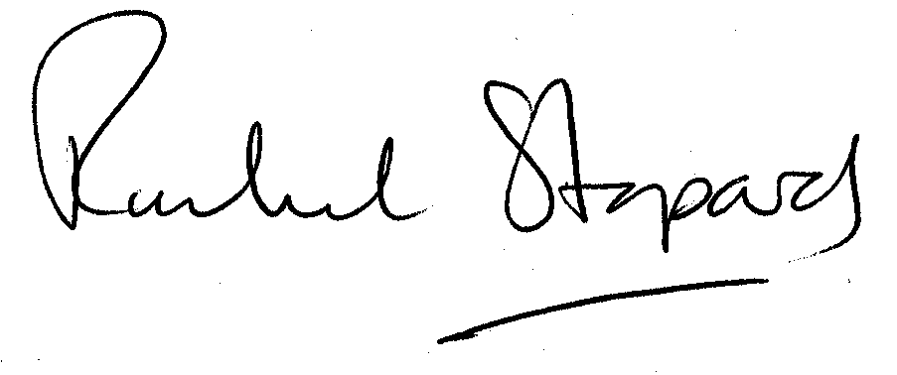
Rachel Stopard
Director of Culture & Environment

