Mr Neil Boothby
CBL
5 St Johns Lane
London
EC1M 4BH
5 St Johns Lane  London  EC1M 4BH |  | Application Ref: 2016/1620/L
 |  | Please ask for: Antonia Powell
 |  | Telephone: 020 7974 2648
 |  | 26 July 2016

Dear Sir/Madam

DECISION

Planning (Listed Building and Conservation Areas) Act 1990

Listed Building Consent Granted

Address:
50 Cumberland Terrace
London
NW1 4HJ

Proposal:
Relocation of basement doorway from hallway to front living room; the creation of a solid platform across the window to the front basement room and the construction of three new steps to access platform.
Drawing Nos: 643-213/G; 217/D; 218/H; 219/F; 220/C; 221/C

The Council has considered your application and decided to grant Listed Building Consent subject to the following condition(s):

Conditions And Reasons:

1 | The works hereby permitted shall be begun not later than the end of three years from the date of this consent.  Reason: In order to comply with the provisions of Section 18 of the Planning (Listed Buildings and Conservation Areas) Act 1990.
2 | All new work and work of making good shall be carried out to match the original work as closely as possible in materials and detailed execution.  Reason: In order to safeguard the special architectural and historic interest of the building in accordance with the requirements of policy CS14 of the London Borough of Camden Local Development Framework Core Strategy and policy DP25 of the London Borough of Camden Local Development Framework Development Policies.
3 | The works hereby approved are only those specifically indicated on the drawing(s) referred to above.  Reason: In order to safeguard the special architectural and historic interest of the building in accordance with the requirements of policy CS14 of the London Borough of Camden Local Development Framework Core Strategy and policy DP25 of the London Borough of Camden Local Development Framework Development Policies.

Informative(s):

Reasons for granting listed building consent. [Delegated]

This application relates solely to the lowering of the basement floor. All other elements are as per previously granted ref: 2012/4298/P and associated 2012/4402/Land 2013/7017/P and associated 2013/7048/L.

This application specifically relates to works within the front room of the basement and is involves:

The provision of three steps to the raised section of floor which is now to be retained across the front basement window.

To infill the existing steps adjacent to the existing doorway to the hall and form a new doorway approximately 1 metre towards the back of the house.

This area of the house has undergone considerable modification historically and this proposed change to the previously approved design is not considered to be harmful to the significance of this historic Grade I building by John Nash and J Thompson.

Public consultation was undertaken by placement of a press notice and site notice, and no responses were received. Historic England have responded with a letter of flexible authorisation. The site's planning history was taken into account when coming to this decision.

Special regard has been attached to the desirability of preserving the listed building and its features of special architectural or historic interest, under s.16 of the Listed Buildings and Conservation Areas Act 1990 as amended by the Enterprise and Regulatory Reform Act (ERR) 2013.

The proposed development is in general accordance with policy CS14 of the London Borough of Camden Local Development Framework Core Strategy, and policy DP25 of the London Borough of Camden Local Development Framework Development Policies. The proposed development also accords with policy 7.8 of The London Plan 2016, and paragraphs 14, 17 and 126-141 of the National Planning Policy Framework.

You can find advice about your rights of appeal at:

http://www.planningportal.gov.uk/planning/appeals/guidance/guidancecontent

Yours faithfully
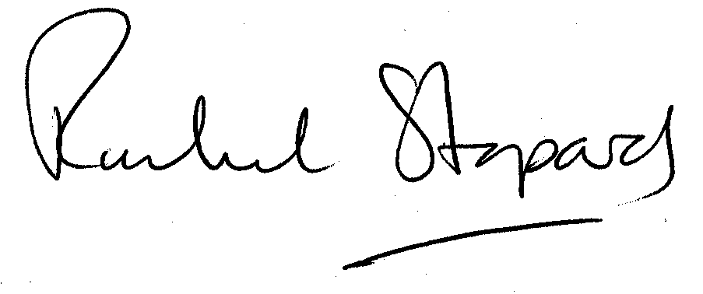
Rachel Stopard
Executive Director Supporting Communities

