**Design and Access Statement**

Town and Country Planning Act 1990

12 and 14a Savernake Road

London

NW3 2JN

A Joint application for two extensions at the rear side of the properties.

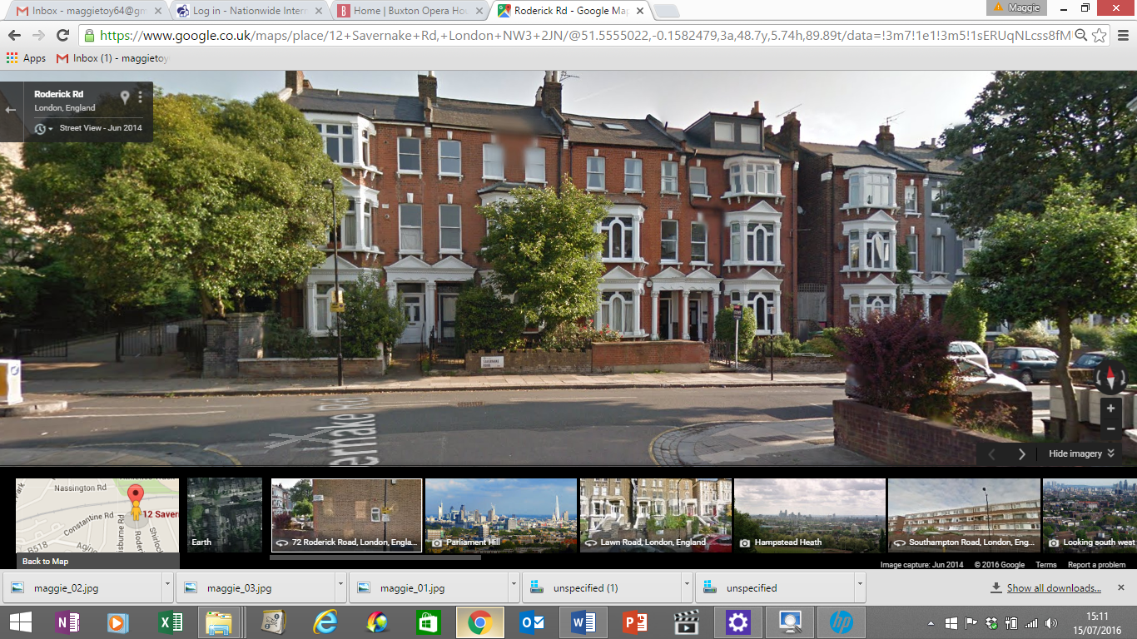

This Design and Access Statement has been prepared in support of a full Joint planning application submitted to the London Borough of Camden by Ms Maggie Toy – agent on behalf of Sheela and Peter De Lacey. This document is prepared in accordance with the guidance set down in ‘Design and Access Statements – How to write, read and use them’, published by CABE and should be read in conjunction with the Drawings 12000; 12001; 12002; 12003; 12004; 12005; 059_101; 1214001; 1214002; submitted with the application.

The properties are NOT within a conservation area.

We are applying to extend the kitchen of both 12 and 14a Savernake Road to the side and rear. There will be no detrimental effect to either neighbour as they are both executing the same extension.

There will be no alteration to the front elevation.

**Planning Policies used to influence the design of this extension**

**Altering and Extending your home SPG5**

3.0 If a joint application is submitted with your neighbour then permission will be granted on the condition that both extensions are constructed at the same time and in this case the height restriction referred to above is not relevant as there would be no impact between the two properties.

The proposed development is in general accordance with the policy requirements of the **London Borough of Camden Replacement Unitary Development Plan 2006**, with particular regard to policies SD1, SD6, B1, B3.

**SD1 - Quality of life**

***A - Sustainable communities***

The Council will seek to ensure that development fosters sustainable communities. In determining applications for planning permission, the Council will therefore take into consideration the special needs and characteristics of individual areas and communities.

***B - Regeneration***

The Council will seek to promote the regeneration of areas in need of environmental, physical, social or economic renewal.

**SD6 - Amenity for occupiers and neighbours**

The Council will not grant planning permission for development that it considers causes harm to the amenity of occupiers and neighbours. The factors the Council will consider include:

a) visual privacy and overlooking;

b) sunlight and daylight levels;

c) artificial light levels;

d) noise and vibration levels;

e) odour, fumes and dust;

f) the adequacy of facilities for storage, recycling and disposal of waste; and

g) microclimate.

**DESIGN**

3.4 Camden is committed to design excellence. Camden’s Community Strategy seeks to make Camden’s streets more attractive through better cleaning, design, enforcement and lighting. Camden already has a reputation for high quality design but wishes to encourage this further. This is reflected in the bi-annual Camden Design Awards, which promote and recognise innovative, sustainable and high quality design in the local built environment, and in the Camden Design Initiative, which actively seeks to improve the look and feel of public spaces and create attractive, accessible places in Camden.

**B1 - General design principles**

The Council will grant planning permission for development that is designed to a high standard. Development should:

a) respect its site and setting;

b) be safe and accessible to all;

c) improve the spaces around and between buildings, particularly public areas;

d) be sustainable by promoting energy efficiency and efficient use of resources;

e) be easily adaptable to changing economic and social requirements;

f) provide appropriate high quality landscaping and boundary treatments; and

g) seek to improve the attractiveness of an area and not harm its appearance or amenity.

In assessing how the design of a development has taken these principles into account, the Council will consider:

h) building lines and plot sizes in the surrounding area;

i) the existing pattern of routes and spaces;

j) the height, bulk and scale of neighbouring buildings;

k) existing natural features, such as topography and trees;

l) the design of neighbouring buildings;

m) the quality and appropriateness of detailing and materials used;

n) the provision of visually interesting frontages at street level; and

o) the impact on views and skylines.

In exceptional circumstances, to re-establish cohesive building groups in areas of high design quality, the Council will only grant planning permission for new in-fill development that is designed as an authentic reconstruction of the missing building.

Applicants should submit a ‘design statement’ with proposals for large-scale developments and for sites in prominent or sensitive locations.

**B3 - Alterations and extensions**

***A - Alterations and extensions***

The Council will not grant planning permission for alterations and extensions that it considers cause harm to the architectural quality of the existing building or to the surrounding area. The Council will consider whether:

a) the form, proportions and character of the building and its setting, including the garden and nearby trees, are respected;

b) extensions are subordinate to the original building in terms of scale and situation;

c) original features are retained or restored;

d) high quality materials that match or complement existing materials are used;

e) unsympathetic alterations or extensions are removed or improved;

f) the architectural integrity of the existing building is preserved; and

g) building services equipment is appropriately located.

3.32 Extensions should be carefully sited and proportioned to respect the historic form of the area, the integrity and proportions of the original building and the amenities of adjoining occupiers. Overly large extensions can disfigure a building and upset its proportions. Insensitive extensions can also be a problem, for example, a side extension that occupies the space between semi-detached houses that form a group, or a rear extension to a property in an otherwise unspoilt group, which would detract from the uniformity of the rear elevation.

**Government Built Environment Policies**

Policy BE2

Townscape: Local Context & Character

Proposals should be designed with regard to their local context, making a positive contribution to the character of the area. Account should be taken of:

(a) The existing landforms and natural features;

(b) The need to respect or improve the quality of existing urban spaces, materials, townscape or historical features which contribute favourably to the character of an area; and

(c) The opportunity for improvement or variety within an area of poor or uniform character, by creating a new area of distinctive quality on suitable sites.

Proposals should not cause harm to the character and/or appearance of an area, or have an unacceptable visual impact on Conservation Areas, Areas of Distinctive

Residential Character, Listed Buildings, Views, Landmarks, Green Chains or

Metropolitan Open Land.

Policy BE9

Architectural Quality

Extensions and alterations to existing buildings, should embody a creative and appropriate design solution, specific to their site's shape, size, location and development opportunities, and should be designed to:

(a) Be of a scale, massing and height that is appropriate to their setting, civic function and/or townscape location;

(b) Respect, whilst not necessarily replicating, the positive local design and landscape characteristics of adjoining development, and satisfactorily relate them;

(c) Exhibit a consistent and well-considered application of the principles of any chosen style;

(d) Have attractive front elevations which have a direct relationship with the street at ground level, with well-proportioned windows, and habitable rooms and entrances on the frontage, wherever possible;

(f) Employ materials of high quality and durability that are of compatible or complementary colour and texture, to the surrounding area.

Particular attention will be given to these matters for proposals affecting Conservation

Areas, and Areas of Distinctive Residential Character.

Extensions and alterations to existing buildings, should embody a creative and appropriate design solution, specific to their site's shape, size, location and development opportunities.

**Scale and Massing**

In recognition of the scale of these houses the proposal respects the scale and mass of the original building.

**Appearance and Materials**

The proposed extension has been designed to reflect and complement the existing property, with reference to local traditional materials, and proportions. Care was taken with the design of the fenestration to create a contemporary appearance allowing light to flood into the new space. Care has also been taken to ensure that there is no negative impact on the neighbours or the built environment, particularly by keeping within the guidelines set out by Camden Council Planning Department. Great care has been taken to use the design style of the house to reflect respond to and complement the original building.

**Access Statement**

The pedestrian and vehicular route to the house will remain in its current position.

**General Accessibility**

**Public Transport**

The site is very well located for access to the public transport network.

**Walkable Amenities**

Many walkable amenities are available to the property

**Pedestrian & Vehicular Access**

The pedestrian route to the site will remain in its current position.

**Design Statement**

**Design**

The design of these side extensions is to be in keeping with the design of the house. The existing layout of house and outbuildings has been taken into account in the planning of the ground floor layout. The outer neighbour’s amenities have also been taken into consideration with the proposal.

**Design Conclusions**

The extension proposal represents a carefully considered design response to the context of the site and the existing building. It takes in to consideration all the aspects of planning recommendations.

