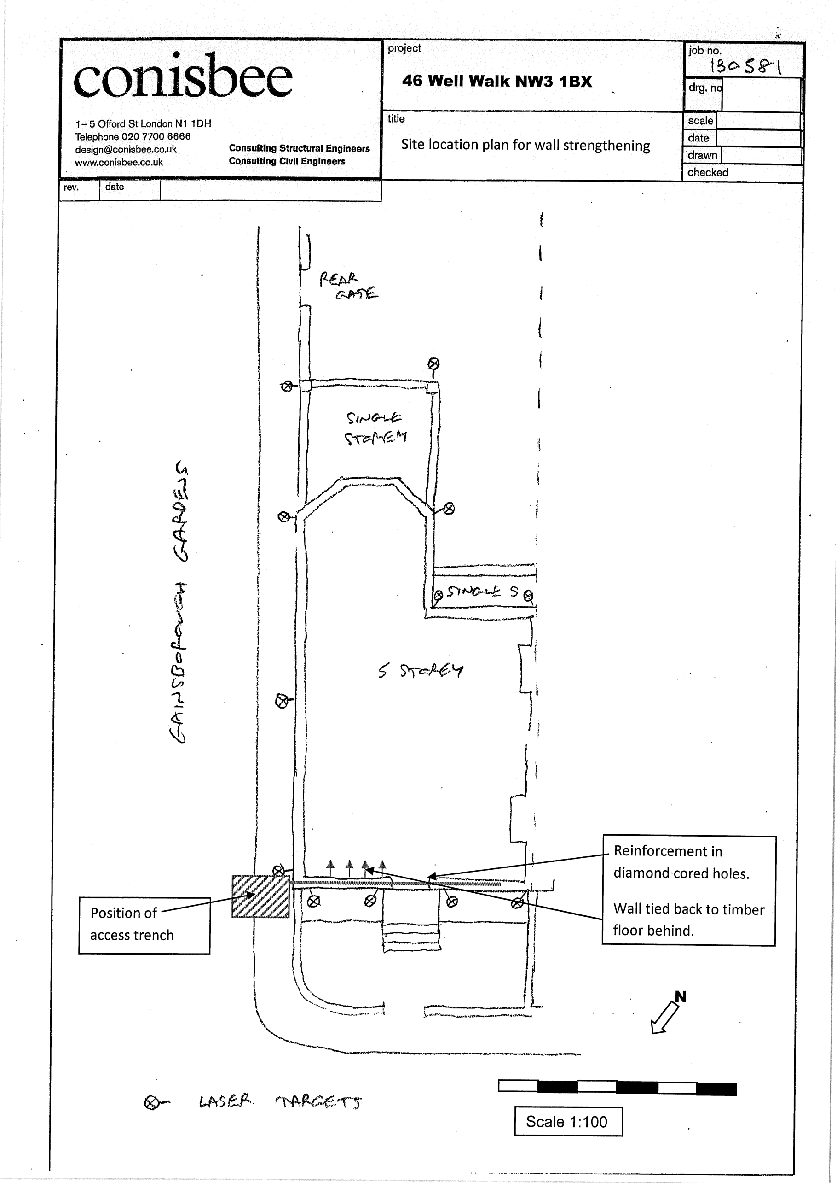

Reinforcement in chase behind face brickwork installed by removing short lengths of face brick – and replacing.

1:100

SK009