Town and Country Planning Act 1990

# Planning, Design and Access Statement

For the planning application

At the premises:

11 Fitzjohn’s Avenue NW3

*Proposal:*

*Alterations and Extension to Existing Building Including Rear and Side Extensions.*

**Statement prepared on 11th July 2016 for:**

**CAMDEN COUNCIL**

THE TOWN AND COUNTRY PLANNING ACT 1990 (AS AMENDED)

## SUMMARY STATEMENT

This statement supports the application for planning permission for the, Alteration and extension to existing building including rear and side extensions.

The statement describes the application site and its environs, the development subject to this application, the merits of the development and planning policy issues, with a summary of the applicant’s case.

It is intended to outline the merits of this development in the context of National Planning Policies and

London Borough of Camden Planning Policies.

In summary of the application the applicant considers that the scheme as submitted, for this proposal is well considered and appropriate to this location.

## The Application Site and its Environs

The application site in question relates to a detached building that houses 15 flats and sits within the Fitzjohns Conservation Area.

The applicant intends to propose an alteration and extension to the existing building including rear and side extensions.

There are a number of bus routes in the vicinity with access to the surrounding towns. Finchley Road and Belsize Park station is within walking distance from the subject site.

The map below illustrates the general area around the site concerned.

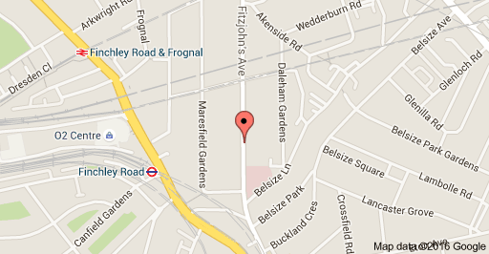

## The Scheme of Development & Planning Policy

The drawings submitted with this application demonstrate that the proposed unit will provide a high quality living environment for future occupiers. In effect, the proposal will not affect the levels of daylight or sunlight currently enjoyed by surrounding residents; the proposal will not affect the levels of privacy and quality of outlook currently enjoyed by surrounding occupiers, the subject site is conveniently located within a few minutes’ walk to Finchley road Station; and habitable rooms would benefit from windows opening effective ventilation.

In relation to the London Plan and Camden’s Residential Design Standards – the proposal exceeds Policy requirements.

In relation to the internal layout of the dwelling, the flat will benefit from high levels of natural light – further enhanced by the building’s orientation, the layout is deemed practical and kitchens and bathroom will have the benefit of mechanical extract fans to ensure adequate ventilation is provided, where necessary.

Although there may be pressure for car parking in the area, given the close proximity to Finchley Road station and with regard to the excellent bus routes in the vicinity, it is considered that no car parking spaces are required. The area has a PTAL rating of 6 which is considered the ‘best’.

The proposal has been designed to be constructed with high levels of sustainability.

In conclusion, the applicant and agent consider the proposal is well conceived, not having a harmful impact on the character and appearance of the area in general and would not be detrimental to the amenities of neighbouring occupiers.

## Appendix 1 – Location Plan

