Mr James Titchner
BDP
16 Brewhouse Yard
London
EC1V 4LJ UK
16 Brewhouse Yard  London  EC1V 4LJ UK |  | Application Ref: 2016/1886/L
 |  | Please ask for: Catherine Bond
 |  | Telephone: 020 7974 2669
 |  | 20 July 2016

Dear Sir/Madam

DECISION

Planning (Listed Building and Conservation Areas) Act 1990

Approval of Details (Listed Building) Granted

Address:
8
9
10
11 Montague Street & 39 Russell Square
London
WC1B 3DG

Proposal:
Details of new stairs & bannisters, WC/ Kitchen layouts, fire compartmentation, party wall arrangements and security measures in relation to conditions 4 a) b) & c) and 5 of listed building consent ref 2015/4344/L, dated 18/09/2015 for: Refurbishment of perimeter properties 8, 9, 10, 11 Montague Street & 39 Russell Square, including refurbishment and restoration of interior spaces, removal of existing external and internal plant and equipment and modifications to existing lifts.
Drawing Nos: (20)AS02; (20)AS004; (20)AS005; (22)AD001; (22)AP001; (22)AP002; (24)AD001; (24)AD002; (24)AD002A; (35)A001; (35)AD001; (74)AD003; Fire Strategy Layout Drawings; 15117-8_10-B-PH-100; 15117-8_10-G-PH-101; 15117-8_10-G-PH-201; 15117-8_10-3-PH-104; 15117-8_10-3-PH-204; Letter from London Fire and Emergency Planning Authority 5 January 2016; Specification for Intruder Alarm 8 Montague Street; Specification for Intruder Alarm 9 Montague Street; Specification for Intruder Alarm 10 Montague Street; Specification for Intruder Alarm 11 Montague Street; Specification for Intruder Alarm 39 Russell Square.

The Council has considered your application and decided to grant Approval of Details (Listed Building) subject to the following condition(s):

Conditions And Reasons:

Informative(s):

Reasons for granting listed building consent (approval of details):

This approval of details application relates to the design of new stairs and bannisters, WC/ Kitchen layouts, fire compartmentation, party wall arrangements and security measures in relation to conditions 4 a) b) and c) and condition 5 of listed building consent ref 2015/4344/L, dated 18/09/2015 for the refurbishment of several of the British Museum's perimeter properties in Montague Street and Russell Square.

It is considered that the details submitted for these conditions are sympathetic with the character of the historic townhouses and demonstrate no harm will be caused to the special interest of the grade II listed buildings.

No public consultation was necessary for this application. The site's planning history was taken into account when coming to this decision.

Special regard has been attached to the desirability of preserving the listed building and its features of special architectural or historic interest, under s.16 of the Listed Buildings and Conservation Areas Act 1990 as amended by the Enterprise and Regulatory Reform Act (ERR) 2013.

As such, the proposed development is in general accordance with policies CS5 and CS14 and of the London Borough of Camden Local Development Framework Core Strategy, and policies DP24, DP25 and DP26 of the London Borough of Camden Local Development Framework Development Policies. The proposed development also accords with policies 7.4, 7.6 and 7.8 of the London Plan March 2015, consolidated with alterations since 2011; and paragraphs 14, 17, 56-66, and 126-141 of the National Planning Policy Framework.

You are advised that all conditions relating to listed building consent 2016/1886 granted on 18/09/2015 which need details to be submitted, have been approved.

You can find advice about your rights of appeal at:

http://www.planningportal.gov.uk/planning/appeals/guidance/guidancecontent

Yours faithfully
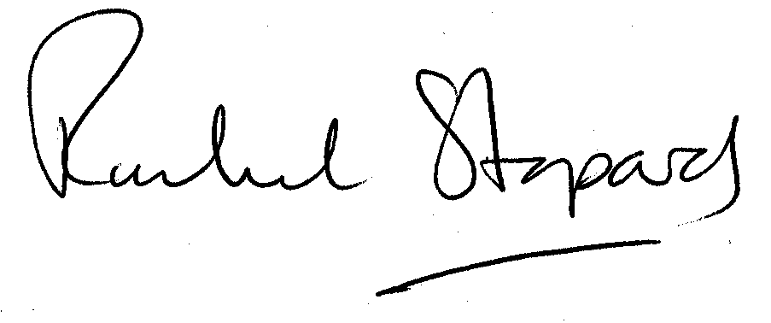
Rachel Stopard
Executive Director Supporting Communities

