Ms Natalie Davies
Gerald Eve LLP
72 Welbeck Street
London
W1G 0AY
72 Welbeck Street  London  W1G 0AY |  | Application Ref: 2016/0160/P
 |  | Please ask for: David Fowler
 |  | Telephone: 020 7974 2123
 |  | 19 July 2016

Dear Sir/Madam

DECISION

Town and Country Planning Act 1990 (as amended)

Approval of Details Granted

Address:
39-45 Kentish Town Road
London
NW1 8NX

Proposal:
Details of condition 6 (level plans) granted under reference 2015/1937/P dated 29/09/15 for erection of a six-storey mixed use building comprising flexible employment/gym at ground floor level and 24 flats together with associated works to create public realm improvements and landscaping.
Drawing Nos: D1807 L.250 C

The Council has considered your application and decided to grant permission subject to the following condition(s):

Condition(s) and Reason(s):

Informative(s):

Reasons for granting permission:

Condition 6 (Level plans)
The Council's Highway Department has assessed the submitted landscape plan and is satisfied that the details provided on are sufficient to discharge the condition.

As such, the proposed development is in general accordance with policy CS11 of the London Borough of Camden Local Development Framework Core Strategy.

You are advised that the following conditions still require discharging:

4 (Green roof details and installation), 9 (Sound insulation), 10 (Vibration levels), 14 (Submission of details), 15 (Samples), 18 (Landscaping), 19 (Kentish Town Road access), 20 (Lighting and CCTV) and 23 (Land remediation measures -capping).

In dealing with the application, the Council has sought to work with the applicant in a positive and proactive way in accordance with paragraphs 186 and 187 of the National Planning Policy Framework.

You can find advice about your rights of appeal at:

http://www.planningportal.gov.uk/planning/appeals/guidance/guidancecontent

Yours faithfully
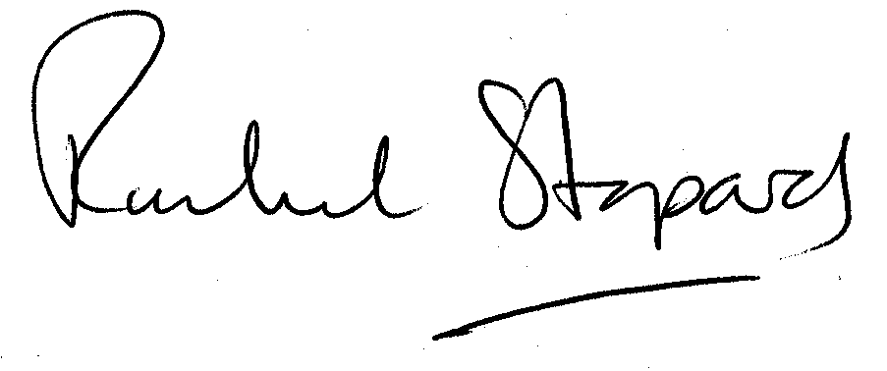
Rachel Stopard
Executive Director Supporting Communities

