**Ferdinand House and Rugmere Entrances (opposite each other)**

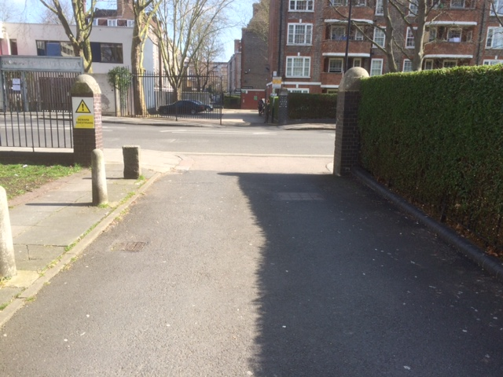

**Broomfield and Tottenhall Entrances (opposite each other)**

