Mr Nazar Georgis
Ellis and Moore Ltd
Sovereign House1
Albert St
London
N3 1QB
Sovereign House1  Albert St  London  N3 1QB |  | Application Ref: 2016/0604/P
 |  | Please ask for: Samir Benmbarek
 |  | Telephone: 020 7974 2534
 |  | 15 July 2016

Dear Sir/Madam

DECISION

Town and Country Planning Act 1990 (as amended)

Full Planning Permission Granted

Address:
28 Arkwright Road
London
NW3 6BH

Proposal:
Remedial work to the existing boundary wall (to include insertion of metal railings) facing Frognal, due to tree and subsidence damage.
Drawing Nos: 14552/110B; 14552/111B; 14552/111B; 14552/113B; 14552/114B; 14552/114B; Design & Access and Heritage Statement (Contains OS Extract)

The Council has considered your application and decided to grant permission subject to the following condition(s):

Condition(s) and Reason(s):

1 | The development hereby permitted must be begun not later than the end of three years from the date of this permission.  Reason: In order to comply with the provisions of Section 91 of the Town and Country Planning Act 1990 (as amended).
2 | All new external work shall be carried out in materials that resemble, as closely as possible, in colour and texture those of the existing building, unless otherwise specified in the approved application.  Reason: To safeguard the appearance of the premises and the character of the immediate area in accordance with the requirements of policy CS14 of the London Borough of Camden Local Development Framework Core Strategy and policy DP24 and DP25 of the London Borough of Camden Local Development Framework Development Policies.
3 | The development hereby permitted shall be carried out in accordance with the following approved plans: 14552/110B; 14552/111B; 14552/111B; 14552/113B; 14552/114B; 14552/114B; Design & Access and Heritage Statement (Contains OS Extract)  Reason: For the avoidance of doubt and in the interest of proper planning.

Informative(s):

Reasons for granting permission:

The proposed boundary wall treatment is considered to be appropriate as it would help to preserve the nearby tree and it associated roots, would maintain pedestrian and vehicular safety and would have minimal impact upon the Redington / Frognal Conservation Area. The boundary treatment for the collapsed wall panel would be metal railings with a black painted finish to match the existing railings opposite at the University College School. The proposed 4x pairs of structural pillars would not be visible from the public realm and therefore would have limited impact upon the host building, street scene and conservation area.

Due to the minimal size of the works, there would be negligible harm to the amenity of any adjoining residential occupiers.

One objection was received and was duly taken into account. The planning history of the site and relevant appeal decisions were taken into account when coming to this decision.

Special regard has been attached to the desirability of preserving the listed building or its setting or any features of special architectural or historic interest which it possesses under s.66 of the Planning (Listed Buildings and Conservation Areas) Act 1990 as amended by the Enterprise and Regulatory Reform Act (ERR) 2013.

Special attention has been paid to the desirability of preserving or enhancing the character or appearance of the conservation area, under s.72 of the Planning (Listed Buildings and Conservation Areas Act) 1990 as amended by the Enterprise and Regulatory Reform Act (ERR) 2013.

As such, the proposed development is in general accordance with policies CS5 and CS14 of the London Borough of Camden Local Development Framework Core Strategy, and policies DP24, DP25 and DP26 of the London Borough of Camden Local Development Policies. The proposed development also accords with policies 7.4, 7.6 and 7.8 of the London Plan 2016 and paragraphs 14, 17, and 56-66 and 126-141 of the National Planning Policy Framework.

Noise from demolition and construction works is subject to control under the Control of Pollution Act 1974. You must carry out any building works that can be heard at the boundary of the site only between 08.00 and 18.00 hours Monday to Friday and 08.00 to 13.00 on Saturday and not at all on Sundays and Public Holidays. You are advised to consult the Council's Compliance and Enforcement team [Regulatory Services], Camden Town Hall, Argyle Street, WC1H 8EQ (Tel. No. 020 7974 4444 or on the website http://www.camden.gov.uk/ccm/content/contacts/council-contacts/environment/contact-the-environmental-health-team.en or seek prior approval under Section 61 of the Act if you anticipate any difficulty in carrying out construction other than within the hours stated above.

Your proposals may be subject to control under the Building Regulations and/or the London Buildings Acts which cover aspects including fire and emergency escape, access and facilities for people with disabilities and sound insulation between dwellings. You are advised to consult the Council's Building Control Service, Camden Town Hall, Argyle Street WC1H 8EQ, (tel: 020-7974 6941).

In dealing with the application, the Council has sought to work with the applicant in a positive and proactive way in accordance with paragraphs 186 and 187 of the National Planning Policy Framework.

You can find advice about your rights of appeal at:

http://www.planningportal.gov.uk/planning/appeals/guidance/guidancecontent

Yours faithfully
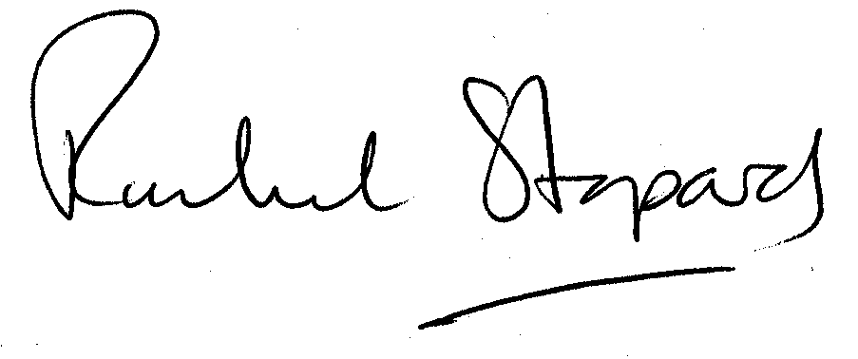
Rachel Stopard
Executive Director Supporting Communities

