**32 Belsize Square** **Site Map**

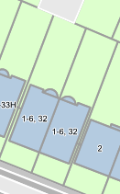

T1