**Esther Randall Court, Little Albany Street NW1 4DY** **Site Map**

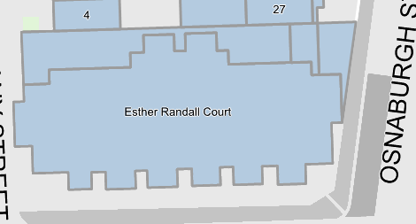

T5

T4

T3

T2

T1