**35 Belsize Square** **Site Map**

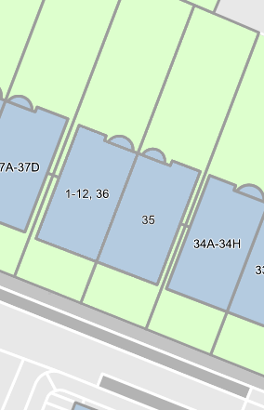

T1