Dear Patients

The surgery will be moving to the new address from Monday 25th April 2016

Address:
Brookfield Park Surgery
www.brookfieldparksurgery.co.uk
68 Chester Road, London
N19 5BZ
Phone: 020 7263 9633
Email: brookfieldpark@nhs.net
Fax: 020 7561 0117

Please Note: There is no need to re-register; you will remain a patient of Brookfield Park Surgery.

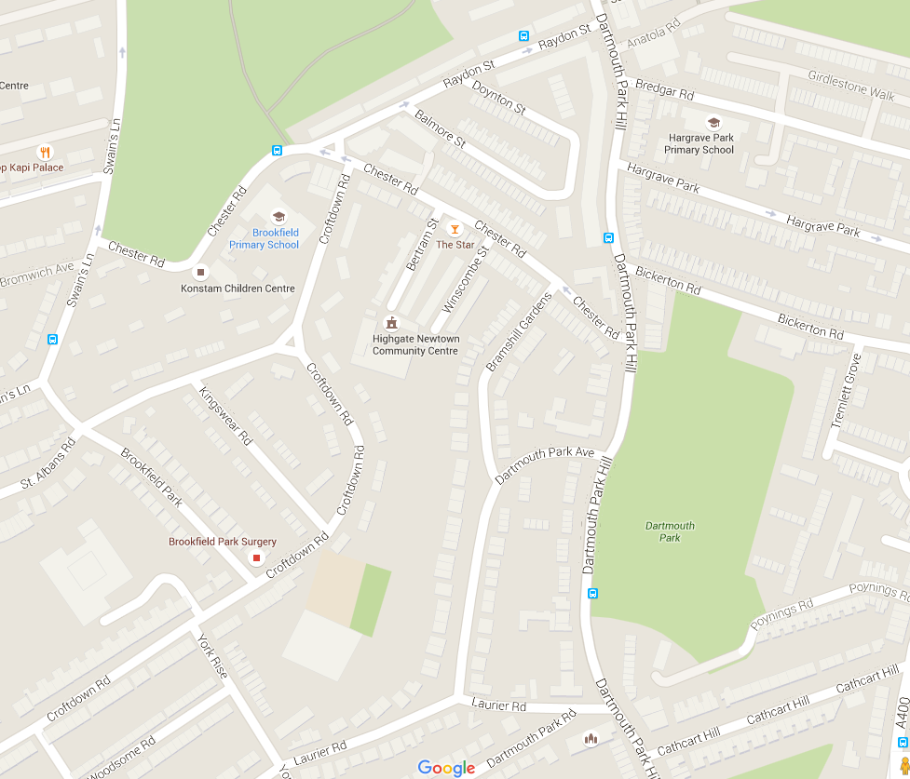
New Surgery
Old Surgery
68 Chester Rd.

