Brookfield Park Surgery

2 Brookfield Park, Kentish Town, NW5 1ER
Tel: 0207 485 7363 Fax. 0207 485 6506
www.brookfieldparksurgery.co.uk
Partners Dr M Anand Dr A Sinha

<<title>> <<surname>>
<<address1>>
<<address2>>
<<address3>>
<<address4>>
<<address5>>
<<address6>>

Dear Patient,

The surgery will be moving to the new address from Monday 25th April 2016

Address:
Brookfield Park Surgery
www.brookfieldparksurgery.co.uk
68 Chester Road, London
N19 5BZ
New Phone: 020 7263 9633
Email: brookfieldpark@nhs.net
New Fax: 020 7561 0117

Please Note: There is no need to re-register; you will remain a patient of Brookfield Park Surgery.

Kind Regards,
Partners.

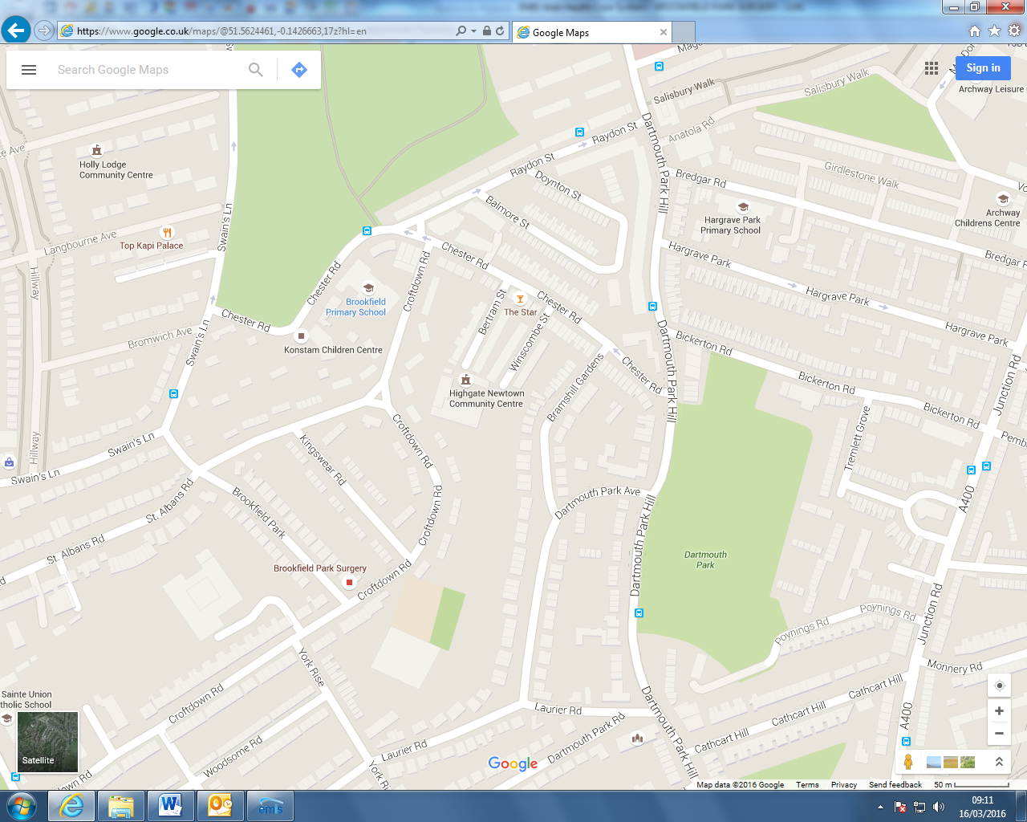
New Surgery
Old Surgery
68 Chester Rd.

