Mr JOHN YARHAM
Bailey Partnership
Bailey Partnership
Suite 2.6
Renslade House
Exeter
Devon
EX4 3AY
Application Ref: 2016/3155/L
Please ask for: Catherine Bond
Telephone: 020 7974 2669
11 July 2016

Dear Sir/Madam

DECISION

Planning (Listed Building and Conservation Areas) Act 1990

Approval of Details (Listed Building) Granted

Address:
Flat A
10 Great Ormond Street
London
WC1N 3RB

Proposal:
Details of new screens and paving as required by conditions 3(a) & 3(b) of listed building consent reference 2015/5501/L dated 18/02/2016 for enclosure of rear lightwell area to the rear basement to include the creation of two openings in the existing wings of basement walls.
Drawing Nos: 26241-314-001.

The Council has considered your application and decided to grant Approval of Details (Listed Building) subject to the following condition(s):

Conditions And Reasons:

Informative(s):

Reasons for granting listed building consent (approval of details):

This approval of details application is for new screens (windows and doors) and for paving, as required by conditions 3(a) & 3(b) of listed building consent reference 2015/5501/L dated 18/02/2016 for enclosure of the lightwell area behind the rear basement, to include the creation of two openings in the existing wings of the basement walls.

It is considered that the details submitted for condition 3(a) of screens, windows and doors are sympathetic with the historic character of the townhouse as well as in keeping with the conservation area context. Regarding condition 3(b), the applicant states in the submission that there will be no new paving introduced in the courtyard, so it is not necessary to submit further information. In conclusion, the details submitted demonstrate no harm will be caused to the special interest of the grade II listed building.

No public consultation was necessary for this application. The site's planning history was taken into account when coming to this decision.

Special regard has been attached to the desirability of preserving the listed building and its features of special architectural or historic interest, under s.16 of the Listed Buildings and Conservation Areas Act 1990 as amended by the Enterprise and Regulatory Reform Act (ERR) 2013.

As such, the proposed development is in general accordance with policies CS5 and CS14 and of the London Borough of Camden Local Development Framework Core Strategy, and policies DP24, DP25 and DP26 of the London Borough of Camden Local Development Framework Development Policies. The proposed development also accords with policies 7.4, 7.6 and 7.8 of the London Plan March 2015, consolidated with alterations since 2011; and paragraphs 14, 17, 56-66, and 126-141 of the National Planning Policy Framework.

You are advised that all conditions relating to listed building consent reference 2015/5501/L dated 18/02/2016 which need details to be submitted, have been approved.

You can find advice about your rights of appeal at:

http://www.planningportal.gov.uk/planning/appeals/guidance/guidancecontent

Yours faithfully
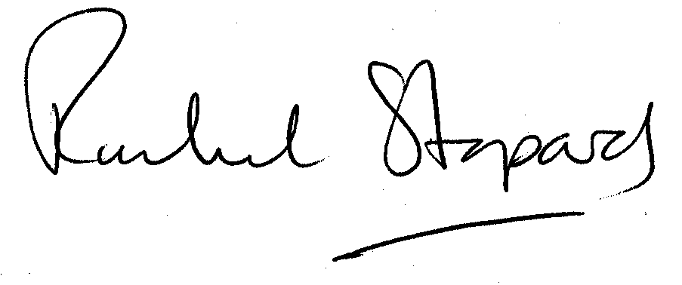
Rachel Stopard
Executive Director Supporting Communities

