Mr. Jose Esteves de Matos
De Matos Ryan
99 - 100 Turnmill Street
London
EC1M 5QP
99 - 100 Turnmill Street  London  EC1M 5QP |  | Application Ref: 2016/2294/L
 |  | Please ask for: Catherine Bond
 |  | Telephone: 020 7974 2669
 |  | 11 July 2016

Dear Sir/Madam

DECISION

Planning (Listed Building and Conservation Areas) Act 1990

Listed Building Consent Granted

Address:
The British Library
96 Euston Road
London
NW1 2DB

Proposal:
Works of refurbishment and alteration for the St. Pancras Transformed project comprising the creation of a new British Library Members' and Friends' Rooms, upgrade of bar and foyer space in the Conference Centre, and associated works.
Drawing Nos: Site Location Plan; 583_A_Z5_01-001_PL1; 583_A_Z5_01-002_PL1; 583_A_Z5_01-003_PL1; 583_A_Z5_10-001_PL1; 583_A_Z5_10-002_PL1; 583_A_Z5_10-003_PL1; 583_A_Z5_22-301_T1(2); 583_A_Z5_63-011_PL1; 583_A_Z5_63-012_PL1; 583_A_Z5_63-013_PL1; 583_A_Z5_64-012_T2; 583_A_Z5_64-013_T2(2); 583_A_Z5_72-301_T1; 583_A_Z5_78-301_T2(2); 583_A_Z5_78-303_T2(2); 583_A_Z5_78-302_T2(2); 583_A_Z5_78-304_T2; 583_A_Z8_01-103_T1(2); 583_A_Z8_01-011_PL1; 583_A_Z8_01-012_PL1; 583_A_Z8_01-013_PL1; 583_A_Z8_01-014_PL1; 583_A_Z8_01-015_PL1; 583_A_Z8_31-301_T2; 583_A_Z8_31-301_T2; 583_A_Z8_32-301_T2(2); 583_A_Z8_32-312_T2(2); 583_A_Z8_32-313_T1(2); Design & Access Statement.

The Council has considered your application and decided to grant Listed Building Consent subject to the following condition(s):

Conditions And Reasons:

1 | The works hereby permitted shall be begun not later than the end of three years from the date of this consent.  Reason: In order to comply with the provisions of Section 18 of the Planning (Listed Buildings and Conservation Areas) Act 1990.
2 | All new work and work of making good shall be carried out to match the original work as closely as possible in materials and detailed execution.  Reason: In order to safeguard the special architectural and historic interest of the building in accordance with the requirements of policy CS14 of the London Borough of Camden Local Development Framework Core Strategy and policy DP25 of the London Borough of Camden Local Development Framework Development Policies.
3 | The works hereby approved are only those specifically indicated on the drawing(s) referred to above.  Reason: In order to safeguard the special architectural and historic interest of the building in accordance with the requirements of policy CS14 of the London Borough of Camden Local Development Framework Core Strategy and policy DP25 of the London Borough of Camden Local Development Framework Development Policies.

Informative(s):

Reasons for granting listed building consent:

The proposed works comprise works of refurbishment and alteration for the St Pancras Transformed project, and the creation of new Members' and Friends' Rooms in the main library building, plus the upgrade of the bar and foyer space in the Conference Centre. The site is the grade I listed British Library completed to the design of Colin St John Wilson and others in the late 1990s. The areas of the building affected by the proposals are generally of moderate to high historic and architectural significance.

The works to form new Members' and Friends' Rooms involve the conversion and updating of existing staff cafeteria and recreational spaces on the north side of the library building. The works include the formation of two new doors openings accommodating salvaged existing doors, plus the erection of a new timber framed glazed screen with details matching other glazed screens fitted along the Level 3 balcony wall which faces the main atrium. The existing carpet will be replaced with a new feature carpet to all refurbished spaces including Levels 2 & 3 balconies. Frameless glazed security gates will be installed to Levels 2 & 3 balconies.

Within the Conference Centre, situated on the south-east section of the site, the ground floor entrance foyer, stairs and first-floor foyer space will be upgraded, including the bar area at first-floor level. The works will include new services such as the fitting of new low energy lights throughout, a new feature carpet and the re-upholstery of bench seats at various levels of the foyer. The bar will be given a new brass counter top and new back bar, in keeping with the original design.

It should be noted that this listed building consent does not include the removal of redundant phone booths in the Level 1 foyer level, which was originally applied for. In discussions with Historic England and the Council, it has been established that the telephone booths are of historic and architectural value and should therefore be left in situ, and if appropriate adapted for a new use. It is likely that a separate listed building consent will be necessary for works to the telephone booths.

The works are all of a reversible nature and do not involve the removal of features of historic or architectural interest. The works will therefore have limited impact on the special interest of the grade I listed building.

Consultation was undertaken by placement of a press advertisement and a site notice. Historic England was consulted and authorised the Council on 25 May 2016 to determine the application in accordance with national and local guidance using its own conservation expertise. No objections have been received prior to making this decision. The site's planning history was taken into account in reaching this decision.

Special regard has been attached to the desirability of preserving the listed building and any features of special architectural or historic interest which it possesses, under s.16 of the Listed Buildings and Conservation Areas Act 1990 as amended by the Enterprise and Regulatory Reform Act (ERR) 2013

As such, the proposed development is in general accordance with policies CS5 and CS14 of the London Borough of Camden Local Development Framework Core Strategy, and policies DP24, DP25 and DP26 of the London Borough of Camden Local Development Framework Development Policies. The proposed development also accords with policies 7.4, 7.6 and 7.8 of the London Plan 2016, consolidated with alterations since 2011; and paragraphs 14, 17, 56 -66 and 126-141 of the National Planning Policy Framework.

Your proposals may be subject to control under the Building Regulations and/or the London Buildings Acts which cover aspects including fire and emergency escape, access and facilities for people with disabilities and sound insulation between dwellings. You are advised to consult the Council's Building Control Service, 5 Pancras Square, London N1C 4AG (tel: 020-7974 6941).

You can find advice about your rights of appeal at:

http://www.planningportal.gov.uk/planning/appeals/guidance/guidancecontent

Yours faithfully
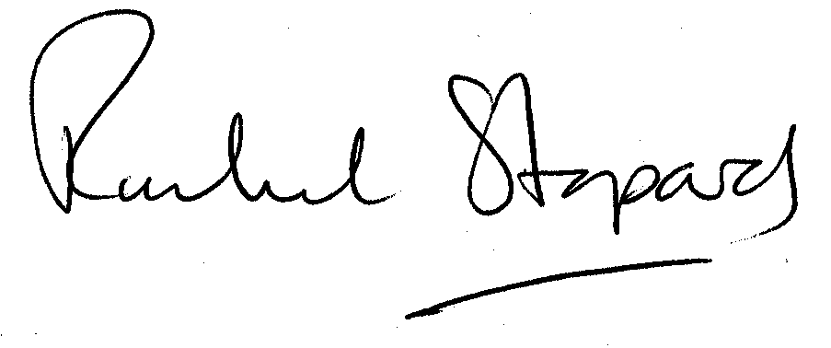
Rachel Stopard
Executive Director Supporting Communities

