Farrer & Co
66 Lincoln's Inn Fields
London
WC2A 3LH
66 Lincoln's Inn Fields  London  WC2A 3LH |  | Application Ref: 2015/3880/P
 |  | Please ask for: Gary Bakall
 |  | Telephone: 020 7974 5618
 |  | 16 February 2016

Dear Sir/Madam

DECISION

Town and Country Planning Act 1990, Section 191 and 192

Certificate of Lawfulness (Existing) Refused

Address:
58 Doughty Street
London
WC1N 2JT

Proposal: Retention of planter box in rear garden

Drawing Nos: PK-PR-01, PK-PR-02, Location Plan, Photographs and covering letter dated 18th September 2015

The Council has considered your application and decided to refuse a certificate of lawfulness for the following reason:

Reason(s) for Refusal

1 | On the basis of the information provided the Council is not satisfied the planting box in the centre of the rear garden is not development requiring planning permission and consider, on the balance of probabilities, that the planting box is development under section 55 of the Town & Country Planning Act 1990

Informative(s):

The Council is minded to issue an enforcement notice against the retention of the planting box as it adversely affects the setting of a Listed Building.

You can find advice about your rights of appeal at:

http://www.planningportal.gov.uk/planning/appeals/guidance/guidancecontent

Yours faithfully
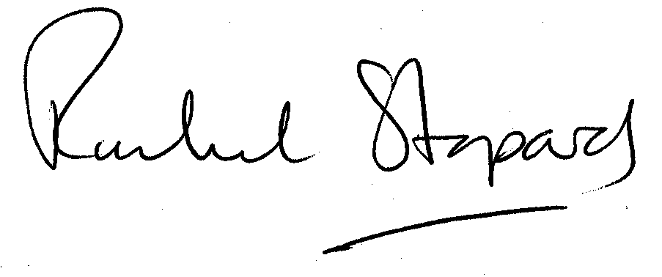
Rachel Stopard
Director of Culture & Environment

