Mr. John Seifert
8 Gloucester Mews West
London
W2 6DY

8 Gloucester Mews West  London  W2 6DY |  | Application Ref: 2016/0853/L
 |  | Please ask for: Catherine Bond
 |  | Telephone: 020 7974 2669
 |  | 5 July 2016

Dear Sir/Madam

DECISION

Planning (Listed Building and Conservation Areas) Act 1990

Listed Building Consent Granted

Address:
5 Chester Terrace
London
NW1 4ND

Proposal:
Various internal alteration at lower-ground floor, upper-ground floor, first floor and third floor levels, comprising variations to listed building consent ref 2016/0645/L granted on 26/05/2015.
Drawing Nos: Site Location Plan; SA0815/201 rev E; SA0815/202 rev C; SA0815/203 rev B; SA0815/204 rev C; SA0815/205 rev C; SA0815/302 rev C; SA0815/304 rev D; SA0815/402 rev C; S17044/001 rev D; S17044/002 rev E; S17044/003 rev D; S17044/004 rev E; S17044/005 rev B; S17044/006 rev C; S17044/101 rev C; S17044/102 rev B; S17044/103 rev B; S17044/104 rev B; S17044/105 rev B; S17044/106 rev A; S17044/401/01 rev D; S17044/401/02 rev B; S17044/401/03 rev C; S17044/401/04 rev C; S17044/402/01 rev D; S17044/402/02 rev E; S17044/403/01 rev D; S17044/403/02 rev D; S17044/404/01 rev D; S17044/404/02(1) rev D; S17044/404/02(2) rev D; S17044/405/01 rev D; S17044/405/02 rev D; S17044/405/03 rev D; S17044/600/04 rev A; S17044/600/05 rev A; S17044/600/06 rev B; S17044/600/11; Heritage, Design & Access Statement.

The Council has considered your application and decided to grant Listed Building Consent subject to the following condition(s):

Conditions And Reasons:

1 | The works hereby permitted shall be begun not later than the end of three years from the date of this consent.  Reason: In order to comply with the provisions of Section 18 of the Planning (Listed Buildings and Conservation Areas) Act 1990.
2 | All new external and internal works and finishes and works of making good to the retained fabric, shall match the existing adjacent work with regard to the methods used and to material, colour, texture and profile, unless shown otherwise on the drawings or other documentation hereby approved or required by any condition(s) attached to this consent.  Reason: In order to safeguard the special architectural and historic interest of the building in accordance with the requirements of policy CS14 of the London Borough of Camden Local Development Framework Core Strategy and policy DP25 of the London Borough of Camden Local Development Framework Development Policies.
3 | The works hereby approved are only those specifically indicated on the drawing(s) referred to above.  Reason: In order to safeguard the special architectural and historic interest of the building in accordance with the requirements of policy CS14 of the London Borough of Camden Local Development Framework Core Strategy and policy DP25 of the London Borough of Camden Local Development Framework Development Policies.

Informative(s):

Reasons for granting listed building consent:

This application for listed building consent is pursuant to listed building consent ref 2015/0645/L which was granted on 26/05/2015 for various internal alterations to the grade I listed building designed by Sir John Nash. This application seeks modifications to the existing listed building consent.

Proposed works at lower-ground floor level comprise the lowering of the floor, the lowering of the level of approved porch slab, raising the height of the lintel over internalised vault 1 door, the installation of an oak boarded floor to the utility room and to the hall, the adjusting of the location of doors in the utility room, the removal of redundant heating ducts from the utility room and WC, and the omission of a curved wall in the proposed cinema room. Proposed works at upper-ground floor level include installation of oak boarding to the kitchen floor, raising the height of sliding doors between the kitchen and dining room, removal of the false ceiling in the kitchen, the addition of a cornice to match that in the dining room, and the opening up of the wall beneath the main stair. On the first floor, the proposed works comprise the opening up of the existing arch between the reception room and the landing, the fitting of removable sliding doors between the reception room and the study, and the lowering of false ceilings between rooms recessed so as not to affect cornices. On the third floor, it is proposed to omit the proposed double wall housing a retractable TV between bedroom 1 and 2, and remove redundant hot air ducts in bedroom 3. It is also proposed to amend all lift doors to single leaf to match the approved doors.

The proposed modifications to the existing listed building consent ref 2015/0645/L are minor in nature and only affect postwar fabric and spaces of lesser significance within the property. The proposed works therefore do not harm the special interest of the grade I listed building.

Public consultation was undertaken by means of a site notice and press notice, whereby no responses were received. Historic England raised no objections. Concerns from Primrose Hill CAAC are not applicable as they relate to external works, which do not form part of this listed building consent. The site's planning history was taken into account when coming to this decision.

Special regard has been attached to the desirability of preserving the listed building and its features of special architectural or historic interest, under s.16 of the Listed Buildings and Conservation Areas Act 1990 as amended by the Enterprise and Regulatory Reform Act (ERR) 2013.

As such, the proposed development is in general accordance with policies CS5 and CS14 and of the London Borough of Camden Local Development Framework Core Strategy, and policies DP24, DP25 and DP26 of the London Borough of Camden Local Development Framework Development Policies. The proposed development also accords with policies 7.4, 7.6 and 7.8 of the London Plan March 2015, consolidated with alterations since 2011; and paragraphs 14, 17, 56-66, and 126-141 of the National Planning Policy Framework.

Your proposals may be subject to control under the Building Regulations and/or the London Buildings Acts which cover aspects including fire and emergency escape, access and facilities for people with disabilities and sound insulation between dwellings. You are advised to consult the Council's Building Control Service, 5 Pancras Square, London N1C 4AG (tel: 020-7974 6941).

Noise from demolition and construction works is subject to control under the Control of Pollution Act 1974. You must carry out any building works that can be heard at the boundary of the site only between 08.00 and 18.00 hours Monday to Friday and 08.00 to 13.00 on Saturday and not at all on Sundays and Public Holidays. You are advised to consult the Council's Noise and Licensing Enforcement Team, 5 Pancras Square, London N1C 4AG (Tel. No. 020 7974 4444 or on the website http://www.camden.gov.uk/ccm/content/contacts/council-contacts/environment/contact-the-environmental-health-team.en or seek prior approval under Section 61 of the Act if you anticipate any difficulty in carrying out construction other than within the hours stated above.

The following items are not covered by this listed building consent, and require separate planning permission and listed building consent to be granted by the Council prior to the commencement of the relevant works:-

(i) Replacement of existing metal windows in the rear elevation of the property with timber sliding sashes;
(ii) Changes to the design of replacement external rear railings.

You can find advice about your rights of appeal at:

http://www.planningportal.gov.uk/planning/appeals/guidance/guidancecontent

Yours faithfully
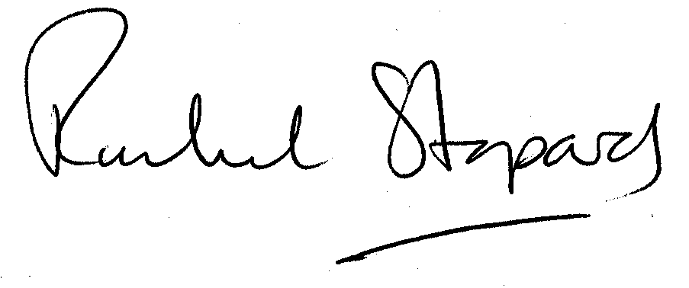
Rachel Stopard
Executive Director Supporting Communities

