Miss Claire Hutt
Planning and Design Group (UK) Ltd
Pure Offices
Lake View Drive
Sherwood Park
Nottingham
Nottinghamshire
NG15 0DT
Application Ref: 2016/1234/L
Please ask for: Catherine Bond
Telephone: 020 7974 2669
5 July 2016

Dear Sir/Madam

DECISION

Planning (Listed Building and Conservation Areas) Act 1990

Listed Building Consent Granted

Address:
1st Floor
The British Library
96 Euston Road
London
NW1 2DB

Proposal:
Internal refurbishment of the 1st floor office space and associated works to house the Alan Turing Institute.
Drawing Nos: Site Location Plan; ML2061_01_100; ML2061_01_200; ML2061_01_608 rev B; ML2061_01_800; 10662-1; BL/0000/630/L1/A1/Z6; GOBO projector product specification: Heritage Statement.

The Council has considered your application and decided to grant Listed Building Consent subject to the following condition(s):

Conditions And Reasons:

1 | The works hereby permitted shall be begun not later than the end of three years from the date of this consent.  Reason: In order to comply with the provisions of Section 18 of the Planning (Listed Buildings and Conservation Areas) Act 1990.
2 | All new work and work of making good shall be carried out to match the original work as closely as possible in materials and detailed execution.  Reason: In order to safeguard the special architectural and historic interest of the building in accordance with the requirements of policy CS14 of the London Borough of Camden Local Development Framework Core Strategy and policy DP25 of the London Borough of Camden Local Development Framework Development Policies.
3 | The works hereby approved are only those specifically indicated on the drawing(s) referred to above.  Reason: In order to safeguard the special architectural and historic interest of the building in accordance with the requirements of policy CS14 of the London Borough of Camden Local Development Framework Core Strategy and policy DP25 of the London Borough of Camden Local Development Framework Development Policies.

Informative(s):

Reasons for granting listed building consent:

The proposed works comprise the re-fit of an existing first-floor office space plus the creation of a new internal entrance feature for the Alan Turing Institute which is to be housed within the grade I listed British Library completed to the design of Colin St John Wilson and others in the late 1990s. As outlined in the list description, the existing office interior is of no historic or architectural significance, although the main building envelope and adjacent internal public spaces contribute to the special interest of the listed building.

The offices are situated on the north-eastern side of the library complex, with ribbon windows looking onto Pancras Road. The space is simple and unembellished, employing standard fittings and fixtures; it is punctuated by a series of columns set out on a modular grid. The proposed works involve the stripping out of the standard fittings, fixtures and finishes, the introduction of lightweight partitioning, fittings and fixtures, and services connected to existing power supplies.

The entrance to the Institute comprises an existing pair of double doors accessed directly from an existing circulation space. To mark the entrance, an internally-lit arched frame structure will be installed in a reversible fashion on the library side of the doors. This structure will be clad in Perspex panels which will be ornamented with a graphic image, as indicated on the submitted drawings. The final design of these panels will be selected through a competition process, but provided that their visual appearance is not a material departure from the submitted design, no further listed building consent application will be required.

A projector will be installed within the ceiling void in the first-floor foyer to the east of the main library space, which is the access point for visitors to the Institute. It will project a graphic image/lettering in coloured light on the floor carpet of the foyer, to alert visitors. The projector equipment will have limited visibility as it will be recessed above the ceiling and will only be detectable through a small circular aperture in the plasterboard.

The works are all of a reversible nature and will have limited impact on the special interest of the grade I listed building.

Consultation was undertaken by placement of a press advertisement and a site notice. Historic England was consulted and authorised the Council on 27 April 2016 to determine the application in accordance with national and local guidance using its own conservation expertise. No objections have been received prior to making this decision. The site's planning history was taken into account in reaching this decision.

Special regard has been attached to the desirability of preserving the listed building and any features of special architectural or historic interest which it possesses, under s.16 of the Listed Buildings and Conservation Areas Act 1990 as amended by the Enterprise and Regulatory Reform Act (ERR) 2013

As such, the proposed development is in general accordance with policies CS5 and CS14 of the London Borough of Camden Local Development Framework Core Strategy, and policies DP24, DP25 and DP26 of the London Borough of Camden Local Development Framework Development Policies. The proposed development also accords with policies 7.4, 7.6 and 7.8 of the London Plan 2016, consolidated with alterations since 2011; and paragraphs 14, 17, 56 -66 and 126-141 of the National Planning Policy Framework.

Your proposals may be subject to control under the Building Regulations and/or the London Buildings Acts which cover aspects including fire and emergency escape, access and facilities for people with disabilities and sound insulation between dwellings. You are advised to consult the Council's Building Control Service, 5 Pancras Square, London N1C 4AG (tel: 020-7974 6941).

You can find advice about your rights of appeal at:

http://www.planningportal.gov.uk/planning/appeals/guidance/guidancecontent

Yours faithfully
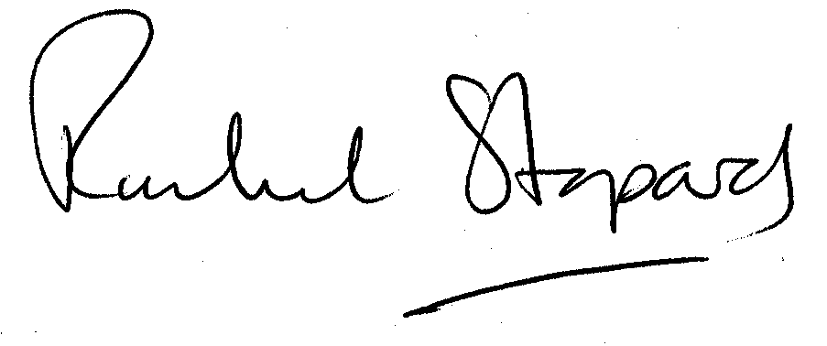
Rachel Stopard
Executive Director Supporting Communities

