Anna Gargan
Gerald Eve LLP
72 Welbeck Street
London
W1G 0AY
72 Welbeck Street  London  W1G 0AY |  | Application Ref: 2016/2653/P
 |  | Please ask for: Ian Gracie
 |  | Telephone: 020 7974 2507
 |  | 27 June 2016

Dear Sir/Madam

DECISION

Town and Country Planning Act 1990 (as amended)

Approval of Details Granted

Address:
Site at Hawley Wharf
Land bounded by Chalk Farm Road Castlehaven Road
Hawley Road London
NW1 8RP

Proposal:
Details of shopfront and communal entrances for building C1 required by condition 18d of planning permission 2012/4628/P dated 23/01/2013 (for mixed use redevelopment of Hawley Wharf site).
Drawing Nos: CX_(21)_6006 Rev T02; C1_(21)_4002 Rev T01; C1_(21)_4003 Rev T01; C1_(21)_4004 Rev T01; C1_(21)_6001 Rev T01; C1_(21)_6002 Rev T01;

The Council has considered your application and decided to grant permission subject to the following condition(s):

Condition(s) and Reason(s):

Informative(s):

The information submitted is considered sufficient in demonstrating, with regard to the residential building fronting Castlehaven Road (C1 building), that the shopfronts and communal entrances are acceptable in design terms.

The full impact of the proposed development has already been assessed. The site's planning history has been taken into account when coming to this decision.

As such, the proposed development is in general accordance with policy CS14 of the London Borough of Camden Local Development Framework Core Strategy and policies DP24 and DP25 of the London Borough of Camden Local Development Framework Development Policies.

You are advised that the following conditions relating to planning permission ref. 2012/4628/P granted on 23/01/2013 still need to be discharged: condition nos. 14 (a, b, c, d, e, f, h), 16 (b, c, d, e, f, g) 17, 18 (a, b, c, e, f, g), 19, 20, 21, 22, 24, 27, 29, 36, 37, 40, 41, 42, 45, 46, 50, 51, 52, 55, 59, 63.

In dealing with the application, the Council has sought to work with the applicant in a positive and proactive way in accordance with paragraphs 186 and 187 of the National Planning Policy Framework.

You can find advice about your rights of appeal at:

http://www.planningportal.gov.uk/planning/appeals/guidance/guidancecontent

Yours faithfully
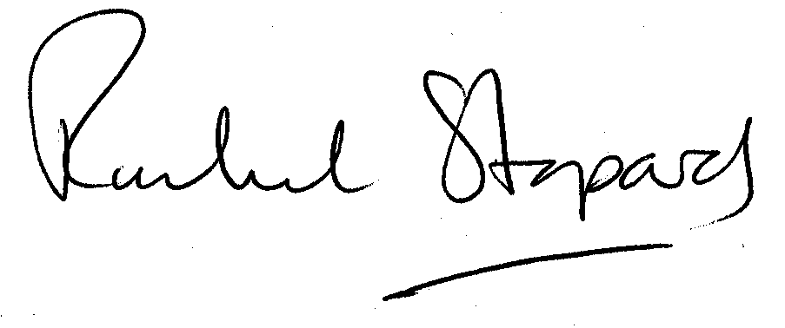
Rachel Stopard
Executive Director Supporting Communities

