Mr. Nas Hoque
Wilson Mason & Partners
8 New Concordia Wharf
Mill Street
London
SE1 2BB

8 New Concordia Wharf  Mill Street  London  SE1 2BB |  | Application Ref: 2016/1261/L
 |  | Please ask for: Catherine Bond
 |  | Telephone: 020 7974 2669
 |  | 21 June 2016

Dear Sir/Madam

DECISION

Planning (Listed Building and Conservation Areas) Act 1990

Listed Building Consent Granted

Address:
UCL Language Centre
26 Bedford Way
London
WC1H 0AP

Proposal:
Partial refurbishment and reconfiguration of existing office, teaching and laboratory space on 3rd floor.
Drawing Nos: Site Location Plan; L(00)002 rev T1; L(01)001 rev T2; L(01)003 rev T1; L(01)004 rev T1; L(02)002 rev T1; L(2-)001 rev T1; L(2-)002 rev T1; L(35)001 rev T1; L(43)001 rev T1; A(01)001; A(01)002; A(01)003; Planning Design and Heritage Statement rev T1.

The Council has considered your application and decided to grant Listed Building Consent subject to the following condition(s):

Conditions And Reasons:

1 | The works hereby permitted shall be begun not later than the end of three years from the date of this consent.  Reason: In order to comply with the provisions of Section 18 of the Planning (Listed Buildings and Conservation Areas) Act 1990.
2 | All new external and internal works and finishes and works of making good to the retained fabric, shall match the existing adjacent work with regard to the methods used and to material, colour, texture and profile, unless shown otherwise on the drawings or other documentation hereby approved or required by any condition(s) attached to this consent.  Reason: In order to safeguard the special architectural and historic interest of the building in accordance with the requirements of policy CS14 of the London Borough of Camden Local Development Framework Core Strategy and policy DP25 of the London Borough of Camden Local Development Framework Development Policies.
3 | The works hereby approved are only those specifically indicated on the drawing(s) referred to above.  Reason: In order to safeguard the special architectural and historic interest of the building in accordance with the requirements of policy CS14 of the London Borough of Camden Local Development Framework Core Strategy and policy DP25 of the London Borough of Camden Local Development Framework Development Policies.

Informative(s):

Reason for granting listed building consent:

The UCL Language Centre is situated at No 26 Bedford Way, which is in the northern section of the grade II* listed Institute of Education designed by Sir Denys Lasdun. The internal partitions and general layout of this purpose-built educational building were designed to be flexible and to accommodate its ongoing and changing needs. The proposed works consist of the partial refurbishment and reconfiguration of existing office, teaching and laboratory space on the 3rd floor. The works include new partitioning, suspended ceilings, new doors Little original fabric survives as the interiors at this level were replaced 25 years ago. The proposed works also involve new lighting, carpets and decorative finishes, all matching recent refurbishments on other floors of the building. The proposals are not considered to be harmful to the special interest of the listed structure or its architectural significance.

Public consultation was undertaken by means of a site notice and press notice, whereby no responses were received. Historic England responded by letter on 6 April 2016, authorising the Council to determine the application using its own conservation expertise .

The site's planning history was taken into account when coming to this decision.

Special regard has been attached to the desirability of preserving the listed building and its features of special architectural or historic interest, under s.16 of the Listed Buildings and Conservation Areas Act 1990 as amended by the Enterprise and Regulatory Reform Act (ERR) 2013.

As such, the proposal is in general accordance with policy CS14 of the London Borough of Camden Local Development Framework Core Strategy, and policy DP25 of the London Borough of Camden Local Development Framework Development Policies. The proposed development also accords with policy 7.8 of The London Plan 2015 consolidated with alterations since 2011, and paragraphs 14, 17 and 126-141 of the National Planning Policy Framework.

Your proposals may be subject to control under the Building Regulations and/or the London Buildings Acts which cover aspects including fire and emergency escape, access and facilities for people with disabilities and sound insulation between dwellings. You are advised to consult the Council's Building Control Service, 5 Pancras Square, London N1C 4AG (tel: 020-7974 6941).

Noise from demolition and construction works is subject to control under the Control of Pollution Act 1974. You must carry out any building works that can be heard at the boundary of the site only between 08.00 and 18.00 hours Monday to Friday and 08.00 to 13.00 on Saturday and not at all on Sundays and Public Holidays. You are advised to consult the Council's Noise and Licensing Enforcement Team, 5 Pancras Square, London N1C 4AG (Tel. No. 020 7974 4444 or on the website http://www.camden.gov.uk/ccm/content/contacts/council-contacts/environment/contact-the-environmental-health-team.en or seek prior approval under Section 61 of the Act if you anticipate any difficulty in carrying out construction other than within the hours stated above.

You can find advice about your rights of appeal at:

http://www.planningportal.gov.uk/planning/appeals/guidance/guidancecontent

Yours faithfully
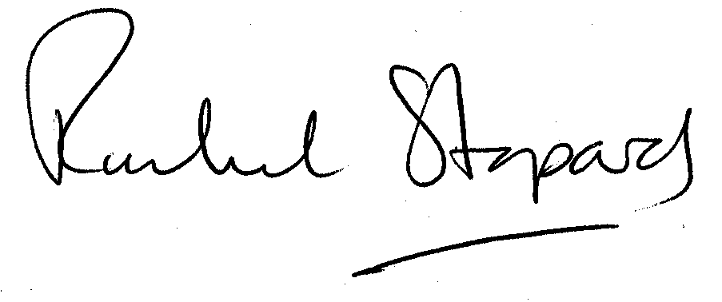
Rachel Stopard
Director of Supporting Communities

