
- Menu
- Search

What are you looking for?

Searching...
Click anywhere to close (ESC)

- Listing
  - Search the List
  - Enrich the List
  - Apply for Listing
  - What is Listing?
  - Listing Guidance
  - Showcasing Designation
- Advice
  - Your Home
  - Planning
  - Latest Advice & Guidance
  - Caring for Heritage
  - Technical Guidance
  - Heritage at Risk
  - Constructive Conservation
  - Heritage Protection Guide
- Research
  - Research Approaches
  - Current Research
  - Research Results
  - Support & Collaboration
  - Inclusive Heritage
- Images & Books
  - Find Photos
  - Search All Publications
  - Buy Books
  - The Historic England Archive
  - Magazines
  - Be an Archive Detective
- Services & Skills
  - Education
  - Grants
  - Our Planning Services
  - Training & Skills
  - Archive Services
  - Heritage Action Zones
- Get Involved
  - Be a Volunteer
  - Protect Your Heritage
  - Help Write History
  - Visit Your Heritage
- News & Features
  - News
  - Statements
  - Newsletter
  - First World War
  - Angel Awards

  - What We Do
  - How We Are Run
  - Jobs
  - Contact Us
  - Volunteer with Historic England

  - Website Terms and Conditions
  - Data Protection
  - Privacy and Cookies
  - Links Policy
  - Historic England Blog: House Rules
  - Gormley’s ROOM Competition Terms and Conditions
This browser is not fully supported by Historic England.
We use cookies to give you the best possible experience online. By using this website, you consent to cookies being used in accordance with our Cookie Policy.
- Home
- ...
- Listing
- Search the List
- List Entry
- Section Navigation
  - Map Search
  - Minor Amendments
  - Download Designation Data
  - Non-Listed Sites
  - About The List
  - Enrich the List

NUMBERS 39-47 AND 49-62 AND ATTACHED RAILINGS

List Entry Summary
This building is listed under the Planning (Listed Buildings and Conservation Areas) Act 1990 as amended for its special architectural or historic interest.
Name: NUMBERS 39-47 AND 49-62 AND ATTACHED RAILINGS
List entry Number: 1356734

Location
NUMBERS 39-47 AND 49-62 AND ATTACHED RAILINGS, 39-47 AND 49-62, DOUGHTY STREET
The building may lie within the boundary of more than one authority.
County: Greater London Authority
District: Camden
District Type: London Borough
Parish:
National Park: Not applicable to this List entry.
Grade: II
Date first listed: 14-May-1974
Date of most recent amendment: 11-Jan-1999

Legacy System Information
The contents of this record have been generated from a legacy data system.
Legacy System: LBS
UID: 477069

Asset Groupings
This list entry does not comprise part of an Asset Grouping. Asset Groupings are not part of the official record but are added later for information.

List entry Description

Summary of Building
Legacy Record - This information may be included in the List Entry Details.

Reasons for Designation
Legacy Record - This information may be included in the List Entry Details.

History
Legacy Record - This information may be included in the List Entry Details.

Details
CAMDEN
TQ3082SE DOUGHTY STREET 798-1/96/311 (East side) 14/05/74 Nos.39-47 AND 49-62 (Consecutive) and attached railings (Formerly Listed as: DOUGHTY STREET Nos.39-62 (Consecutive))
GV II
Terrace of 23 houses, excluding No.48 which is listed separately (qv). Nos 39-46 c1792; Nos 47-62 c1807-9; terrace completed by 1820. No.62 rebuilt in facsimile since 1974. Built by J Wigg, G Slaton and J Wilson. Multi-coloured stock brick most with evidence of tuck pointing; No.45 painted. Plain stucco first-floor sill band. Slate mansard roofs with dormers except Nos 53-55 and 62. Nos 39-47, 49-52 and 56-61: three storeys, attics and dormers. Three windows each; No.39 with four windows (one blind) and three-window return to Guilford Street. Round-arched doorways with panelled or recessed pilaster-jambs, cornice-heads, most with patterned fanlights and panelled doors. Nos 44-47, 49, 51 and 52 have doorways with stuccoed surrounds; Nos 57-61, doorways with Greek Doric engaged columns carrying cornice heads with guttae. Gauged brick flat arches to recessed, mostly 2-pane sashes. Nos 49, 52, 56, 57 and 60 with cast-iron balconies to first-floor windows. Stucco cornices and blocking courses, except No.39. Most houses with original lead rainwater heads and pipes. INTERIORS: not inspected. Nos 53-55 and 62: four storeys and basements. Three windows each, No.62 with 3-window return to Roger Street, plus three-storey three-window extension. Nos 53-54, round-arched doorways with moulded jambs and lion-head stops, cornice-heads and patterned radial fanlights. No.55 has projecting round-arched, rusticated stucco portico with cornice and later C19 doorway. Patterned, half-glazed door and overlight. No.62 has return with projecting Doric porch, part-glazed doors and patterned fanlight. Gauged brick flat arches to recessed sash windows; first-floor with cast-iron balconies. Cornice, continuing from other houses in terrace, at third-floor level. INTERIORS: not inspected but Nos 53-55 noted to have stick baluster stairs. SUBSIDIARY FEATURES: attached cast-iron railings with urn finials to areas. (Survey of London: Vol. XXIV, King's Cross Neighbourhood, Parish of St Pancras, IV: London: -1952: 50-54).
Listing NGR: TQ3077682208

Selected Sources
Books and journals
'Survey of London' in Survey of London - Kings Cross neighbourhood The Parish of St Pancras Part 4: Volume 24 , (1951), 50,51,52
'Survey of London' in Survey of London - Kings Cross neighbourhood The Parish of St Pancras Part 4: Volume 24 , (1951), 53,54
National Grid Reference: TQ 30786 82188

Map
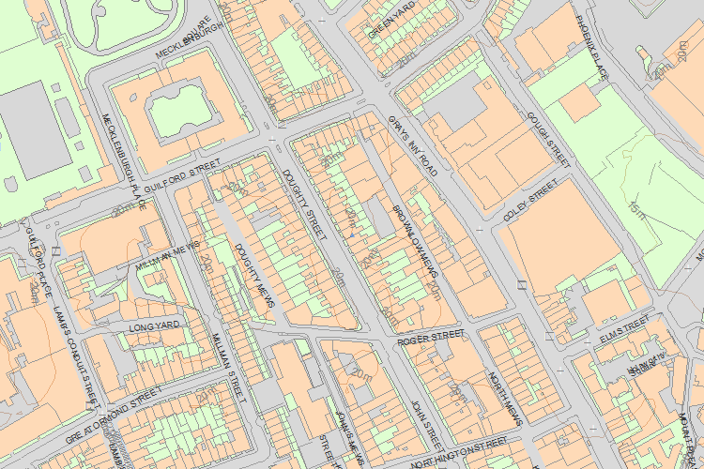© Crown Copyright and database right 2016. All rights reserved. Ordnance Survey Licence number 100024900.
© British Crown and SeaZone Solutions Limited 2016. All rights reserved. Licence number 102006.006.
Use of this data is subject to Terms and Conditions.
The above map is for quick reference purposes only and may not be to scale. For a copy of the full scale map, please see the attached PDF - 1356734 .pdf
The PDF will be generated from our live systems and may take a few minutes to download depending on how busy our servers are. We apologise for this delay.
This copy shows the entry on 20-Jun-2016 at 12:11:52.
End of official listing

Your Contributions

