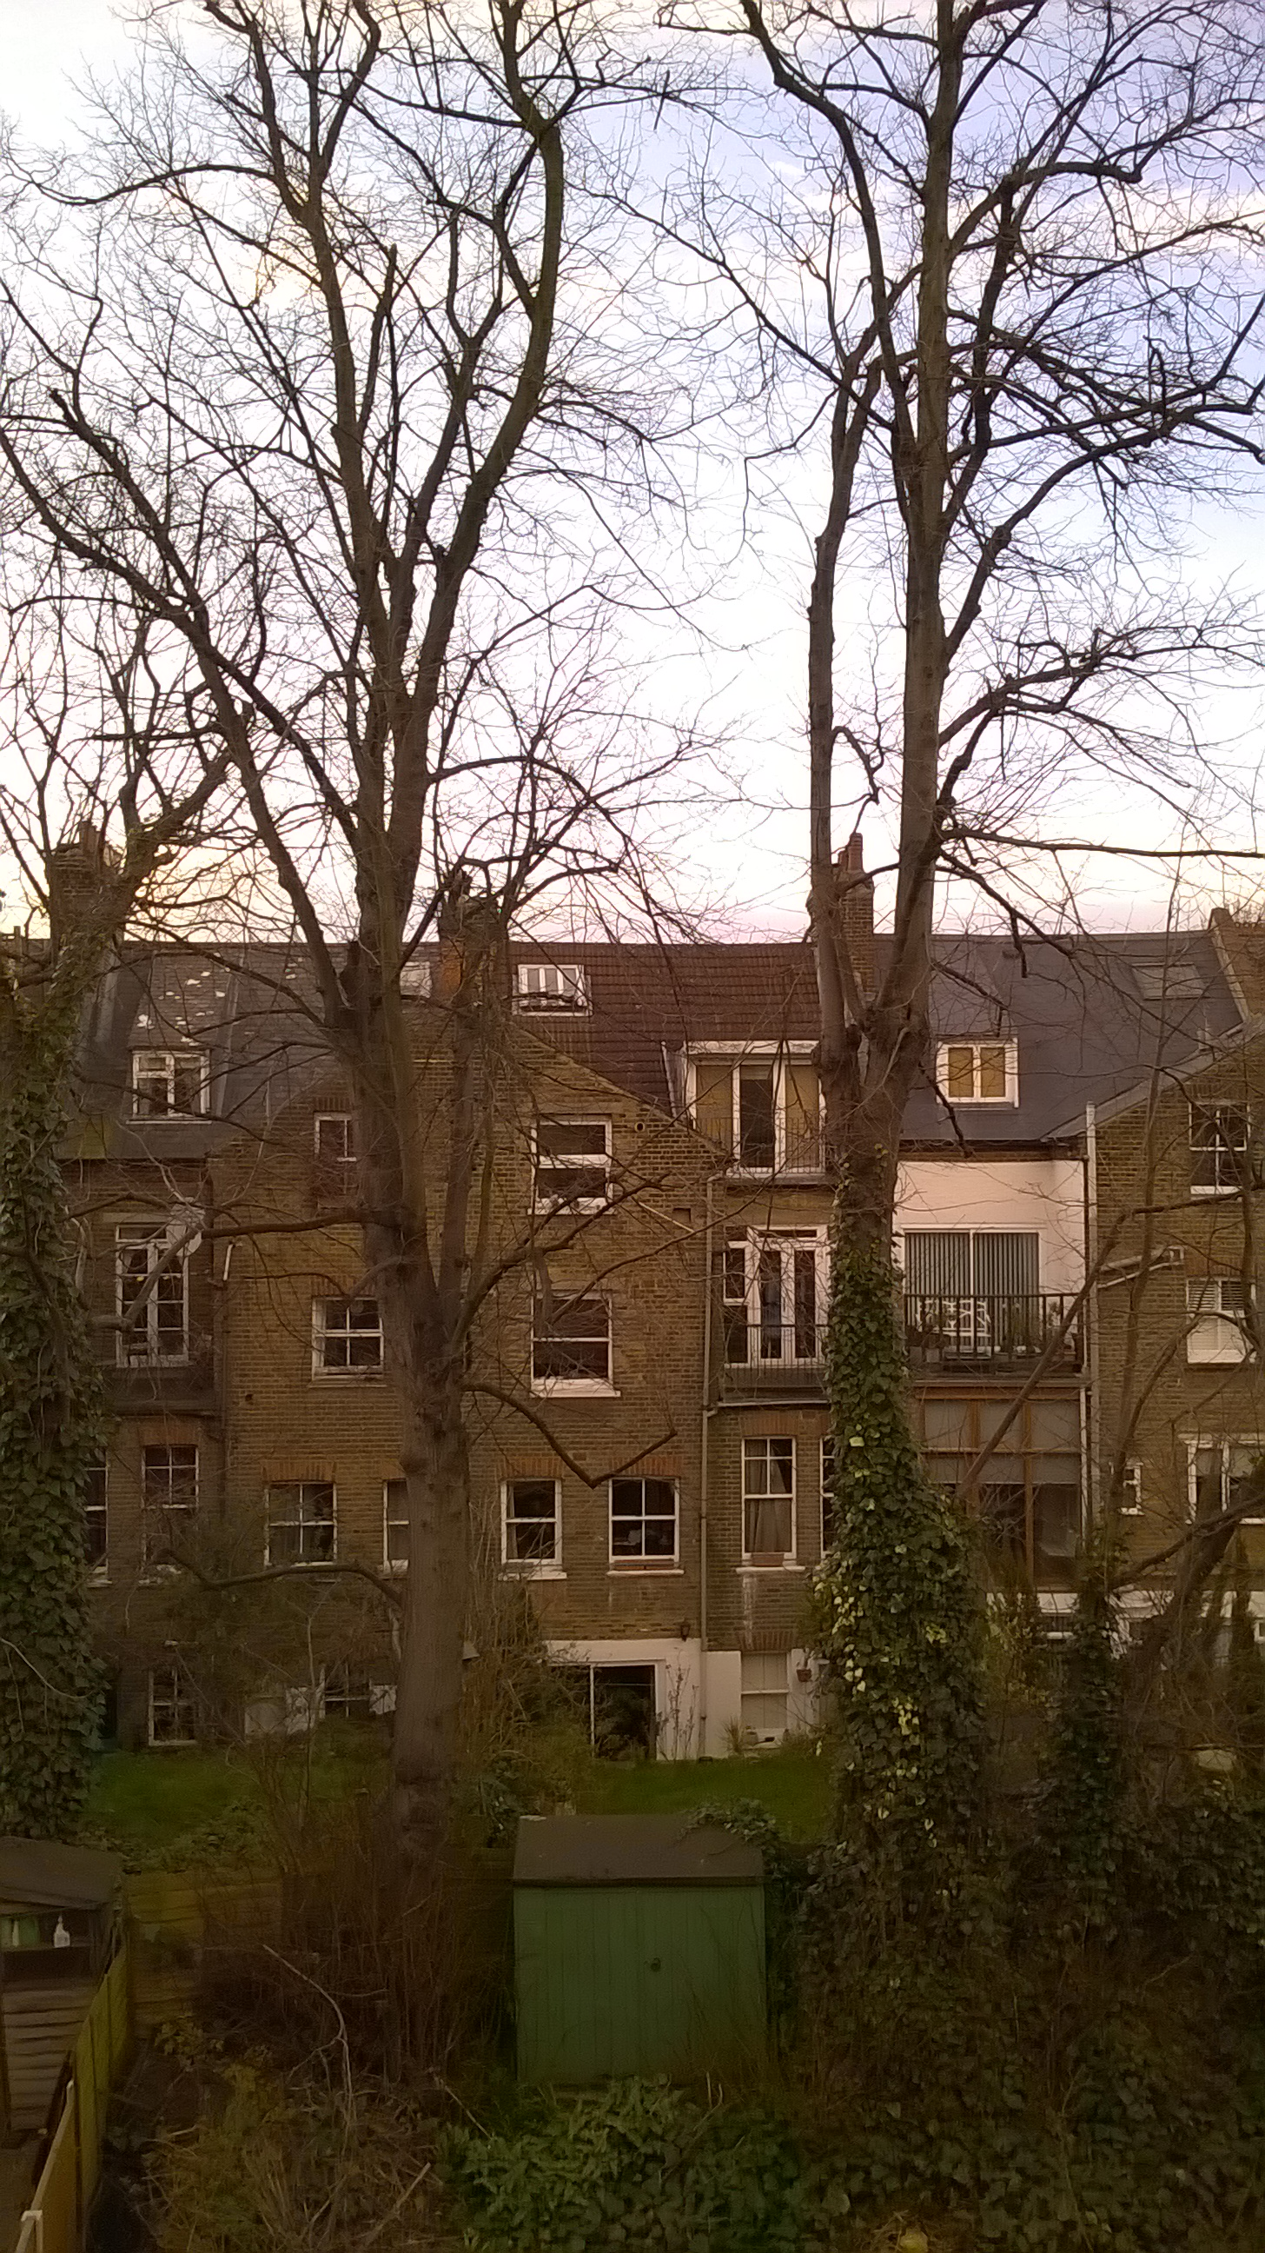
Mature trees in Garden of 25 Kingdon Road Refuge for birds and wildlife in the neighbourhood

