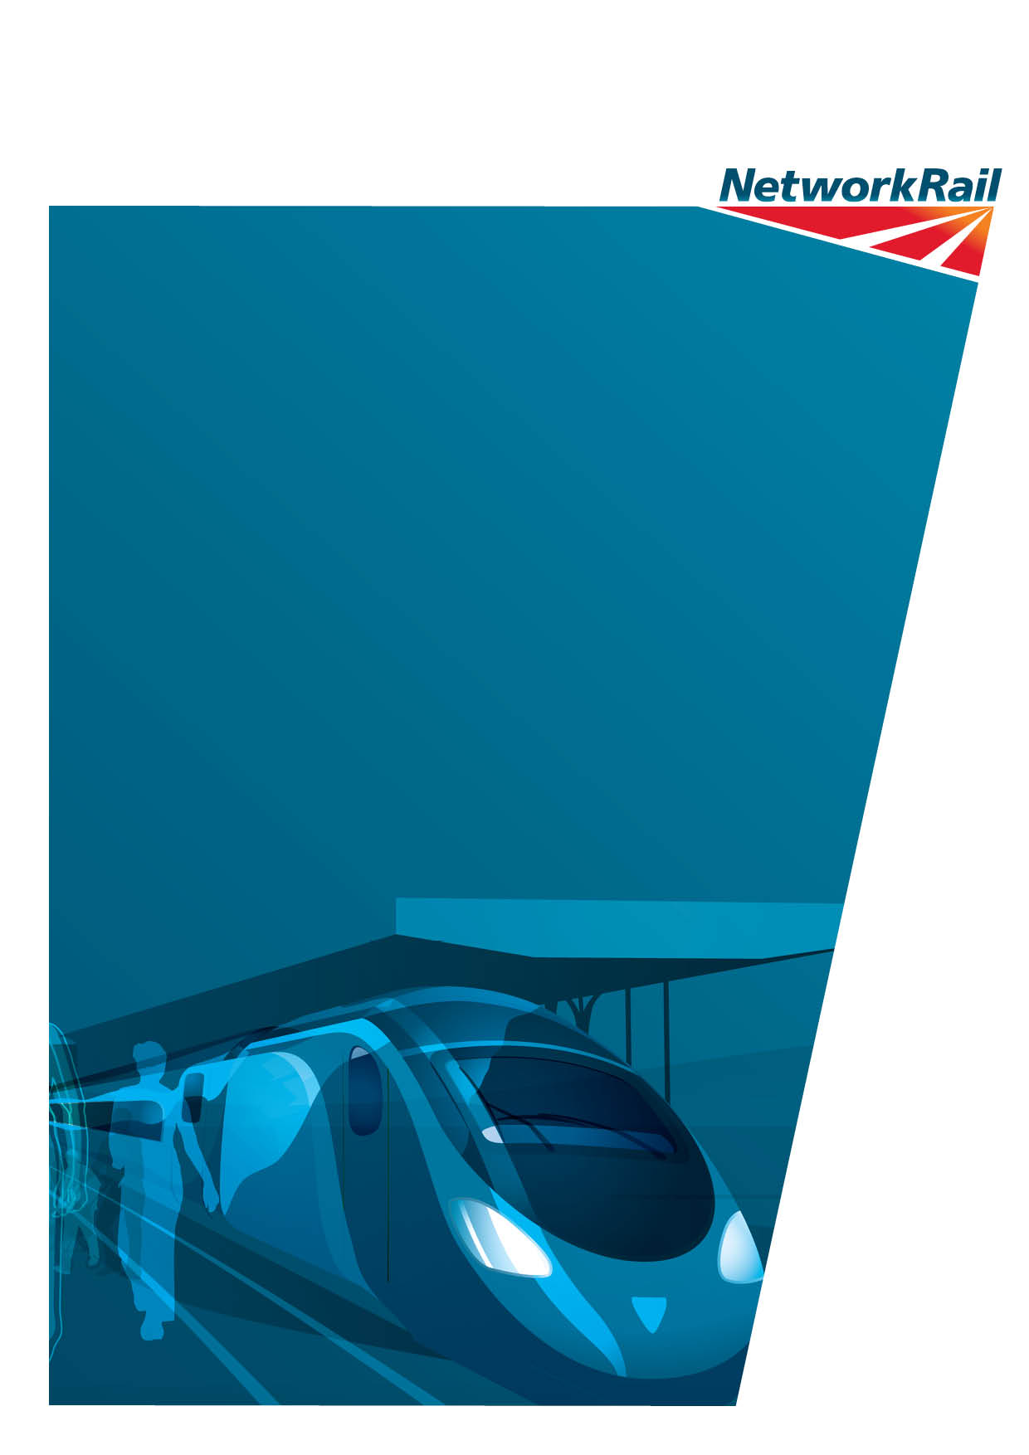
Design Access and Heritage Statement
Document Reference: TP/LNE/2016 – 083
Date: June 2016
Installation of excess fare ticket vending machine, Platform 8 Concourse, King’s Cross Railway station

Contents
1.0 Introduction
2.0 Background
3.0 Policy Context
4.0 Proposal and Heritage Statement
5.0 Conclusions

Introduction

- This design, access and heritage statement is submitted in support of an application for Listed Building Consent for the installation of a single ticket vending machine on the central concourse (platform 8 side) at King’s Cross station. In line with the requirements of the amended Town & Country Planning (General Development Procedure) order 1995 this statement gives an outline of the design and access principles adopted by the application. It also includes a heritage statement in line with the principles of the National Planning Policy Framework.
- The works briefly comprise the installation of a single “Astreo” ticket dispenser unit placed in a wall recess in front of the arches forming the gateline between the main train shed and Western Concourse at the city end of platform 8 (position E on the attached block plan).
- The structure of this report is as follows: Section 2 of the report covers the relevant background information and justification; Section 3 examines the relevant planning policies; Section 4 details the scheme proposals and provides a heritage statement; and Section 5 provides a conclusion/summary.

Background Information
- The significant increase in passenger growth on the railway and the change in purchasing habits of passengers has led to a demand for more self service ticket vending machines, particularly at busy stations.
- At King’s Cross there are currently 21 such ticket macines. Provision of an additional 10 units is a committed obligation under the company’s franchise agreement with the Department Of Transport. In addition the provision of a ticket dispensing machine is considered necessary as it allows for ticketless passengers to purchase tickets prior to crossing the gateline.
- The locaiton is chosen to provide the minimal visual intruction but also the most efficient position witout affecting pedestrian flows around the gateline, given that the machine will attract heavy use during the rush hour. In addition the installaiton of the machine gies an opportunity to restore the detail of the current excess fares window (inconveniently located half-way down platform 8) to match the other units on the range.

Policy Context
- The governing principles for development affecting listed buildings are covered by the guidance given in the National Planning Policy Framework. This is discussed more fully in section 4 below. However the key document covering development in King’s Cross is the King’s Cross Conservation Management Plan (2005), a document approved jointly between Network Rail, Historic England and Camden Council to manage the day to day operation and future development of the station in terms of its historic and architectural interest.
- There are over 30 specific policies designed to facilitate the development of the station in a sympathetic manner. Whilst there is no specific policy relating to the installation of additional facilities on the Main or Western Concourses an overall design philosophy has been established for the whole station to achieve a consistent approach to the appearance of the station and reduce essential features to a minimum as far as possible. The relevant policies are: Policy 6 (Control of change and new works); Policy 35 (platform furniture, signage & cable management; and commercial and retail spaces. They are outlined below:
Policy 6.1: Ensure that there is a co-ordinated conservation strategy and that this is applied to the whole site.
The guiding principles should be minimum intervention and reversibility: change only as much as necessary and as little as possible.
Policy 6.2: New work should be readily identifiable as such and should not compromise the architectural integrity of the original.
Policy 6.3: Investigations should precede all work where the existing structure will be affected. Full consideration should be given to the structural capacity of the existing building and should take into account any known alterations, bomb damage and historic areas of weakness.
Policy 6.4: Removal of any existing fabric should be preceded by systematic recording. See policy 15.0.
Policy 6.5: Seek to ensure that any major new work that involves passenger related facilities will have sufficient capacity to accommodate future growth to minimise the need
for further disruption in the short to medium term.

Policy 35.2: A co-ordinated and consistent design approach should be adopted to integrate all fixtures, fittings and station furniture (trolley points, waste bins, cycle racks, platform seating using similar materials and designs). For example integrating clocks and loudspeakers with the Customer Information System (CIS) and grouping telephone help points with other items of platform furniture (fire extinguishers, directional signs, PA loudspeakers &c). Materials should be specified of an appropriate quality for the listed status of the station and easy to maintain, preferably self-finished such as stainless steel.

Policy 35.3: A cable management strategy should be adopted to conceal cabling as far as possible. Cable runs should be as discrete as possible.

Policy 36.2: Free-standing mobile units, kiosks, promotion and exhibition stands should be located where they do not obscure significant architectural details.

- The proposal is thus tested against these policies in the following section.

4 Proposals and Heritage Statement

- The area of the Main Concourse where the machine is proposed is a site which is discreetly located within the corner recess of an archway, currently occupied by a waste bin. There are no visible architectural features in this location, with the arch wall being a plain brown brick although it is noted the return wall has a horizontal detail. However given the size and scale of the machine proposed (height 1.8m) it does not unduly obscure such detail given the latter rises towards the crown of the arch. The machine is in a position where it does not unduly restrict the circulation of passengers nor intrude on the openness of the concourse. Previous views have been expressed to retain as little as possible in terms of extraneous platform furniture along the Western Range on platform 8. The harmony of the range is broken to some extent by some existing platform furniture and installations including the staircase down to the gents toilets, corporate signage and trolley enclosure, but overall does not suffer from an excess of clutter. The location of the machine at the very end of the range, with the return of the wall giving a visual end stop in any case, does not perpetuate a sense of additional clutter and can be absorbed in the overall visual appearance of the station, being noticeable only in close proximity (it would be fairly indistinguishable from long views down platform 8). A specification indicating height, width and depth is included in the application.
- Given there are existing ducts beneath the chosen location there are no further requirements for additional cabling up through the floor or on the adjacent wall thereby protecting the existing surfaces. The machines would be fixed by means of bolts, but these are easily replaced should the machine need to be removed in the future and thus will cause minimal damage to the existing floor covering. There is no requirement for additional signage as a high proportion of ticketless passengers would be directed to the machine by gateline staff. The colour of the machine itself will be muted grey with red band (as shown on the specification sheet, as opposed to the visual photomontage which shows an element of blue).

- The proposal satisfies the requirements of both the conservation management plan and the NPPF in that it retains existing features and characteristics of the overall Main Concourse itself, the machine being a standard design used elsewhere both in the station and on the network.

Heritage Statement – design in accordance with the National Planning Policy Framework (section 12)
- The proposed development site is of historic and architectural importance, its features protected and guided by its designation as a Grade II listed building. As such, in considering the proposal, the heritage impact must be assessed according to the guidance set out in the NPPF in relation to the historic environment.
- The advice given in the NPPF to local authorities in respect of LBC applications is clear (paragraph 128):
- “In determining applications, local planning authorities should require an applicant to describe the significance of any heritage assets affected, including any contribution made by their setting. The level of detail should be proportionate to the assets’ importance and no more than is sufficient to understand the potential impact of the proposal on their significance. As a minimum the relevant historic environment record should have been consulted and the heritage assets assessed using appropriate expertise where necessary. Where a site on which development is proposed includes or has the potential to include heritage assets with archaeological interest, local planning authorities should require developers to submit an appropriate desk-based assessment and, where necessary, a field evaluation.”
- (Paragraph 129) “Local planning authorities should identify and assess the particular significance of any heritage asset that may be affected by a proposal (including by development affecting the setting of a heritage asset) taking account of the available evidence and any necessary expertise. They should take this assessment into account when considering the impact of a proposal on a heritage asset, to avoid or minimise conflict between the heritage asset’s conservation and any aspect of the proposal.”
- (Paragraph 132) “When considering the impact of a proposed development on the significance of a designated heritage asset, great weight should be given to the asset’s conservation. The more important the asset, the greater the weight should be. Significance can be harmed or lost through alteration or destruction of the heritage asset or development within its setting. As heritage assets are irreplaceable, any harm or loss should require clear and convincing justification. Substantial harm to or loss of a grade II listed building, park or garden should be exceptional. Substantial harm to or loss of designated heritage assets of the highest significance, notably scheduled monuments, protected wreck sites, battlefields, grade I and II* listed buildings, grade I and II* registered parks and gardens, and World Heritage Sites, should be wholly exceptional.”
Key Areas of Significance
- The characteristics and importance of the station have been previously identified in the Conservation Management Plan. The main shed walls are recognized as being of high significance (page 53 of the Conservation Plan) but the proposal does not cause demonstrable harm to the features and the proposal is consistent with (in particular) policies 6.2, 35.2, 35.3 and 36.2 of the Conservation Plan. The proposal is very minor in nature in the context of the overall building, but although it does introduce a further modern structure on the façade of the train shed it is considered that the requirements of serving the growing number of ticketless passengers and the restoration of the current excess fares window to its original condition outweigh the relatively minor aesthetic impact of this one additional machine will have on the façade.
Access Statement
- The proposals do not affect the current arrangements for mobility impaired access to the platforms and circulation on the concourse. Although the machine could in theory form another obstacle for visually impaired people it is not in a location where people would normally go and thus it impact will be minimal.

5 Conclusions
- The demand for self-service ticket machines has grown exponentially as demand for train travel has increased. In addition as patronage increases the number of people who travel into the terminus will also increase. To meet this demand and help re-distribute passenger flows through the concourse a single excess fares machine is proposed on an unobtrusive section of the main concourse (western range). It will have minimal impact on the overall appearance of the station and does not affect the overall integrity and architectural quality of the building. There are no other material considerations which should preclude the application from being approved.

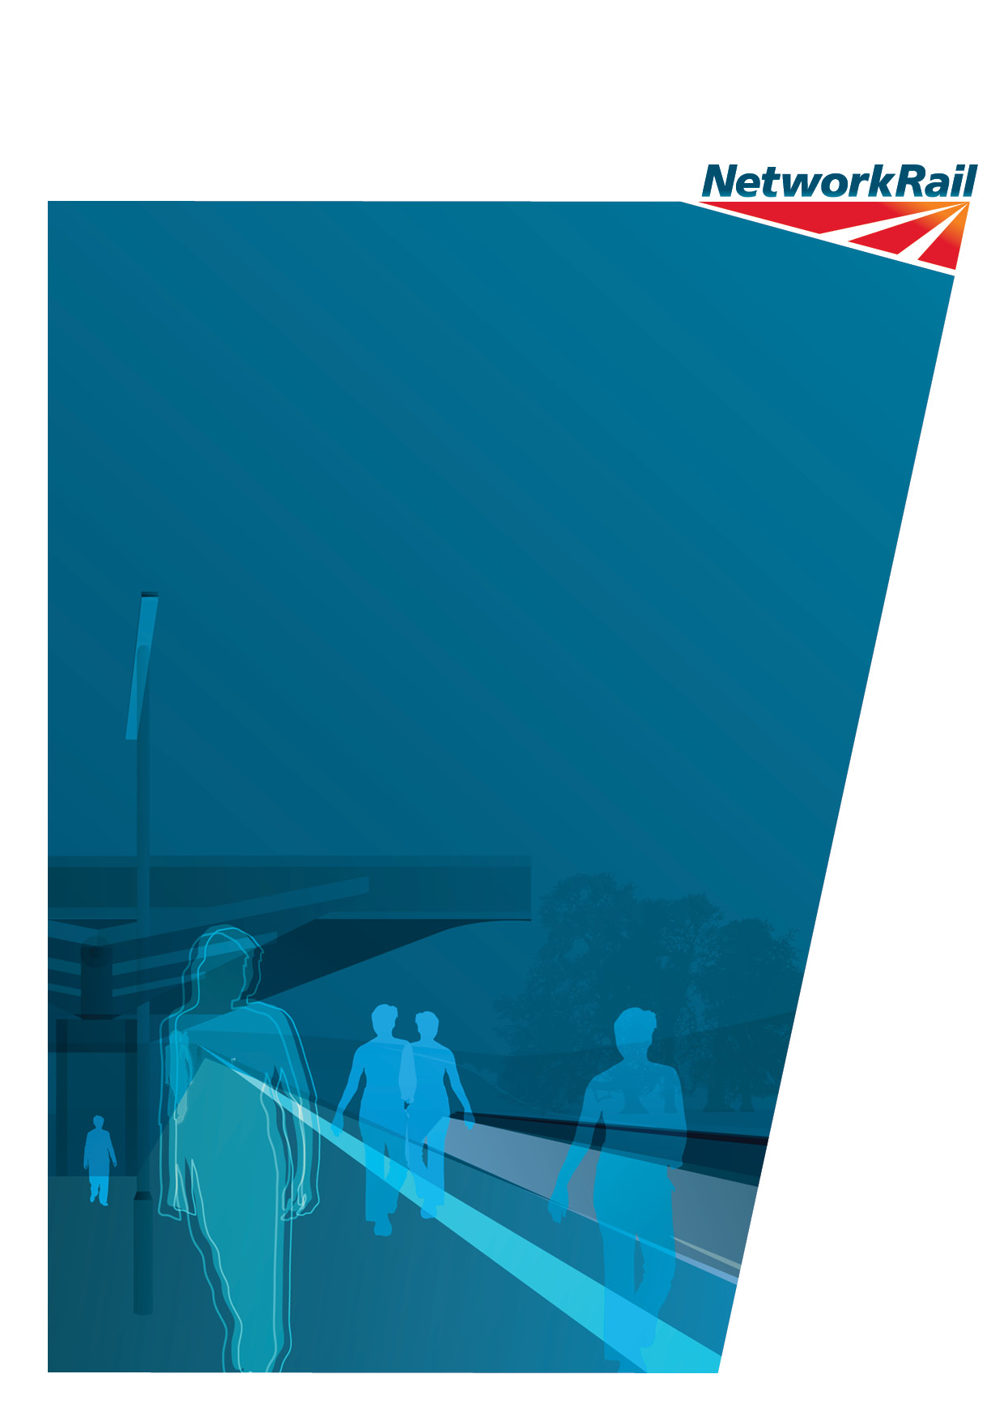

Network Rail
1 Eversholt Street
London
NW1 2DW
www.networkrail.co.uk

