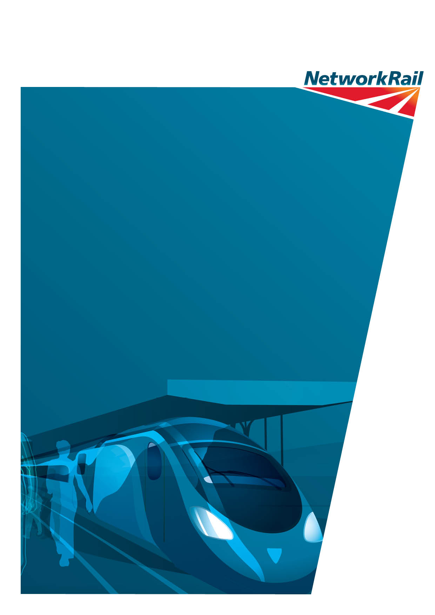
Design Access and Heritage Statement
Document Reference: TP/LNE/2016 – 082
Date: May 2016
Installation of ticket vending machine, West Concourse, King’s Cross Railway station

Contents
1.0 Introduction
2.0 Background
3.0 Policy Context
4.0 Proposal and Heritage Statement
5.0 Conclusions

Introduction

- This design, access and heritage statement is submitted in support of the discharge of a condition relating to a listed building consent granted in 2006 in respect of the King’s Cross Western Concourse development. It relates to the installation of two ticket vending machines on the western concourse at King’s Cross station. In line with the requirements of the amended Town & Country Planning (General Development Procedure) order 1995 this statement gives an outline of the design and access principles adopted by the application. It also includes a heritage statement in line with the principles of the National Planning Policy Framework. The application is based on the requirements of condition 8 of Listed Building Consent 2006/3394L which states:
- The works briefly comprise the installation of two pairs of “ToDler” ticket dispenser units over existing covered ducts at the northern end of the concourse directly opposite and half way between the WH Smith and Waitrose shops (the latter being the entrance immediately to the left of the ticket office).
- The structure of this report is as follows: Section 2 of the report covers the relevant background information and justification; Section 3 examines the relevant planning policies; Section 4 details the scheme proposals and provides a heritage statement; and Section 5 provides a conclusion/summary.

Background Information
- The significant increase in passenger growth on the railway and the change in purchasing habits of passengers has led to a demand for more self service ticket vending machines, particularly at busy stations.
- At King’s Cross there are currently 21 such ticket macines. Provision of an additional 10 units is a committed obligation under the company’s franchise agreement with the Department Of Transport. This application seeks to locate four such machines on the Western Cocnourse.

Policy Context
- The governing principles for development affecting listed buildings are covered by the guidance given in the National Planning Policy Framework. This is discussed more fully in section 4 below. However the key document covering development in King’s Cross is the King’s Cross Conservation Management Plan (2005), a document approved jointly between Network Rail, Historic England and Camden Council to manage the day to day operation and future development of the station in terms of its historic and architectural interest.
- There are over 30 specific policies designed to facilitate the development of the station in a sympathetic manner. Whilst there is no specific policy relating to the installation of additional facilities on the Western Concourse (given it is essentially “new” in relation to the existing station) but an overall design philosophy has been established for the whole station to achieve a consistent approach to the appearance of the station and reduce essential features to a minimum as far as possible (as managed through the condition 8 of the overall LBC). The relevant policies are: Policy 6 (Control of change and new works); Policy 35 (platform furniture, signage & cable management; and commercial and retail spaces. They are outlined below:
Policy 6.1: Ensure that there is a co-ordinated conservation strategy and that this is applied to the whole site.
The guiding principles should be minimum intervention and reversibility: change only as much as necessary and as little as possible.
Policy 6.2: New work should be readily identifiable as such and should not compromise the architectural integrity of the original.
Policy 6.3: Investigations should precede all work where the existing structure will be affected. Full consideration should be given to the structural capacity of the existing building and should take into account any known alterations, bomb damage and historic areas of weakness.
Policy 6.4: Removal of any existing fabric should be preceded by systematic recording. See policy 15.0.
Policy 6.5: Seek to ensure that any major new work that involves passenger related facilities will have sufficient capacity to accommodate future growth to minimise the need
for further disruption in the short to medium term.

Policy 35.2: A co-ordinated and consistent design approach should be adopted to integrate all fixtures, fittings and station furniture (trolley points, waste bins, cycle racks, platform seating using similar materials and designs). For example integrating clocks and loudspeakers with the Customer Information System (CIS) and grouping telephone help points with other items of platform furniture (fire extinguishers, directional signs, PA loudspeakers &c). Materials should be specified of an appropriate quality for the listed status of the station and easy to maintain, preferably self-finished such as stainless steel.

Policy 35.3: A cable management strategy should be adopted to conceal cabling as far as possible. Cable runs should be as discrete as possible.

Policy 36.2: Free-standing mobile units, kiosks, promotion and exhibition stands should be located where they do not obscure significant architectural details.

- The proposal is thus tested against these policies in the following section.

4 Proposals and Heritage Statement

- The area of the Concourse where the machines are proposed is a site which has been used frequently for temporary installations such as exhibition or information displays because it is in a position where they do not unduly restrict the circulation of passengers nor intrude on the openness of the concourse. Views into the concourse through the numerous double doors from outside would not be impaired through the provision of these two pairs of modest ticket machines. A specification indicating height, width and depth is included in the application.
- Given there are existing ducts beneath the chosen location there are no further requirements for additional cabling up through the floor thereby protecting the existing floor surface. The machines would be fixed by means of bolts, but these are easily replaced should the machines need to be removed in the future and thus will cause minimal damage to the existing floor covering.

- The proposal satisfies the requirements of both the conservation management plan and the NPPF in that it retains existing features and characteristics of the overall Western Concourse itself, the machines being a standard design used elsewhere both in the station and in nearby St Pancras as well as elsewhere on the network (photograph of the units at St Pancras is included in the application for information).

Heritage Statement – design in accordance with the National Planning Policy Framework (section 12)
- The proposed development site is of historic and architectural importance, its features protected and guided by its designation as a Grade II listed building. As such, in considering the proposal, the heritage impact must be assessed according to the guidance set out in the NPPF in relation to the historic environment.
- The advice given in the NPPF to local authorities in respect of LBC applications is clear (paragraph 128):
- “In determining applications, local planning authorities should require an applicant to describe the significance of any heritage assets affected, including any contribution made by their setting. The level of detail should be proportionate to the assets’ importance and no more than is sufficient to understand the potential impact of the proposal on their significance. As a minimum the relevant historic environment record should have been consulted and the heritage assets assessed using appropriate expertise where necessary. Where a site on which development is proposed includes or has the potential to include heritage assets with archaeological interest, local planning authorities should require developers to submit an appropriate desk-based assessment and, where necessary, a field evaluation.”
- (Paragraph 129) “Local planning authorities should identify and assess the particular significance of any heritage asset that may be affected by a proposal (including by development affecting the setting of a heritage asset) taking account of the available evidence and any necessary expertise. They should take this assessment into account when considering the impact of a proposal on a heritage asset, to avoid or minimise conflict between the heritage asset’s conservation and any aspect of the proposal.”
- (Paragraph 132) “When considering the impact of a proposed development on the significance of a designated heritage asset, great weight should be given to the asset’s conservation. The more important the asset, the greater the weight should be. Significance can be harmed or lost through alteration or destruction of the heritage asset or development within its setting. As heritage assets are irreplaceable, any harm or loss should require clear and convincing justification. Substantial harm to or loss of a grade II listed building, park or garden should be exceptional. Substantial harm to or loss of designated heritage assets of the highest significance, notably scheduled monuments, protected wreck sites, battlefields, grade I and II* listed buildings, grade I and II* registered parks and gardens, and World Heritage Sites, should be wholly exceptional.”
Key Areas of Significance
- The characteristics and importance of the station have been previously identified in the Conservation Management Plan and the proposal is consistent with (in particular) policies 6.2, 35.2, 35.3 and 36.2 of the Conservation Plan. The proposals are very minor in nature in the context of the overall building, relating to the modern extension to the original station, but nevertheless respect the principles employed in the development of the Western Concourse to ensure it matches the standards and principles which govern the overall structure.
Access Statement
- The proposals do not affect the current arrangements for mobility impaired access to the platforms and circulation on the concourse. Although the machines can in theory form another obstacle for visually impaired people the surrounding area is not restricted in width and as stand-alone units in bright colours their impact is minimal.

5 Conclusions
- The demand for self-service ticket machines has grown exponentially as demand for train travel has increased. In order to meet this demand and help re-distribute passenger flows through the concourse a further set of four machines are proposed on an existing ducted position in the Western Concourse. They will have minimal impact on the overall appearance of the Western Concourse and do not affect the overall integrity and architectural quality of the building. There are no other material considerations which should preclude the application from being approved.

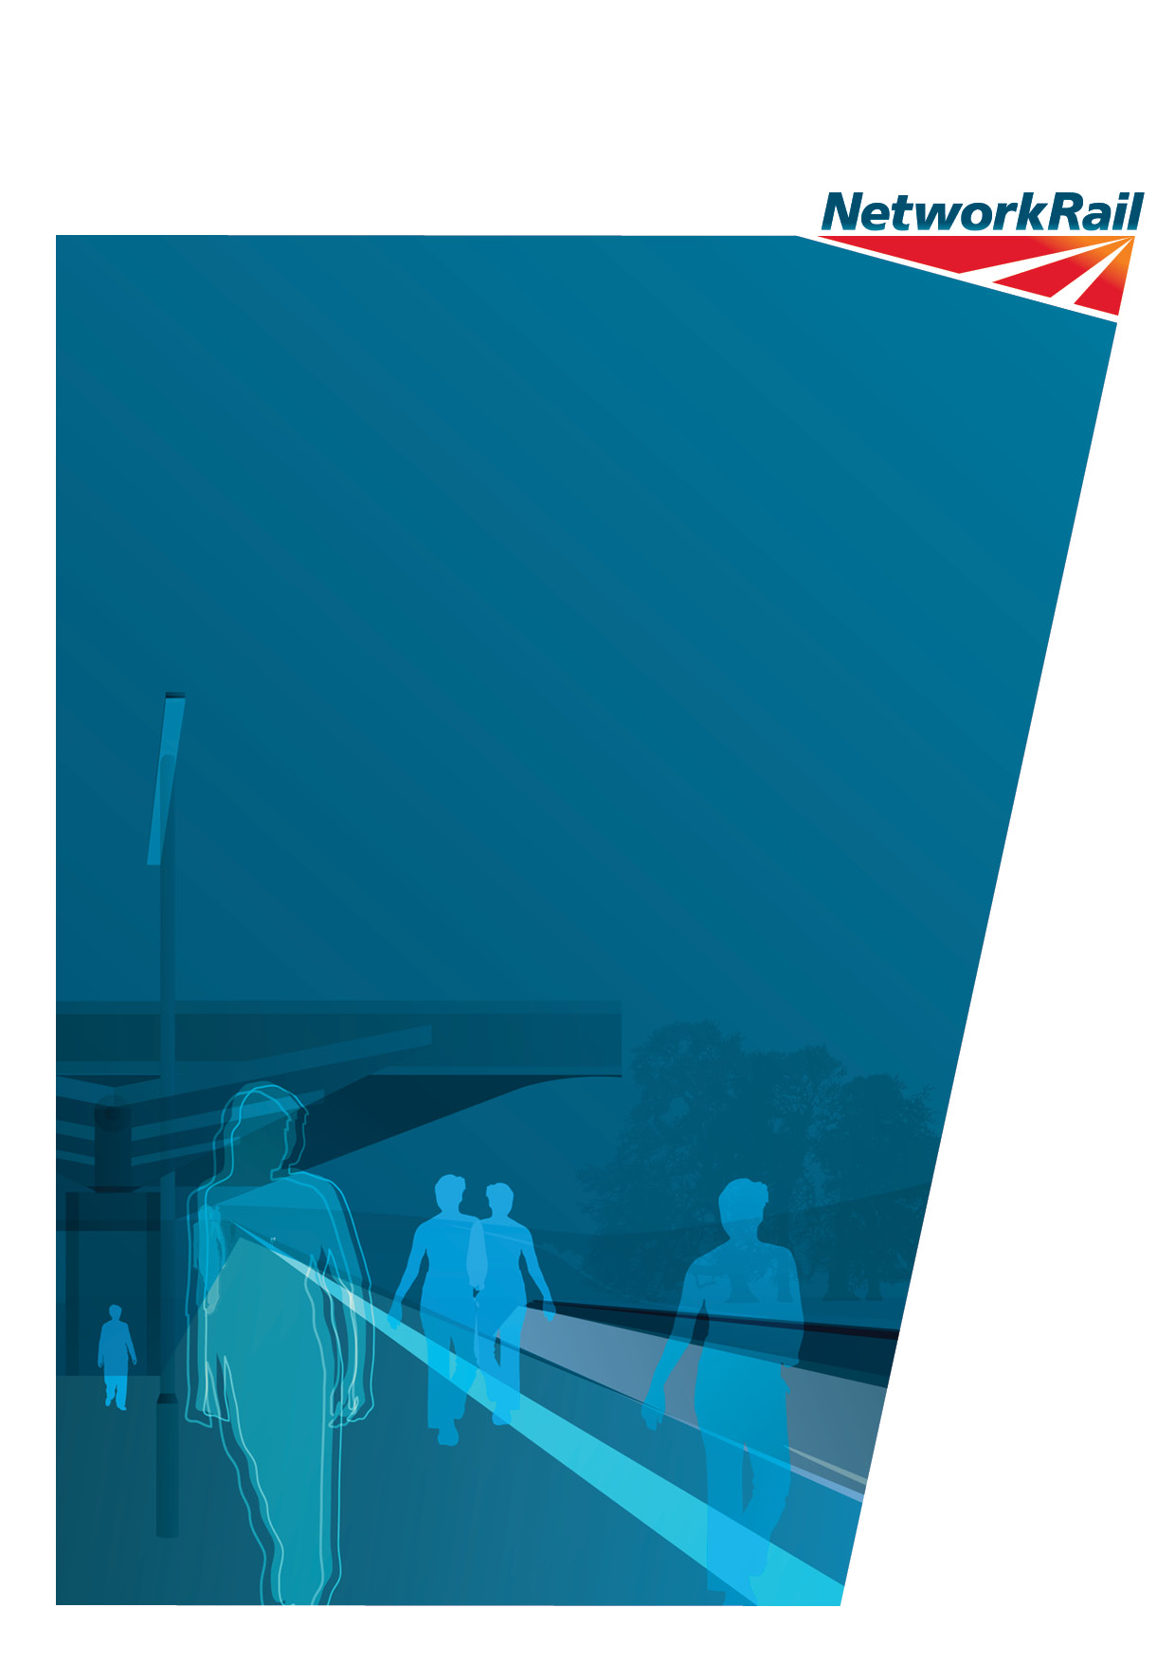

Network Rail
1 Eversholt Street
London
NW1 2DW
www.networkrail.co.uk

