Mr. Michael Tite
HemingwayTite
3 Greenland Place
London
NW1 0AP
3 Greenland Place  London  NW1 0AP |  | Application Ref: 2016/2571/L
 |  | Please ask for: Catherine Bond
 |  | Telephone: 020 7974 2669
 |  | 1 June 2016

Dear Sir/Madam

DECISION

Planning (Listed Building and Conservation Areas) Act 1990

Approval of Details (Listed Building) Granted

Address:
Rhyl Primary School
7-31 Rhyl Street
London
NW5 3NB

Proposal:
Approval of conditions 3a (Ramp drawings), 3b (Raised Floor drawings), 3c (Signage & Canopy), 3d (Room Divider), 3e (Downpipe) and 3f (Railings & Gate drawings) granted under reference 2015/0997/L dated 23/10/15 for Listed Building consent for the refurbishment of Rhyl Street entrance and associated reception area, offices and meeting rooms including demolition of current canopy, erection of new entrance canopy, new ramp, sign and steps with associated internal and external alterations.
Drawing Nos: 1403_P_1115; 1403_P_1116; 1403_P_1120; 1403_P_1121; 1403_P_1122; 1403_P_1123; 1403_P_1201 rev C; 1403_P_1206; 1403_P_1207; 1403_P_1302 rev E; Flushjoint rainwater goods product information; Letter from Michael Tite dated 6 May 2016.

The Council has considered your application and decided to grant Approval of Details (Listed Building) subject to the following condition(s):

Conditions And Reasons:

Informative(s):

Reasons for granting listed building consent (approval of details) (Council's own):

This approval of details application is for clearance of conditions 3a (Ramp drawings), 3b (Raised Floor drawings), 3c (Signage & Canopy), 3d (Room Divider), 3e (Downpipe) and 3f (Railings & Gate drawings) granted under reference 2015/0997/L dated 23/10/15 for Listed Building consent for the refurbishment of Rhyl Street entrance and associated reception area, offices and meeting rooms including demolition of current canopy, erection of new entrance canopy, new ramp, sign and steps with associated internal and external alterations.

It is considered that the details submitted are in keeping with the principles of the overall consented proposal and are sympathetic to the character of the school building and its setting. No harm is caused to the special interest of the grade II listed building.

The site's planning history was taken into account when coming to this decision. No public consultation was necessary for this application.

Special regard has been attached to the desirability of preserving the listed building and its features of special architectural or historic interest, under s.16 of the Listed Buildings and Conservation Areas Act 1990 as amended by the Enterprise and Regulatory Reform Act (ERR) 2013.

As such, the proposed development is in general accordance with policies CS5 and CS14 and of the London Borough of Camden Local Development Framework Core Strategy, and policies DP24, DP25 and DP26 of the London Borough of Camden Local Development Framework Development Policies. The proposed development also accords with policies 7.4, 7.6 and 7.8 of the London Plan March 2015, consolidated with alterations since 2011; and paragraphs 14, 17, 56-66, and 126-141 of the National Planning Policy Framework.

You are advised that all conditions relating to listed building consent ref 2015/0997/L granted on 23/10/2015 which need details to be submitted, have been approved.

You can find advice about your rights of appeal at:

http://www.planningportal.gov.uk/planning/appeals/guidance/guidancecontent

Yours faithfully
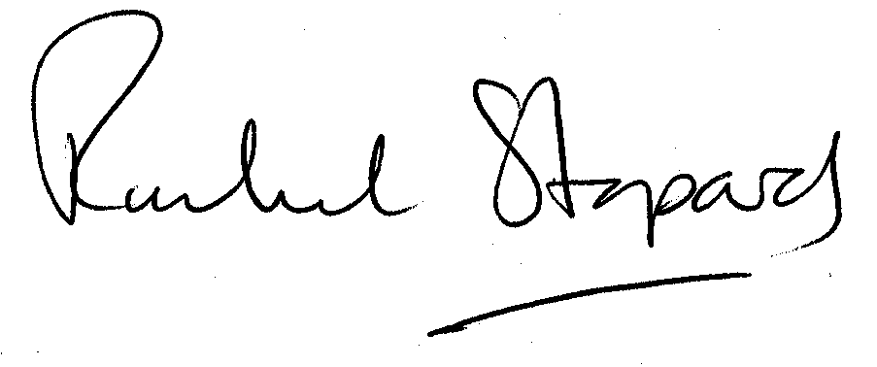
Rachel Stopard
Director of Supporting Communities

