Mr. Euan Pearson
Pearson Planning & Chartered Surveyors
PO Box 28606
Edinburgh
EH4 9BQ
Scotland
PO Box 28606  Edinburgh  EH4 9BQ  Scotland |  | Application Ref: 2016/1683/L
 |  | Please ask for: Catherine Bond
 |  | Telephone: 020 7974 2669
 |  | 31 May 2016

Dear Sir/Madam

DECISION

Planning (Listed Building and Conservation Areas) Act 1990

Listed Building Consent Granted

Address:
Unit 20
Brunswick Centre
London
WC1N 1AE

Proposal:
Installation of telecommunications cabling through communal basement to retail unit
Drawing Nos: Site Location Plan; Schematic showing cable run below shops; Cabling Details written statement; Photos 1 to 8 Cabling Route; Photos 9 to 15 Cabling Route; Design & Access Statement; Heritage Statement.

The Council has considered your application and decided to grant Listed Building Consent subject to the following condition(s):

Conditions And Reasons:

1 | The works hereby permitted shall be begun not later than the end of three years from the date of this consent.  Reason: In order to comply with the provisions of Section 18 of the Planning (Listed Buildings and Conservation Areas) Act 1990.
2 | All new external and internal works and finishes and works of making good to the retained fabric, shall match the existing adjacent work with regard to the methods used and to material, colour, texture and profile, unless shown otherwise on the drawings or other documentation hereby approved or required by any condition(s) attached to this consent.  Reason: In order to safeguard the special architectural and historic interest of the building in accordance with the requirements of policy CS14 of the London Borough of Camden Local Development Framework Core Strategy and policy DP25 of the London Borough of Camden Local Development Framework Development Policies.
3 | The works hereby approved are only those specifically indicated on the drawing(s) referred to above.  Reason: In order to safeguard the special architectural and historic interest of the building in accordance with the requirements of policy CS14 of the London Borough of Camden Local Development Framework Core Strategy and policy DP25 of the London Borough of Camden Local Development Framework Development Policies.

Informative(s):

Reasons for granting listed building consent:

The application affects the grade II listed Brunswick Centre situated within the Bloomsbury Conservation Area, a postwar concrete megastructure comprising a shopping complex with housing above, with a large communal basement below containing services, carparking and a cinema space. The shopping complex was extended and upgraded a decade ago, and includes Unit 20 which is subject of this application.

It is proposed to install telecommunications cabling from under the pavement of Handel Street to the north through the communal basement to the retail unit which currently houses a mobile phone outlet. Cabling in the basement will be black plastic-coated, with a diameter of 5cm. Trunking in the retail unit will be white plastic to match existing paintwork. Cabling and trunking will be affixed to the concrete surfaces by cable clips at 5m intervals. The works will not affect the exterior of the listed building or impact on any areas of high significance. It is therefore considered that no harm will be caused to the special interest of the grade II listed building.

No public consultation was necessary for this application. The site's planning history was taken into account when coming to this decision.

Special regard has been attached to the desirability of preserving the listed building and its features of special architectural or historic interest, under s.16 of the Listed Buildings and Conservation Areas Act 1990 as amended by the Enterprise and Regulatory Reform Act (ERR) 2013.

As such, the proposal is in general accordance with policy CS14 of the London Borough of Camden Local Development Framework Core Strategy, and policy DP25 of the London Borough of Camden Local Development Framework Development Policies. The proposed development also accords with policy 7.8 of the London Plan 2016, and paragraphs 14, 17 and 126-141 of the National Planning Policy Framework.

Your proposals may be subject to control under the Building Regulations and/or the London Buildings Acts which cover aspects including fire and emergency escape, access and facilities for people with disabilities and sound insulation between dwellings. You are advised to consult the Council's Building Control Service, 5 Pancras Square, London N1C 4AG, (tel: 020-7974 6941).

Noise from demolition and construction works is subject to control under the Control of Pollution Act 1974. You must carry out any building works that can be heard at the boundary of the site only between 08.00 and 18.00 hours Monday to Friday and 08.00 to 13.00 on Saturday and not at all on Sundays and Public Holidays. You are advised to consult the Council's Noise and Licensing Enforcement Team, 5 Pancras Square, London N1C 4AG (Tel. No. 020 7974 4444 or on the website http://www.camden.gov.uk/ccm/content/contacts/council-contacts/environment/contact-the-environmental-health-team.en or seek prior approval under Section 61 of the Act if you anticipate any difficulty in carrying out construction other than within the hours stated above.

You can find advice about your rights of appeal at:

http://www.planningportal.gov.uk/planning/appeals/guidance/guidancecontent

Yours faithfully
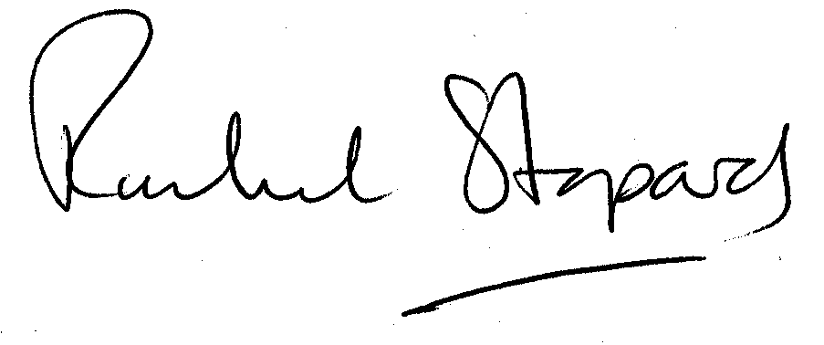
Rachel Stopard
Director of Supporting Communities

