Mr. John Seifert
8 Gloucester Mews West
London
W2 6DY

8 Gloucester Mews West  London  W2 6DY |  | Application Ref: 2016/0869/L
 |  | Please ask for: Catherine Bond
 |  | Telephone: 020 7974 2669
 |  | 31 May 2016

Dear Sir/Madam

DECISION

Planning (Listed Building and Conservation Areas) Act 1990

Approval of Details (Listed Building) Granted

Address:
5 Chester Terrace
London
NW1 4ND

Proposal:
Details for secondary glazing to existing front windows and for new double glazed windows on rear elevation in relation to condition 4a (1:10 sections of all windows including jambs, head and cill, ventilation grills, external doors and gates) of listed building consent ref 2015/0645/L granted on 26/05/15, for internal alterations including installation of new internal staircase from third floor level to a new roof terrace area, changes to room layouts, double glazed units installed in the rear elevation and a new access door to garage).
Drawing Nos: Mr John Seifert Sheet 1 of 3; Mr John Seifert Sheet 2 of 3; Mr John Seifert Sheet 3 of 3; D30232/19/1 of 2; D30232/19/2 of 2; D30232/20/1 of 2; D30232/20/2 of 2; D30232/23/1 of 2; D30232/23/2 of 2; D30232/24/2 of 2; D30232/24/2 of 2.

The Council has considered your application and decided to grant Approval of Details (Listed Building) subject to the following condition(s):

Conditions And Reasons:

Informative(s):

Reasons for granting listed building consent (approval of details):

This approval of details application is to clear details of secondary glazing to existing front windows and for new double glazed windows on rear elevation in relation to condition 4a (1:10 sections of all windows including jambs, head and cill, ventilation grills, external doors and gates) of listed building consent ref 2015/0645/L granted on 26/05/15.

It is considered that the details submitted are in keeping with the principles of the overall consented proposal and are sympathetic to the character of the Nash townhouse. No harm is caused to the special interest of the grade I listed building.

Public consultation was undertaken by means of a site notice and press notice, whereby no responses were received. The site's planning history was taken into account when coming to this decision.

Special regard has been attached to the desirability of preserving the listed building and its features of special architectural or historic interest, under s.16 of the Listed Buildings and Conservation Areas Act 1990 as amended by the Enterprise and Regulatory Reform Act (ERR) 2013.

As such, the proposed development is in general accordance with policies CS5 and CS14 and of the London Borough of Camden Local Development Framework Core Strategy, and policies DP24, DP25 and DP26 of the London Borough of Camden Local Development Framework Development Policies. The proposed development also accords with policies 7.4, 7.6 and 7.8 of the London Plan March 2015, consolidated with alterations since 2011; and paragraphs 14, 17, 56-66, and 126-141 of the National Planning Policy Framework.

You are advised that all conditions relating to listed building consent ref 2015/0645/L (granted on 26/05/2015) which need details to be submitted, have been approved.

You can find advice about your rights of appeal at:

http://www.planningportal.gov.uk/planning/appeals/guidance/guidancecontent

Yours faithfully
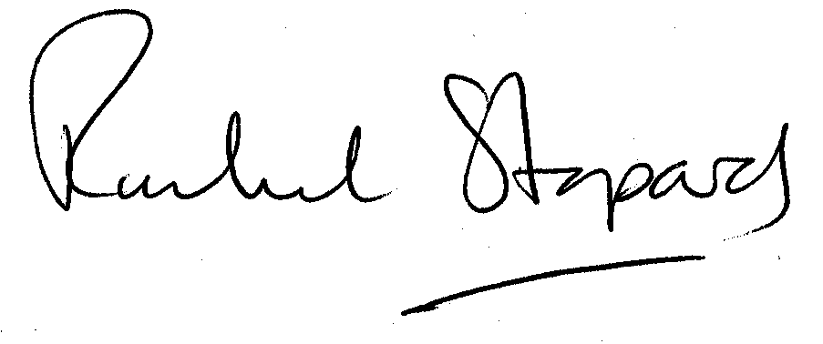
Rachel Stopard
Director of Supporting Communities

