Development Name: 69 Highgate High Street
Dwelling Types: Private Residential Maisonette
Checklist POL 1: GWP of Insulants
Element | Proposed Insulation Materials | Unfoamed [U] /  Foamed [F] / Installed Using Propellants [P] | Manufacturer | Product Name | GWP  (if foamed) | Name of Blowing Agent Used (where installed using a propellant) | GWP of Blowing Agent  (if present) | Reference to literature confirming GWP  (if foamed or installed using a propellant)
Roofs
Roof Type 1 | Polyisocyanurate Foam | F | Bauder | PIR Tapered Insulation | 3 kg CO2-Eq./kg |  |  | Bauder PIR Insulation Technical Data Sheet
Roof Type
Loft Access
Walls
External Walls | Pentane blown - Expanded Polystyrene | F | Sto | StoTherm EPS Board | 0 kg CO2-Eq./kg |  |  | Sto EPS – BREEAM Credit Letter
External Walls | Thermoset Phenolic Insulation | F | Kingspan | 'Kooltherm K12' Insulation | 3 kg CO2-Eq./kg |  |  | Kingspan – GWP & ODP Technical Sheet
External Walls | Mineral Wool | U | Knauf (or similar) |  | ------
Internal Walls | Glass Mineral Wool | U | Isover | Acoustic Partition Roll (APR1200) | ------
Doors
Lintels
Thermal and Acoustic Insulation
Floors
Ground Floor | Thermoset Insulation | F | Kingspan | Thermafloor TF70 | 3 kg CO2-Eq./kg |  |  | Kingspan – GWP & ODP Technical Sheet
Upper Floors
Basement
Foundations
Thermal Stores
Hot Water Cylinder | Polyurethane foam | F | Envirofoam | Envirofoam 16.425 | 0.7 kg CO2-Eq./kg |  |  | Envirofoam Technical Sheet
Cold Water | Polyurethane foam | F | Kingspan | Tarecpur | Less than 5 |  |  | Letter / website
Storage Tanks | Polyurethane foam | F | Kingspan | Tarecpur | Less than 5 |  |  | Letter / website
Pipe Insulation | Closed cell elastomeric foam | F | Armacell | Class O | 0 kg CO2-Eq./kg
Other Thermal Stores
Note: The manufacturing process of insulating materials changes regularly. Because of this, this document does not include a complete list of insulating materials that comply and manufacturers should be approached for up-to-date information on their products.

Confirmation
By completing the criteria above, I confirm that all dwellings of this specification type on the development indicated meet the stated criteria.
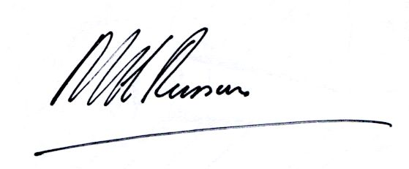
Signature - This must be an electronic signature or this document must be physically signed in pen:
Date: 12/05/16
Print Name and Role: Michael Russum, Architect

Signoff Type: Design Stage / Post Construction Stage

