**DESIGN & ACCESS STATEMENT**

**SITE ADDRESS: 68 CHOMLEY GARDENS, LONDON, NW6 1AJ.**

FRONT OF PROPERTY – NO CHANGE TO THIS AT ALL

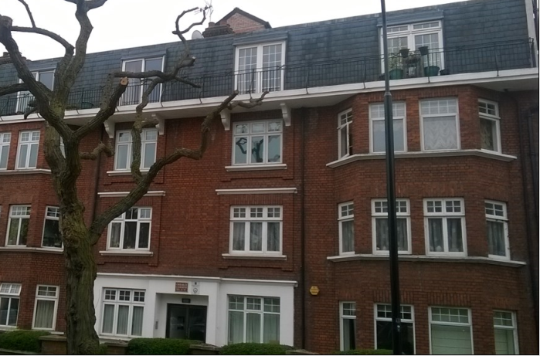

Anglian Home Improvements have been contracted to replace the single door to the rear of the property for some French doors. The property is multi- occupancy flats and therefore we need a planning application. The majority of the windows to the front and rear appear to be either PVCu or aluminium

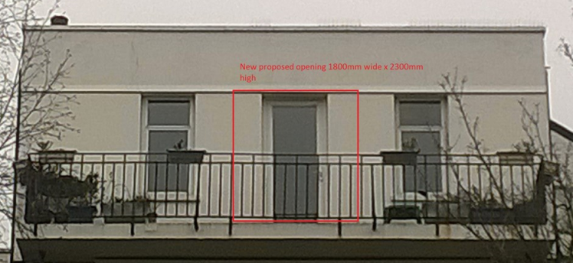

REAR OF PROPERTY –TOP FLAT DOOR TO BE CHANGED FROM SINGLE TO DOUBLE DOORS

REAR VIEW OF WHOLE OF PROPERTY

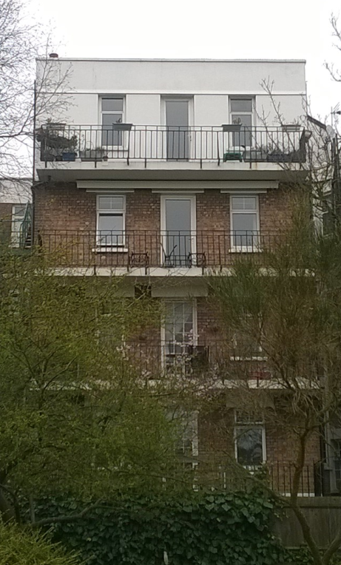

**AMOUNT:** There will be 1 new door in total.

**LAYOUT**: The door width will be widened to allow for the new double door to fit in the aperture.

**SCALE**: The door will be central to the rear of the property.

**LANDSCAPING**: Our proposal will not require any landscaping as this is a new door replacement.

**APPEARANCE:** The new French doors will be white aluminium frames.

**ACCESS:** Access will be gained by entering the property via the main entrance. There are no changes to the parking arrangements or access onto the property. There are no special measures needed with highways to install the windows or bring materials to site.

**DEVELOPMENTS WITHIN OR AFFECTING CONSERVATION AREA, LISTED BUILDING OR ITS SETTING.** We have considered carefully the proposed changes to the property and feel that the new doors should not have a detrimental effect on the property as a whole and its surrounding area or setting.

