
- Menu
- Search

What are you looking for?

Searching...
Click anywhere to close (ESC)

- Listing
  - Search the List
  - Enrich the List
  - Apply for Listing
  - What is Listing?
  - Listing Guidance
  - Showcasing Designation
- Advice
  - Your Home
  - Planning
  - Latest Advice & Guidance
  - Caring for Heritage
  - Technical Guidance
  - Heritage at Risk
  - Constructive Conservation
  - Heritage Protection Guide
- Research
  - Research Approaches
  - Current Research
  - Research Results
  - Support & Collaboration
  - Inclusive Heritage
- Images & Books
  - Find Photos
  - Search All Publications
  - Buy Books
  - The Historic England Archive
  - Magazines
  - Be an Archive Detective
- Services & Skills
  - Grants
  - Our Planning Services
  - Education
  - Training & Skills
  - Archive Services
  - Heritage Action Zones
- Get Involved
  - Be a Volunteer
  - Protect Your Heritage
  - Help Write History
  - Visit Your Heritage
- News & Features
  - News
  - Statements
  - Newsletter
  - First World War
  - Angel Awards

  - What We Do
  - How We Are Run
  - Jobs
  - Contact Us
  - Volunteer with Historic England

  - Website Terms and Conditions
  - Data Protection
  - Privacy and Cookies
  - Links Policy
  - Historic England Blog: House Rules
  - Gormley’s ROOM Competition Terms and Conditions
This browser is not fully supported by Historic England.
We use cookies to give you the best possible experience online. By using this website, you consent to cookies being used in accordance with our Cookie Policy.
- Home
- ...
- Listing
- Search the List
- List Entry
- Section Navigation
  - Minor Amendments
  - Download Designation Data
  - Non-Listed Sites

59, ST GILES HIGH STREET

List Entry Summary
This building is listed under the Planning (Listed Buildings and Conservation Areas) Act 1990 as amended for its special architectural or historic interest.
Name: 59, ST GILES HIGH STREET
List entry Number: 1245863

Location
59, ST GILES HIGH STREET
The building may lie within the boundary of more than one authority.
County: Greater London Authority
District: Camden
District Type: London Borough
Parish:
National Park: Not applicable to this List entry.
Grade: II
Date first listed: 10-Aug-1989
Date of most recent amendment: Not applicable to this List entry.

Legacy System Information
The contents of this record have been generated from a legacy data system.
Legacy System: LBS
UID: 477938

Asset Groupings
This list entry does not comprise part of an Asset Grouping. Asset Groupings are not part of the official record but are added later for information.

List entry Description

Summary of Building
Legacy Record - This information may be included in the List Entry Details.

Reasons for Designation
Legacy Record - This information may be included in the List Entry Details.

History
Legacy Record - This information may be included in the List Entry Details.

Details
CAMDEN
TQ2981SE ST GILES HIGH STREET 798-1/104/1508 (South side) 10/08/89 No.59
II
Terraced house and shop, now house and restaurant. Early C19. Flemish bond brick. Slate mansard roof with brick end stack. 4 storeys 2 windows. Mid C20 shop windows set in mid C19 architrave with pilasters to bracketed cornice and glazing bars; panelled door with overlight to right. Gauged brick flat arches to 1st floor plate glass sashes set in semicircular arched recesses linked by stone imposts; 1st floor, gauged brick flat arches to 12-pane sashes; 2nd floor, 9-pane sashes with wide continuous band beneath sills. Pear-drop dentils to cornice. INTERIOR: has stick baluster staircase and some cornices.
Listing NGR: TQ2991881295

Selected Sources
Legacy Record - This information may be included in the List Entry Details
National Grid Reference: TQ 29918 81295

Map
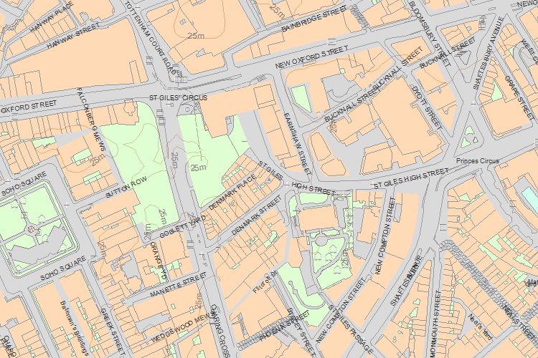© Crown Copyright and database right 2016. All rights reserved. Ordnance Survey Licence number 100024900.
© British Crown and SeaZone Solutions Limited 2016. All rights reserved. Licence number 102006.006.
Use of this data is subject to Terms and Conditions.
The above map is for quick reference purposes only and may not be to scale. For a copy of the full scale map, please see the attached PDF - 1245863 .pdf
The PDF will be generated from our live systems and may take a few minutes to download depending on how busy our servers are. We apologise for this delay.
This copy shows the entry on 26-May-2016 at 11:43:30.
End of official listing

