
- Menu
- Search

What are you looking for?

Searching...
Click anywhere to close (ESC)

- Listing
  - Search the List
  - Enrich the List
  - Apply for Listing
  - What is Listing?
  - Listing Guidance
  - Showcasing Designation
- Advice
  - Your Home
  - Planning
  - Latest Advice & Guidance
  - Caring for Heritage
  - Technical Guidance
  - Heritage at Risk
  - Constructive Conservation
  - Heritage Protection Guide
- Research
  - Research Approaches
  - Current Research
  - Research Results
  - Support & Collaboration
  - Inclusive Heritage
- Images & Books
  - Find Photos
  - Search All Publications
  - Buy Books
  - The Historic England Archive
  - Magazines
  - Be an Archive Detective
- Services & Skills
  - Grants
  - Our Planning Services
  - Education
  - Training & Skills
  - Archive Services
  - Heritage Action Zones
- Get Involved
  - Be a Volunteer
  - Protect Your Heritage
  - Help Write History
  - Visit Your Heritage
- News & Features
  - News
  - Statements
  - Newsletter
  - First World War
  - Angel Awards

  - What We Do
  - How We Are Run
  - Jobs
  - Contact Us
  - Volunteer with Historic England

  - Website Terms and Conditions
  - Data Protection
  - Privacy and Cookies
  - Links Policy
  - Historic England Blog: House Rules
  - Gormley’s ROOM Competition Terms and Conditions
This browser is not fully supported by Historic England.
We use cookies to give you the best possible experience online. By using this website, you consent to cookies being used in accordance with our Cookie Policy.
- Home
- ...
- Listing
- Search the List
- List Entry
- Section Navigation
  - Minor Amendments
  - Download Designation Data
  - Non-Listed Sites

26, DENMARK STREET

List Entry Summary
This building is listed under the Planning (Listed Buildings and Conservation Areas) Act 1990 as amended for its special architectural or historic interest.
Name: 26, DENMARK STREET
List entry Number: 1271982

Location
26, DENMARK STREET
The building may lie within the boundary of more than one authority.
County: Greater London Authority
District: Camden
District Type: London Borough
Parish:
National Park: Not applicable to this List entry.
Grade: II
Date first listed: 14-May-1974
Date of most recent amendment: Not applicable to this List entry.

Legacy System Information
The contents of this record have been generated from a legacy data system.
Legacy System: LBS
UID: 477062

Asset Groupings
This list entry does not comprise part of an Asset Grouping. Asset Groupings are not part of the official record but are added later for information.

List entry Description

Summary of Building
Legacy Record - This information may be included in the List Entry Details.

Reasons for Designation
Legacy Record - This information may be included in the List Entry Details.

History
Legacy Record - This information may be included in the List Entry Details.

Details
CAMDEN
TQ2981SE DENMARK STREET 798-1/104/304 (North side) 14/05/74 No.26
GV II
Terraced house with later shop. Early C18. Multi-coloured stock brick. Tiled mansard roof with dormer. 3 storeys and attic. 3 windows. C20 shop to ground floor. Upper floors with rough arches (cut flat above) to flush frame cross windows. INTERIOR: not inspected.
Listing NGR: TQ2990981281

Selected Sources
Legacy Record - This information may be included in the List Entry Details
National Grid Reference: TQ 29909 81281

Map
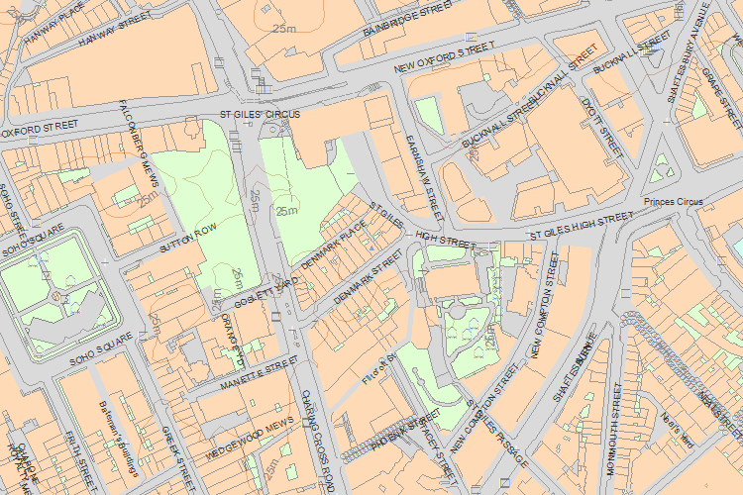© Crown Copyright and database right 2016. All rights reserved. Ordnance Survey Licence number 100024900.
© British Crown and SeaZone Solutions Limited 2016. All rights reserved. Licence number 102006.006.
Use of this data is subject to Terms and Conditions.
The above map is for quick reference purposes only and may not be to scale. For a copy of the full scale map, please see the attached PDF - 1271982 .pdf
The PDF will be generated from our live systems and may take a few minutes to download depending on how busy our servers are. We apologise for this delay.
This copy shows the entry on 26-May-2016 at 11:38:17.
End of official listing

