25th March 2016

Seonaid Carr

Case Officer

Regeneration and Planning Development Management

London Borough of Camden

Town Hall

London

WC1H 8ND

Dear Ms Carr

Regents Park Estate, London, NW1 – Discharge of Condition 24

Please find enclosed a discharge of condition planning application for Condition 24, Ref: PP-05178591, relating to the existing planning permission ref: 2015/3076/P for the Regent’s Park Estate, London, NW1.

In respect of the above application, the following documents have been submitted via the Planning Portal:

* Cover Letter (this document);
* Project Management Plan;
* Planning application fee of £97:00.

With regards to the Project Management Plan; the precautionary approach to the possible presence of Bats is dealt with in the site induction section where all site operatives will be advised of the possibility of Bats at the two locations raised in Condition 24 and advised of the procedure if Bats are encountered. The details can be found in Section 4 page 17, further information is contained in Section 8 where protected species in general are covered.

We look forward to receiving confirmation that the application has been validated. However, should you require any further information please do not hesitate to contact the undersigned.

Yours faithfully

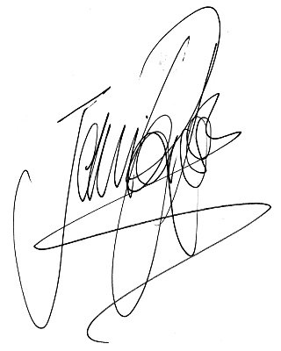For Tibbalds Planning and Urban Design

Jennifer Ross

Director

[jennifer.ross@tibbalds.co.uk](mailto:jennifer.ross@tibbalds.co.uk)

Direct dial: 020 7089 2131