25th March 2016

Seonaid Carr

Case Officer

Regeneration and Planning Development Management

London Borough of Camden

Town Hall

London

WC1H 8ND

Dear Ms Carr

Regents Park Estate, London, NW1 – Discharge of Condition 6: Community Safety Statement

Please find enclosed a discharge of condition planning application for Condition 6: Community Safety Statement, Ref: PP-05173598, relating to the existing planning permission ref: 2015/3076/P for the Regent’s Park Estate, London, NW1.

In respect of the above application, the following documents have been submitted via the Planning Portal:

* Cover Letter (this document);
* Community Safety Statement (Part 1 and Part 2);
* Planning application fee of £97:00.

We look forward to receiving confirmation that the application has been validated. However, should you require any further information please do not hesitate to contact the undersigned.

Yours faithfully

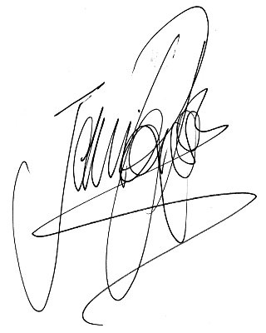For Tibbalds Planning and Urban Design

Jennifer Ross

Director

[jennifer.ross@tibbalds.co.uk](mailto:jennifer.ross@tibbalds.co.uk)

Direct dial: 020 7089 2131