Clare Lodge
Peter Inskip and Peter Jenkins Architects
19-23 White Lion Street
London N1 9PD
19-23 White Lion Street  London N1 9PD |  | Application Ref: 2015/5950/L
 |  | Please ask for: Antonia Powell
 |  | Telephone: 020 7974 2648
 |  | 18 May 2016

Dear Sir/Madam

DECISION

Planning (Listed Building and Conservation Areas) Act 1990

Listed Building Consent Granted

Address:
53 Bedford Square
London
WC1B 3DP

Proposal:
The cleaning of the north, east and south elevations of the mews house fronting Bedford Avenue.
Drawing Nos:
53 BSH GA 000 Site location Plan;
53 BS C 001 rev A;
53 BS C 003;
Heritage Statement dated 20/10/2015 by Peter Inskip and Peter Jenkins Architects;
Design and Access Statement by Peter Inskip and Peter Jenkins Architects

The Council has considered your application and decided to grant Listed Building Consent subject to the following condition(s):

Conditions And Reasons:

1 | The works hereby permitted shall be begun not later than the end of three years from the date of this consent.  Reason: In order to comply with the provisions of Section 18 of the Planning (Listed Buildings and Conservation Areas) Act 1990.
2 | The works hereby approved are only those specifically indicated on the drawing(s) referred to above.  Reason: In order to safeguard the special architectural and historic interest of the building in accordance with the requirements of policy CS14 of the London Borough of Camden Local Development Framework Core Strategy and policy DP25 of the London Borough of Camden Local Development Framework Development Policies.
3 | All new work and work of making good shall be carried out to match the original work as closely as possible in materials and detailed execution.  Reason: In order to safeguard the special architectural and historic interest of the building in accordance with the requirements of policy CS14 of the London Borough of Camden Local Development Framework Core Strategy and policy DP25 of the London Borough of Camden Local Development Framework Development Policies.

Informative(s):

This application initially involved the cleaning of the external elevations of No. 53 Bedford Square and the building to the rear fronting Bedford Avenue.

However it has been agreed that the front and side elevations of Grade I Bedford Square are particularly sensitive and should not be cleaned as the historic darkened brickwork is an essential part of the character and appearance of the grade I listed frontages of Bedford Square.

Sample panels of cleaning have been carried out to the masonry of the Bedford Avenue mews house and discussed on site. The agreed method of cleaning is Doff steam system for the stone copping and stone details and hand cleaning for the brickwork particularly where the mortar is at risk. In addition it has been decided that a lead flashing to the coping would be protection from the rain and tree deposits which cause a marked green and black organic build up.

Public consultation was undertaken by placement of a press notice and site notice and no responses were received. The Bloomsbury Association wrote in support of the cleaning of the mews house only. They did not support the cleaning of the Bedford square building. The final scheme reflects this.

The site's planning history was taken into account when coming to this decision.

Special regard has been attached to the desirability of preserving the listed building and its features of special architectural or historic interest, under s.16 of the Listed Buildings and Conservation Areas Act 1990 as amended by the Enterprise and Regulatory Reform Act (ERR) 2013.

As such, the proposal is in general accordance with policy CS14 of the London Borough of Camden Local Development Framework Core Strategy, and policy DP25 of the London Borough of Camden Local Development Framework Development Policies. The proposed development also accords with policy 7.8 of the London Plan 2011, and paragraphs 14, 17 and 126-141 of the National Planning Policy Framework.

The revised scheme of cleaning the mews house only is considered acceptable and the application is therefore granted.

You can find advice about your rights of appeal at:

http://www.planningportal.gov.uk/planning/appeals/guidance/guidancecontent

Yours faithfully
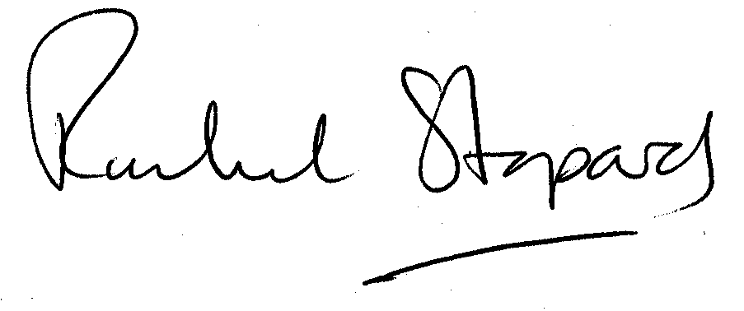
Rachel Stopard
Director of Supporting Communities

