157 GLOUCESTER AVENUE, LONDON NW1 8LA
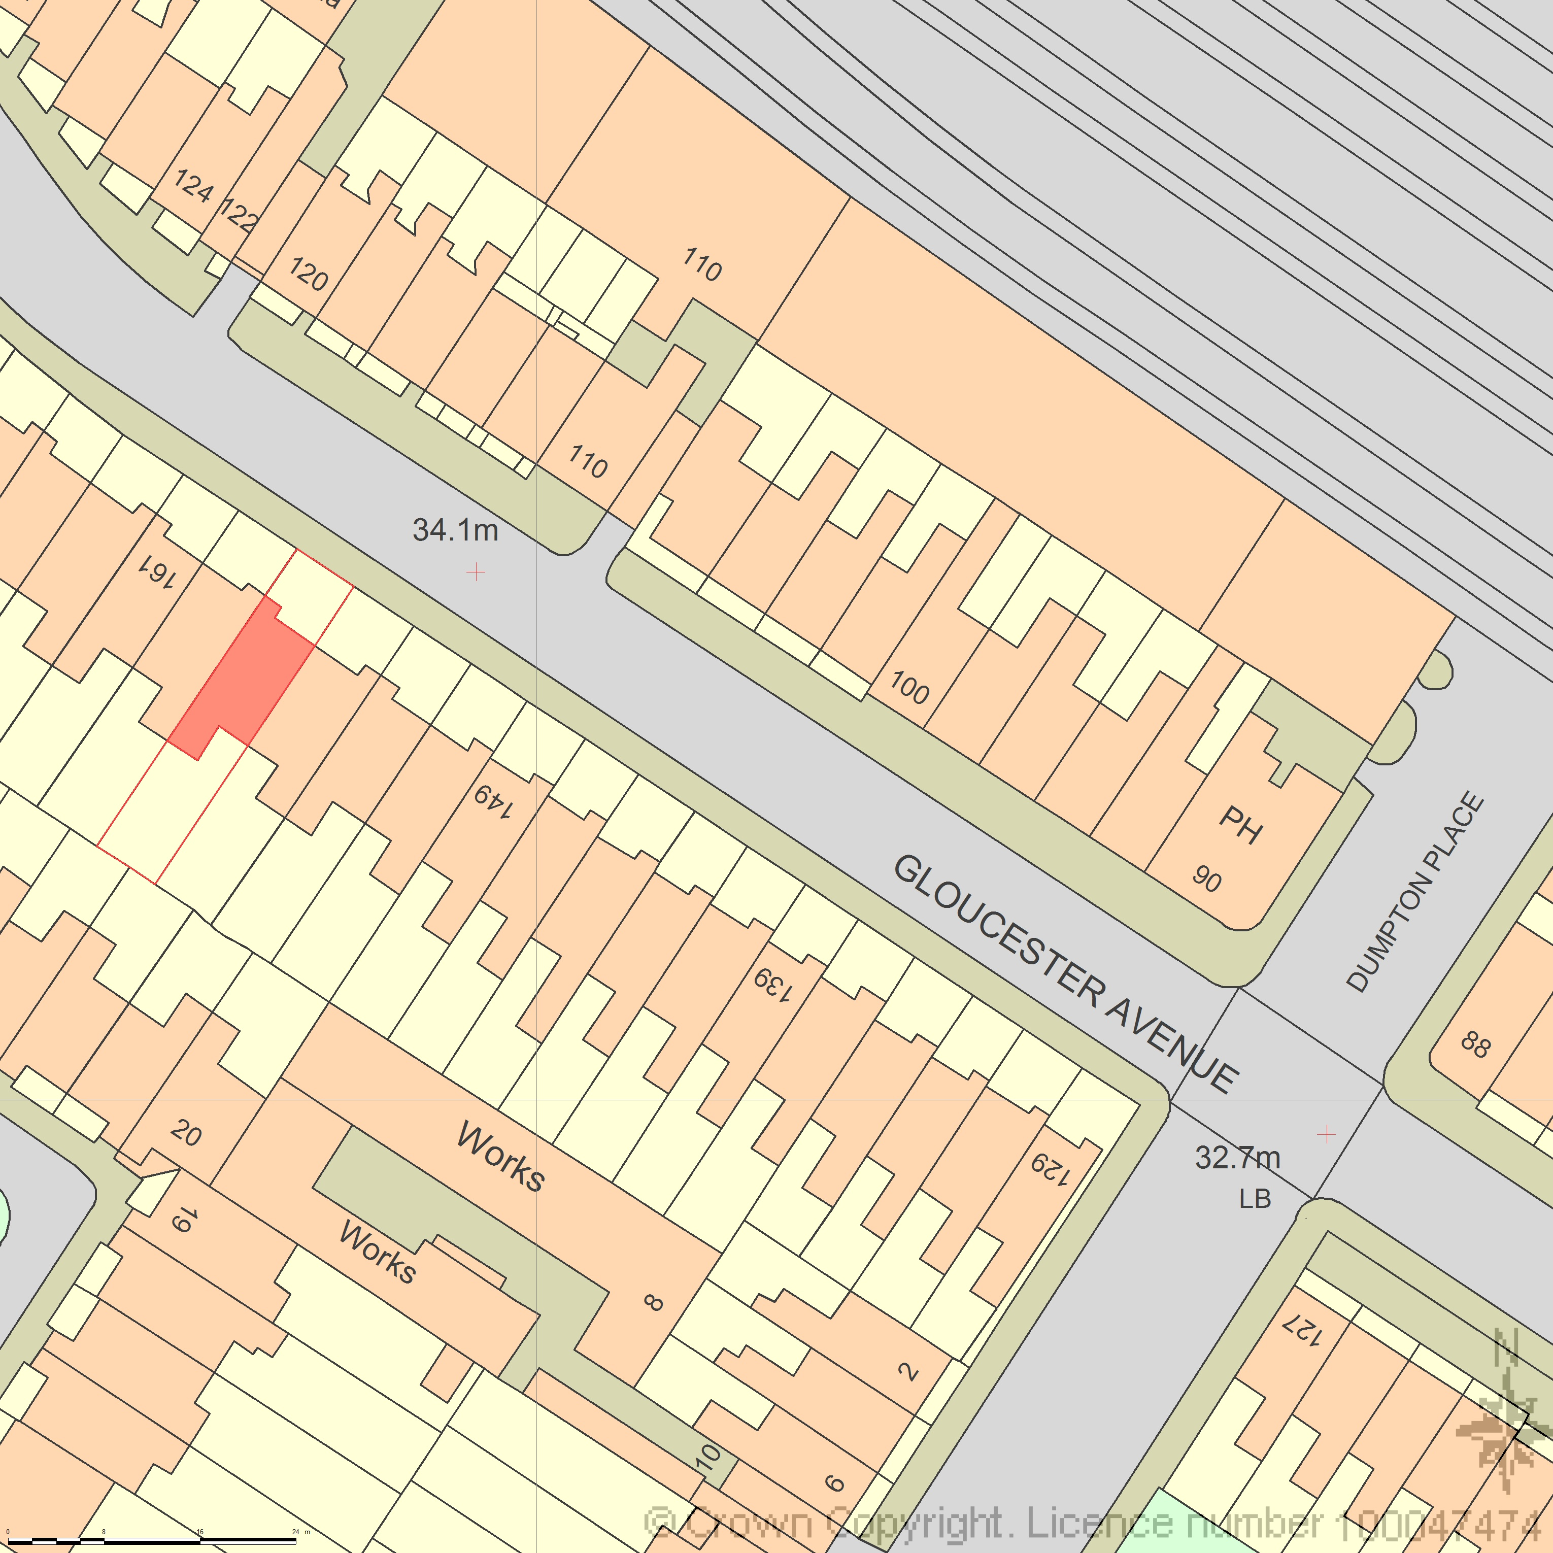
LOCATION AND BLOCK PLAN
AREA 130m x 130m A3
SCALE 1:500
CENTRE COORDINATES: 528120, 184127


Supplied by Streetwise Maps Ltd
www.streetwise.net
Licence No: 100047474
30/07/2026 04:01:41

