Extracts from *Lost Rivers of London* Nicholas Barton

ISBN: 0948-66715-X

Page 134. Discusses the problems of building near old rivers and sewers, including a quote from surveyor J. G. Head circa 1950;

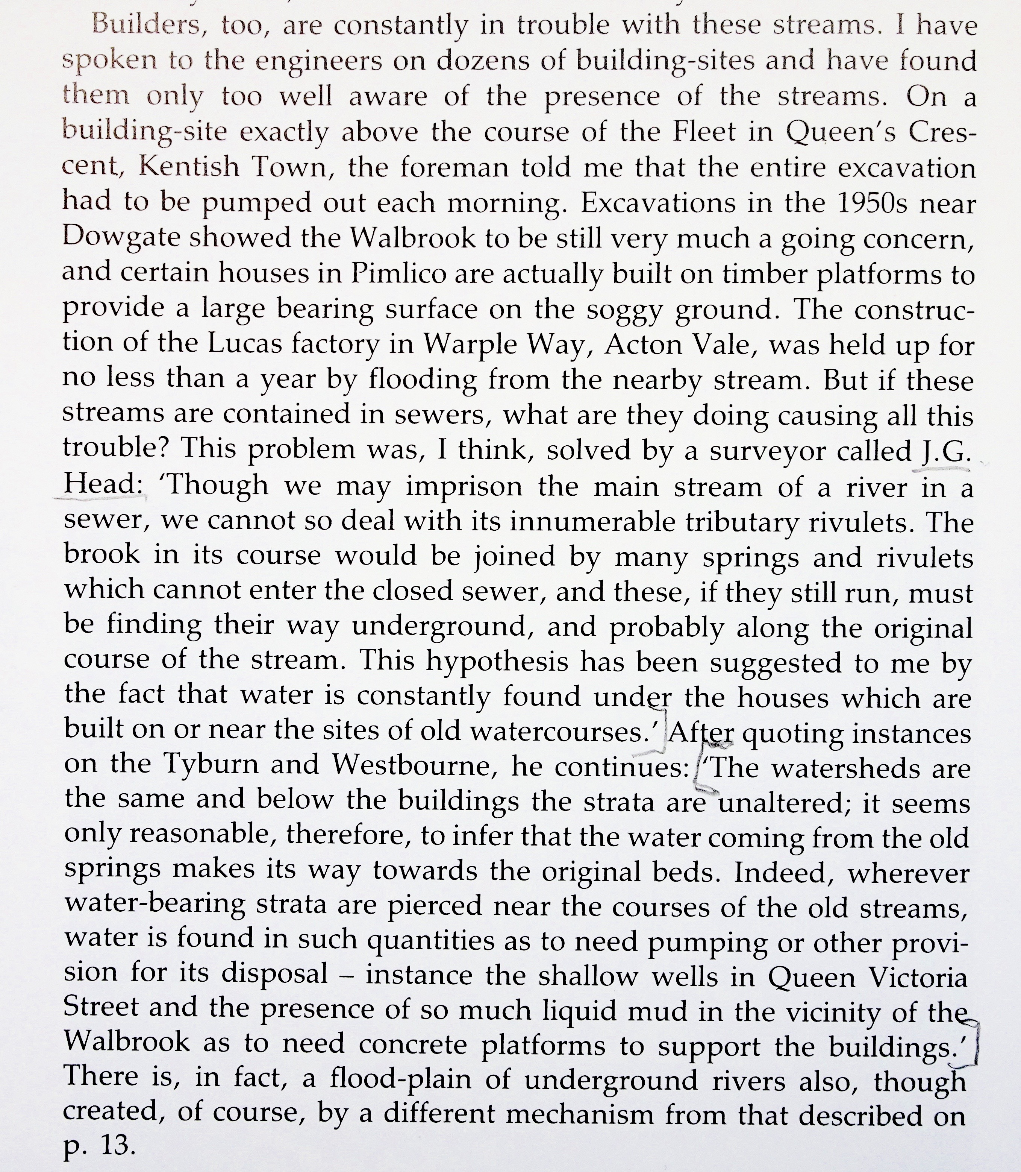

The Fleet River bursts and wrecks the construction of the Metropolitan Railway at Farringdon. 1862.

