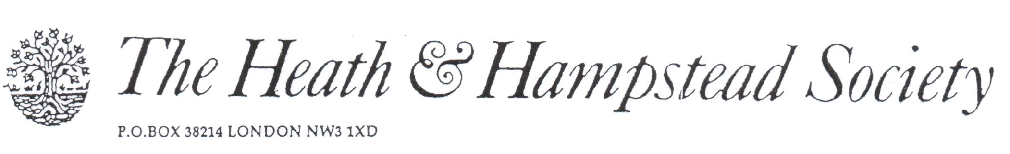
The Society examines all Planning Applications relating to Hampstead, and assesses them for their impact on conservation and on the local environment.

To London Borough of Camden, Development Control Team

Planning Ref: 2016/2156/P
Address: 8 Oak Hill Park Mews, NW3
Description: Removal of Condition to permission 2015/3569/P.
Case Officer: Anna Roe Date 5 May 2016

This Condition was rightly attached to Permission 2015/3569/P to prevent overlooking and loss of privacy to adjacent houses.

We objected to a previous, very similar, application on this site, 2012/4929/P; the applicant plainly thinks that repeated attempts to get his way will bring him success.

He advances no justification for its removal in this case; there is none.

Please refuse.

