Enforcement Delegated Report |  |  | Receipt date: | 28-8-2015
Officer |  | Enforcement Case
John Sheehy |  | EN15/0869
Breach Address |  | Photos & Other material
12 Egbert Street,  London, NW1 8LJ |  | See Appendix

Authorised Officer Signature
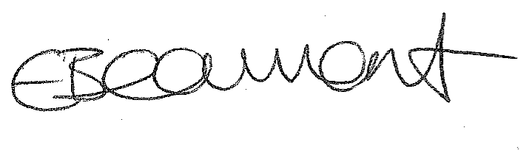11.02.16

Alleged Breach
Installation of lamp, 3 x security cameras and 1 x alarm box on the front elevation at ground floor level.
Recommendation: | Issue an enforcement notice
Priority: | P3

Site Description
The property is a 3-storey-with-basement dwellinghouse located on the northern side of Egbert Street, a cul-de-sac in Primrose Hill. On both sides of the street are terraces of townhouses dating from the mid-19th century. These have retained their fine-grained character with original brick, stucco and cast iron detailing. The townhouses are two bays wide, each with a front light well, an external staircase and a visible basement level.

The property is identified in the Primrose Hill Conservation Area Statement as making a positive contribution to the character and appearance of the Conservation Area.

Investigation History
- 28-8-2015: complaint received, case opened;
- 14-9-2015: officers visited the site and took photographs;
- 30-11-2015: officers wrote to the site owner, stating that works do not benefit from permission, advising their removal, warning of enforcement action if no action taken, and requesting a timeframe under which the items would be removed;
- 9-12-2015: site owner replied, but did not provide the requested deadline for removal of the unauthorised works;
- 18-12-15: officers responded stating that the works are clearly in breach of policies and need to be removed as a matter of urgency. As no deadline was provided, officers stated that the removal works should be completed by 15 Jan;
- 3-1-16: site owner wrote to officers, however, again, did not provide a date for removal of the unauthorised works;
- 8-1-16: officers replied that an Enforcement Notice would be issued unless evidence was provided within a week to show that the works were imminent. No response received.
- 15-1-16: officers visited site, unauthorised works still in place.

Planning history:

November 2014 Planning permission granted for erection of a mansard roof extension with two front dormer windows, one rear dormer window and rooflight; and the erection of a 2 storey rear infill glazed extension at lower ground and ground floor level, ref. 2014/5248/P.

Existing and proposed drawings for this application show one alarm box on the front elevation, at first floor level.

Relevant policies / GPDO Category
LDF Core Strategy and Development Policies
Core strategy
CS5 Managing the impact of growth and development
CS14 Promoting high Quality Places and Conserving Our Heritage

Development Policies
DP24 Securing High Quality Design
DP25 Conserving Camden’s Heritage
DP26 Managing the impact of development on occupiers and neighbours

London Plan 2011
National Planning Policy Framework
Camden Planning Guidance
- CPG1 Chapters 2, 3 and 4
Primrose Hill Conservation Area Strategy

Assessment
Background

The property is located in Primrose Hill Conservation Area (CA).

The properties within the terrace 2-14 Egbert Street are all identified in the Conservation Area Statement as making a positive contribution to the character and appearance of the CA.

On the other side of the street, nos. 1-13 are also identifies as positive contributors.

Need for planning permission for CCTV cameras

Part 33 Class A of the General Permitted Development Order allows for Closed Circuit Television Cameras to be installed to properties, however this is subject to a number of constraints, including the following:

(f)any part of the camera would be less than 10 metres from any part of another camera installed on a building;
If, a camera is to be installed the following condition needs to be complied with:
(a)the camera shall, so far as practicable, be sited so as to minimise its effect on the external appearance of the building on which it is situated;

All three cameras are located within 10m of each other on the front elevation of the building so do not comply with the requirement under (f) above.

With regard to siting (a), two of the cameras are located conspicuously and unacceptably within the stuccoed part of the ground front elevation fronting onto Egbert Street. The other camera is located obtrusively within the doorway of the property. All 3 cameras are located in unsuitable positions which fail to minimize their impact on the external appearance of the building, an attractive period property within the Primrose Hill Conservation Area.

Policy context

Policy DP24 states that the Council will grant permission for development that is designed to a high standard.

In terms of the works to this property, the following considerations contained within this policy are relevant:

- development should consider the character, setting, context and the form and scale of neighbouring buildings;
- development should consider the character and proportions of the existing building, where extensions and alterations are proposed.

Policy DP25 ‘Conserving Camden’s Heritage’ states that within Conservation Areas, the Council will only grant permission for development that preserves and enhances the character and appearance of the Conservation Area.
Camden Planning Guidance on Design (CPG1) states in paragraph 4.7 that:
- “Alterations should also take into account the character and design of the property and its surroundings… [in some cases] closely matching materials and design details are more appropriate so as to ensure new work blends with the old”.
Under the “Materials” sub-heading of paragraph 4.7 of CPG1 the following guidance is provided:
- “You should use materials that complement the colour and texture of materials in the existing building… In historic areas traditional materials such as brick, stone, timber and render will usually be the most appropriate complement to the existing historic fabric; modern materials such as steel and glass may be appropriate but should be used sensitively and should not dominate the existing property” and;
- “Materials and alterations should weather well, so their ageing process contributes positively to the character of the building, and the site’s wider context”.
Primrose Hill Conservation Area Statement Policy PH1 states that “All development should respect existing features such as building lines, roof lines, elevational design, and where appropriate, architectural characteristics, detailing, profile, and materials of adjoining buildings”
Policy PH11 states “The choice of materials in new work is important and will be subject to control by the Council. Original, traditional materials should be retained wherever possible and repaired only if necessary… Generally the use of original (or as similar as possible) natural materials will be required…”
Assessment

The unauthorised elements that have been installed to the ground floor front of no. 12 are as follows:

- One glass and chrome lamp near the front door;
- Three sphere-shaped cameras, finished in white plastic with a dark glass lens, mounted on a conical white plastic base:
- Two of the cameras are located beside the boundary with no. 10, with the lens pointed towards the door of no. 12;
- One is located on the inner frame of the door opening, on the left hand side as one faces the property; and
- One plastic alarm box – under the approved drawings for 2014/5248/P, this was shown on the existing and proposed first floor front elevation. No permission was granted for this item to be relocated to ground floor and, combined with the other items that have been located at ground floor level, this contributes to unsightly clutter at ground floor front elevation of this sensitive period property which fronts onto one of the best preserved streets in the Primrose Hill Conservation Area;

These five separate elements which have been added to the front elevation of the property at ground floor level are made from materials and finishes that are not part of the palate of traditional materials used in the remainder of the building or in the surrounding townscape. The additions have resulted in a conspicuous change in the appearance of the building at ground floor level. In the context of the building, they amount to “material” development which would require permission. The works cannot be considered as permitted development due to the number and type of the alterations and the materials which do not resemble those used in the remainder of the dwellinghouse.

The works are prominently visible in short and long views along Egbert Street and Chalcot Road. There are no street trees in Egbert St to shield the front elevation from views.

The continuity of materials, scale and finish, together and the treatment of openings within the nineteenth century townhouses on Egbert Street results in a satisfying whole. A harmonious, rhythmic pattern is a distinctive feature of the street and the wider conservation area. Within this continuous, unified street scene there is limited scope for alterations. In this case, the works that have been carried out without permission rupture the continuity of the street scene and detract from its uniform, rhythmic character.

The use of white plastic, chrome and dark glass fails to reflect the materials and finishes used in the host building and the surrounding townhouses. The appearance of the building and of the street is harmed by the unsightly clutter which does not integrate with the original building, the street or the Conservation Area. The works fail to comply with adopted guidance contained in CPG1 and with design and conservation area policies CS15, DP24 and DP25.

The owner has stated that the works are a necessary security measure and extra illumination is needed to the steps of no.12 as older family members sometimes visit the property. However, it is noted that none of the nearby properties have had a similar set of items attached to the front elevation. Furthermore it is considered that there are more sensitive ways of illumination which do not require prominent lamps at ground floor front elevation of a sensitive period property.

No other security cameras were noted. Number 2 Egbert Street has carriage lamps either side of the front door. While these do not integrate comfortably with the property, they would appear to have been in place for over 4 years and also have a traditional appearance. Likewise at no. 14 the light within the doorway would appear to have been in place for over 4 years and is less harmful as it is painted white to match the nearby stucco.

In terms of the alleged need for additional illumination, it is noted that a traditional streetlamp is located adjacent to the property in front of no. 10 Egbert Street. In terms of its proportions, the street is relatively wide relative to the height of the buildings and, in addition, the steps to the front of no. 12 have a bold ceramic pattern which acts as a visual aid to partially-sighted people.

It is necessary and expedient to issue the Notice in order to ensure that the unauthorised works are removed within a controlled timeframe and that they do not remain in place.

No amenity issues are raised in terms of sunlight, daylight outlook or privacy.

Recommendation:
That the Head of Legal Services be instructed to issue an Enforcement Notice under Section 172 of the Town & Country Planning Act 1990 as amended to secure the removal of the security cameras and lamp from the front ground floor elevation and the relocation of the alarm box to its previous position at first floor, and to pursue any legal action necessary to secure compliance and officers be authorised in the event of non-compliance, to prosecute under section 179 or appropriate power and/or take direct action under 178 in order to secure the cessation of the breach of planning control.

The Notice shall allege the following breach of planning control:

Installation of lamp, 3 x security cameras and 1 x alarm box on the front elevation at ground floor level.

The Council requires the following steps to be taken:

- Completely remove the 3 x security cameras (annotated in red and labelled nos. 1,2 and 3 on appendix 1) and lamp (annotated in red and labelled no. 5 on appendix 1) from the ground floor front elevation and make good any resulting damage caused;
- Either completely remove the alarm box (annotated in red and labelled no.4 on appendix 1) or relocate it to its previous position at first floor level on the front elevation shown on plan 7419-04-a approved under application ref. 2014/5248/P (see appendix 2) and make good any resulting damage caused.

PERIOD OF COMPLIANCE

Three months of the Notice taking effect.

REASON WHY THE COUNCIL CONSIDER IT EXPEDIENT TO ISSUE THE NOTICE:

- The cameras, alarm box and light on the front elevation of the building, by reason of their location and appearance and cumulative impacts adds harmful clutter and forms an incongruous and obtrusive set of features which are harmful to the character and appearance of the building, the streetscape and the Primrose Hill Conservation Area. As such, the works are contrary to policy CS14 (Promoting high Quality Places and Conserving Our Heritage) of the London Borough of Camden Local Development Framework Core Strategy; and DP24 (Securing High Quality Design) and DP25 (Conserving Camden's Heritage) of the London Borough of Camden Local Development Framework Development Policies.

The Council does not consider that planning permission should be given because planning conditions could not overcome these problems.
Appendix 1 – plan to show locations of unauthorised additions.
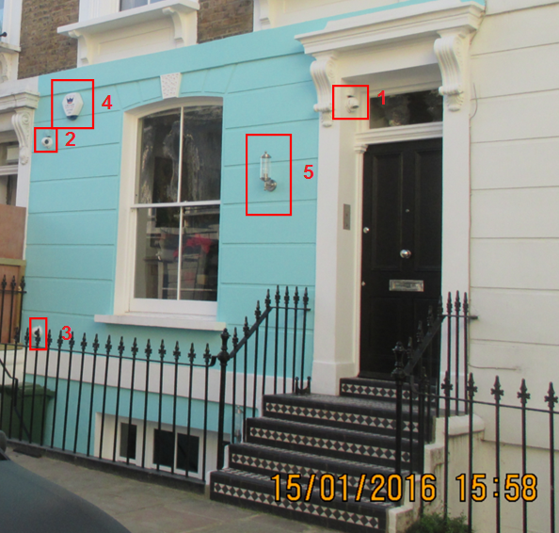
Appendix 2 – plan to show location of alarm box on front elevation (left of drawing below between first floor windows)
